Boom Goes the Dynamite: How Destructible Environments Affect Gameplay
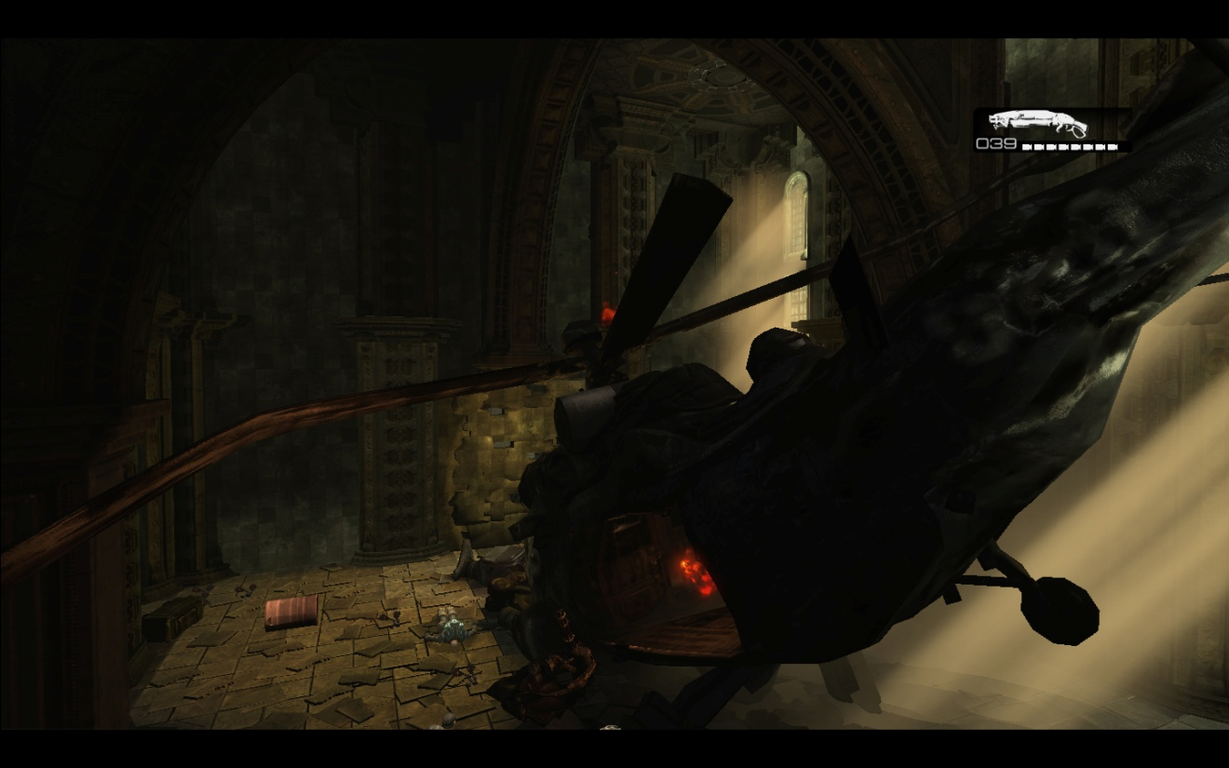

MASTER OF INTERACTIVE TECHNOLOGY
THESIS

PRESENTED BY KEVIN CHANDLER

To the Graduate Faculty:
I am submitting herewith a project written by Kevin Chandler entitled
“Boom Goes the Dynamite: How Destructible Environments Affect Gameplay.” I recommend that it be accepted in partial fulfillment of the requirements for the degree of Master of Interactive Technology in Digital Game Development, with Specialization in Level Design.

_________________________________
Myque Ouellette, Supervisor

I have read this Project and recommend its acceptance:

_________________________________
Michael McCoy, Advisor

Accepted for the Faculty:

_________________________________
Gary Brubaker
Deputy Director, Academics
SMU Guildhall
Boom Goes the Dynamite: How Destructible Environments Affect Gameplay

A Thesis Presented to the Graduate Faculty of

The Guildhall

Southern Methodist University

in

Partial Fulfillment of the Requirements

for the degree of

Masters of Interactive Technology

with a

Specialization in Level Design

by

Kevin Chandler

B.A., Journalism Baylor University
August 14, 2011

Acknowledgements

Shanna
For convincing me life is too short to not pursue my passion. Without your support and your patience this would not have been possible. I love you so much and I’m looking forward to the adventures we will have as a family.

Natalie
My daughter, for bringing so much joy and making me want to be the very best I can be.

Prof. Ouellette
For sticking with me through this long process and lending a much needed critical eye.

Prof. McCoy
For your guidance in the planning stages to pick something in my wheelhouse.

Kevin Chandler M.I.T., SMU Guildhall, 2011
Boom Goes the Dynamite: How Destructible Environments Affect Gameplay
Supervisor: Professor Myque Ouellette
Master of Interactive Technology degree conferred December 18, 2009
Thesis / Project completed August 14, 2011
Abstract
As graphics hardware continues to improve and level editors advance to match, the temptation is to add destructible physics objects to enhance traditional gameplay. However, physics objects take a lot of processing power better spent on other things. In addition, destructible features in a level take a lot of planning time as well as extra art and scripting resources. Level designers should have a set of general guidelines when designing levels so no resources are wasted. The rules examined in this thesis are:
- Visibility - The amount of effort in communicating an object’s destructibility is proportional to its importance in player progression.
- Utility – Destructible objects with a gameplay purpose are more fun than objects that destroy with no apparent purpose. .
- Believability – Destructible objects should explode or fall apart in a way that matches the player’s expectations.
Testing proved that players did better in the level when they noticed destructible features that followed the rules. Players encountering features that disobeyed the rules did not have as much fun and found the level to be more difficult. However, testing proved communicating a feature’s destructibility and its function effectively is the key to creating fun destructible environments.

Table of Contents
Acknowledgements iv
Table of Figures viii
Table of Tables x
Chapter 1: Introduction 1
Background 1
Problem and Purpose Statement 2
Research Problem 3
Significance of the Study 4
Overview of Methodology 4
Limitations 5
Definitions 6
Chapter 2: Literature and Field Review 8
Literature Review 9
Field Review 15
Early Games 17
Primary Mechanic 19
Secondary Mechanic 21
Tertiary Mechanic 22
Visibility 24
Utility 25
Believability 27
Destruction in Gears of War 28
Summary 29
Chapter 3: Methodology 31
Level Abstract: Hail to the King 36
Gameplay Overview 36
Technical Overview 37
Details 38
Story 40
Visual References 42
Maps 46
Data Collection and Procedures 64
Sample Test Questions 66
Summary 67
Chapter 4: Results 68
Demographics 69
Survey Question Results 77
Area 1: Crash Site 77
Area 2: City Streets 87
Area 3: Amphitheater 102
Overall 115
Chapter 5: Discussion 130
Demographics 131
Results 133
Visibility Rule 133
Utility 145
Believability 154
Overall 156
Limitations 159
Conclusion 160
References 165
Games 167
Appendix A: Sample Survey Document 168
Appendix B: Testing Results 182

Table of Figures
Figure 1 Dig Dug (1982) 17
Figure 2 Space Invaders (Taito 1978) 18
Figure 3 Super Mario Brothers (Nintendo 1985) 19
Figure 4 Red Faction (2001) 20
Figure 5 Red Faction 2(2002) 21
Figure 6 Bulletstorm 22
Figure 7 Mercenaries 2: World in Flames (2008). 23
Figure 8 Red Faction: Guerilla (2009) 24
Figure 9 Battlefield: Bad Company 28
Figure 10 An example of the architecture in Gears of War. 42
Figure 11 An example of what a ruined council chamber might look like. 43
Figure 12 An example of what a sunken city looks like. 43
Figure 13 Typical stonework found in Gears of War. 44
Figure 14 An example of the lighting scheme found in the central chamber. 44
Figure 15 An example of the lighting scheme for the exterior. 45
Figure 16 King Raven Helicopter. 45
Figure 17 Area 1: Crash Site 47
Figure 18 Area 2: City Streets 48
Figure 19 Area 3: Amphitheater 49
Figure 20 Red Barrels 50
Figure 21 Cracked Wall 51
Figure 22 Burnt Out Car 52
Figure 23 Statue and Planter 53
Figure 24 Tanker 54
Figure 25 Weak Sign 54
Figure 26 Intact Door 55
Figure 27 Pillars 56
Figure 28 Useless Statue 57
Figure 29 Planter 58
Figure 30 Green Barrel 59
Figure 31 Pickup Truck 60
Figure 32 Van 60
Figure 33 Statue 61
Figure 34 Area 2: City Streets 87
Figure 35 Area 3 Amphitheater 102

Table of Tables
Table 1 Participant Age 69
Table 2 Participant Gender 70
Table 3 Experience with Gears of War 71
Table 4 Game Genres Played Most Often 72
Table 5 What is your favorite game genre 72
Table 6 How many hours a week do you play games 73
Table 7 When playing first person shooters do you prefer singleplayer or multiplayer? 74
Table 8 Bartle Gamer Type 75
Table 9 How did you break down the wall? 77
Table 10 Was the objective in this area clear? 78
Table 11 If the objective was not clear, why not? 78
Table 12 When did you first notice? 79
Table 13 When did you first notice the cracks in the wall? 81
Table 14 Were the cracks in the wall enough to indicate the wall was weak and could be destroyed? 82
Table 15 Did you notice the red barrel? 83
Table 16 Did red barrels help you complete the objective 83
Table 17 What does a Red Barrel indicate to you? 85
Table 18 How Fun was Area 2 85
Table 19 How Difficult was Area 1 86
Table 20 List objects you think are destructible in Area 2 88
Table 21 List the Objects you think are destructible in Area 2 by participant 89
Table 22 Did the opening cinematic convey that the wrecked cars can be set off like explosives 91
Table 23 If the opening cinematic did not convey that the wrecked cars can be set off like explosives, why not? 91
Table 24 How easy was using explosions to defeat enemies 92
Table 25 Did you ever find yourself shooting at an object expecting it to explode or fall apart and it did not 93
Table 26 If so, describe how it felt 94
Table 27 Was the objective to breach the amphitheater clear and straightforward 95
Table 28 If the objective to breach the amphitheater was not clear and straightforward, why not? 96
Table 29 Was there anything that indicated the door could be destroyed? 96
Table 30 What was your solution to breach the door 98
Table 31 Did you notice the door glowing at any point 99
Table 32 If you noticed the door glowing , what did this indicate to you 100
Table 33 How fun was Area 2 100
Table 34 How Difficult was Area 2 101
Table 35 List the objects you think are destructible in Area 3 103
Table 36 List the Objects you think are destructible in Area 3 (By Participant) 103
Table 37 Did the opening cinematic show statues can be knocked over with an explosion 105
Table 38 How did you defeat the enemies and complete the objective 107
Table 39 Did you use the collapsing statues to defeat any of the enemies? 107
Table 40 Did the falling statues make completing the objective easier? 108
Table 41 Was the objective to defeat the boomer clear and straightforward? 109
Table 42 How did you defeat the Boomer 110
Table 43 Did you shoot the glowing sign 111
Table 44 Did you notice the glowing red sign? Did it have a purpose? 112
Table 45 How fun was Area 3 113
Table 46 How Difficult was Area 3 114
Table 47 Average Time taken to complete each area 116
Table 48 Time taken to complete each area for each tester 116
Table 49 Number of deaths in each area (average) 117
Table 50 Number of deaths in each area per tester 118
Table 51 How fun was this level 119
Table 52 How difficult was the level overall? 119
Table 53 Did you notice that Destructible features were a major part in helping you complete the objective 120
Table 54 When did you notice destruction was a theme 121
Table 55 Did you enjoy watching things blow up? 122
Table 56 Were there frustrating moments in the level? 123
Table 57 Frustrating moments in the level 124
Table 58 Were you able to destroy enemies with destructible objects. 125
Table 59 Did destruction make the experience more satisfying? 126
Table 60 What did you dislike about the level 127
Table 61 What did you dislike about the level? 129
Table 62 Fun Level vs. Recognition of Destructible Wall In Area 1 134
Table 63 Fun Level vs. Recognition of Destructible Wall (Average) 135
Table 64 Difficulty Level vs. Recognition of Destructible Wall in Area 1 136
Table 65 Difficulty Level vs. Recognition of Destructible Wall (Average) 136
Table 66 Did those who saw the cars caused explosive damage have more fun in Area 2? 137
Table 67 Did those who saw the cars caused explosive damage have more fun? (Average) 138
Table 68 Did those who saw the cars caused explosive damage find Area 2 easier? 139
Table 69 Did those who saw the cars caused explosive damage find Area 2 easier? 139
Table 70 Did those who used the tanker to destroy the enemy have more fun in Area 3 (Average)? 140
Table 71 Did those who used the tanker to destroy the boomer have more fun in Area 3? 141
Table 72 Did those who used the tanker to destroy the boomer find Area 3 easier? 142
Table 73 Did those who used the tanker to destroy the enemy find Area 3 more difficult? 143
Table 74 Did those who used the environment to achieve the goal find Area 1 more fun. 145
Table 75 Did those who used the environment to achieve the goal find the area more fun (Average) 146
Table 76 Did those who used the environment to have an easier time breaking down the wall in Area 1? 147
Table 77 Did those who used the environment to achieve the goal find the goal easier to understand? (Average) 147
Table 78 Did players who used the environment to destroy enemies have more fun in Area 2? 148
Table 79 Did players who found explosives easy to use have more fun? (Average) 149
Table 80 Did players who found explosives easy to use find Area 2 easier? 150
Table 81 Did players who found explosives easy to use have more find the level easier? (Average) 150
Table 82 Fun level for those who used the statues to defeat enemies vs. those who did not 152
Table 83 Fun level for those who used the statues to defeat enemies vs. those who did not (Average) 152
Table 84 Players in Area 2 who noticed a feature that was not believable vs. fun levels 154
Table 85 Players in Area 2 who noticed a feature that was not believable vs. fun levels (average) 155
Table 86 Players who noticed the destruction theme and their fun and difficulty levels (Average) 156
Table 87 Players who had frustrating moments and their fun and difficulty ratings. 157

Chapter 1: Introduction
Destructible environments are the pinnacle of physics implementation in video games because of how the player can reshape the world to their whim. In modern games, when a player fires a projectile at a destroyable object, scripting or real time simulation recreates real world forces such as gravity, inertia, momentum and acceleration. This creates a reasonable recreation of what real world materials would do in the same situation and changes the play area either visually, spatially or both. With the freedom to change the environment, the difficulty of the designer’s job increases greatly.

Background
In the quest for more immersive gameplay, designers incorporate physics into games to mimic how real objects behave when hit by bullets and explosions. Recent titles like Red Faction: Guerilla (Volition 2009) or Battlefield: Bad Company (Dice 2008) feature explosions and projectiles that can blow apart walls and structures in a believable manner. As of 2009, 244 games have some form of destructible object or environment (Giant Bomb, 2009). Unfortunately, this power is a gimmick in many games rather than a viable level design technique. With technology improving and destructible environment gameplay on the rise, the importance of a set of rules to guide designers becomes vital to designing meaningful experiences involving destruction.
This thesis studies how playing video games changes when players can alter the environment through destruction. Games can use destructible environments in three ways.
Primary Mechanic – The player has to remove destructible obstacles in order to continue progressing in the game, as they are blocking the critical path of the level.
Secondary Mechanic – The game flows regardless of the destructible environments, however they serve a gameplay purpose such as providing another way to solve a puzzle or take out an enemy.
Tertiary Mechanic – Without destructible environments, the game is completely playable, however seeing things blow up and change the visual surroundings of the player creates more excitement.

Problem and Purpose Statement

Research on this topic is virtually non-existent, however what we can glean from realistic game titles that use destructible objects is that it is costly and time consuming to have realistic destruction effects. The problem encountered is how to effectively manage a design team’s time but create the strongest possible play experience while using destructible features in a level.
On the processing side, physics objects cost a lot of power. Get too many on the screen at a time and frame rates drop drastically on many game platforms. The exception to the rule is Red Faction: Guerilla (Volition 2009). Volition managed to create a highly optimized destruction based engine, but at a huge price. They had to create an engine from the ground up that supports realistic destruction, and it took seven years of development to produce Red Faction Guerilla. In interviews, the developers brag that their physics code was so powerful and so optimized that their artists and level designers had to learn structural architecture so their buildings would actually stay standing in the game. Buildings that looked good artistically would collapse like a house of cards when placed in the game world. Learning about architecture and redesigning the buildings took time away from other aspects of design such as story, combat, level flow and mood.
On the art side, creating a destructible object is triple the work of a static model at the very least. You need to have an initial solid version of a destructible object, a transition state where the model blows apart, and a destroyed state which shows the model after the objects come to rest.
For Level Designers, creating levels that incorporate destruction is extremely risky because it means asking artists to do much more work and for programmers to give up the ability to do other things in the game or level that are graphically intensive. This means the plan for the level needs to be solid from the very start, because if it plays poorly, it means wasting time and energy in three different departments.
For these reasons, having a clear understanding of what works and what does not when designing levels for games with destructible environments is highly desirable. Level Designers must see where destructible physics can combine seamlessly with a level to enhance gameplay without having too many objects on screen at once through inefficient design.
This thesis tests how to blend the principles of good design such as flow, balance and pacing in first or third person shooter games using three basic tenets of destructible level design.
- Visibility – The amount of effort in communicating an object’s destructibility is proportional to its importance in player progression.
- Utility – Destructible objects have uses that can help the player progress through the level.
- Believability – Destructible objects should explode or fall apart in a way that matches the player’s expectations.

Research Problem

Can several key tenets of designing shooter games with destructible environments, tenets regarding visibility, utility and believability, really make a difference in the amount of fun between players experiencing the same features? Do players who recognize destructible objects follow the tenets have more fun and have an easier time than those who noticed destructible features that do not follow the rules?

Significance of the Study

By discovering how level designers can make effective use of destruction we can see even more amazing games using destruction. With a clearly defined set of rules in the planning stages, level designers can ask artists and programmers to take greater risks of time and energy on levels with big explosive destructible sequences because players encounter each destructible feature and appreciate them accordingly.

Overview of Methodology

Testing involved using a single player map in the Gears of War (Epic, 2006) engine built around the three tenets of destructible design of visibility, utility and believability. Testers progressed in a linear fashion through a map designed to test the effectiveness of objects created with these three rules in mind.
The testing attempted to discern whether players that noticed and used destructible features that follow the rules found the level to be more fun and less difficult. Testers took a pre test survey to gather demographic data then played through a level with destructible features designed to test whether following the rules makes a level more fun and conversely if features that disobey the rules create a negative reaction. After completing the level, the testers took a post test questionnaire consisting of objective and subjective questions.
In the level, if the player applied damage to an object that follows the rules, the object fell apart in the anticipated way and the survey gauged whether the player had a more satisfying experience. If the object has a secondary mechanic use, such as exploding to apply damage to enemies, the player gets additional satisfaction from the destruction. These effects cause the player to want to try destroying more things and as a result find destructible objects more fun than those who did not destroy the objects..
Alternately, the testing also attempted to reveal if players that noticed destructible features of the level that do not follow the rules found the level more difficult and not as fun.
Comparing the enjoyment players had in their playthroughs and cross-referencing that with what kind of destructible features they noticed and enjoyed, the results suggest the theory correct: Players that notice and enjoy objects that follow the rules of visibility, utility, and believability find the level more fun than those who did not. Objects that do not follow these rules are noticed by the players and as a result had less fun.

Limitations

In a perfect world, to test this thesis it would be best to create the level in a brand new game, have a full art team to create the required assets, hire an army of programmers to create an efficient physics system and build several different versions of the same level.
The Gears of War editor is a good fit for creating a destructible level due to its ability to create reproducible destructible features and multiple ways to provide in-game hints to players so they do not miss destructible features (i.e. cinematics, objectives, and point of interest markers). However, a type of bias known as normalcy bias becomes prevalent because players expect a certain type of gameplay and become resistant to additional ways to play the game; which could have made proof of the thesis less pronounced. Normalcy bias is the effect of what people expect to experience in a given test causing them to make unexpected decisions when faced with situations outside the norm. In this case, building the test level in games already released adds normalcy bias because players who have played games like Gears of War a great deal do not expect widespread use of destruction where those playing a brand new game would be more open minded.
Using destructible objects to defeat enemies requires a little bit more strategy. Maneuvering the enemy into the right position to use an explosive barrel requires a good vantage point and timing. Gears of War players are used to flying between cover and performing gruesome melee attacks. This level tends to put explosives out of the reach of the player, forcing the player to shoot from a distance.
The other major limitation to the study is a lack of a control group to first confirm that players who experience the level with destructible environments have more fun than those playing the same level without those elements. As a result the testing only confirms that players who noticed or experienced certain destructible features had different opinions about whether an area of the level was fun or difficult than those who did not notice those features.

Definitions

Destructible Features: A 3D rendered object or collection of objects in the level that responds to damage applied by the player in the form of explosives or projectiles.
Destructible: Any object using in-game mechanics such as weapons fire or explosions.
Destructible Environment: A gameplay area made up of destructible features..
FPS: First Person Shooter
TPS: Third Person Shooter, a variant of First Person Shooter that uses first person shooter controls and mechanics, but with an avatar seen on the screen under player control.
Gears: Abbreviation for the game Gears of War.
Cinematic Detachment – The effect a cinematic has on some players that cause them to assume actions performed by an avatar in a cinematic are not possible to perform while the player has control of the avatar.
Normalcy Bias – A tendency for people to reject new data outside of their normal expectations.

Chapter 2: Literature and Field Review
An article by Tyler Cameron, video game analyst and blogger, says that the best destructible environments are dynamic, fun and believable, but limited enough in scope so players cannot break the game (Cameron 2009). According to game survey website Giant Bomb, 244 games have some form of destructible object or environment (Giant Bomb 2009). Looking at games that use destruction; there are three basic ways to use destructible environments:
- Primary Mechanic - Destructible environments used as an obstacle to be overcome which keeps the player from progressing until destroyed.
- Secondary Mechanic - Destructible environments used as a secondary game mechanic to provide an alternate way to progress through a level.
- Tertiary Mechanic - Destructible environments used as visual flair to enhance the other game mechanics but with limited interaction with the world.
The three different philosophies each address the problem of how to use destruction to enhance a game product. The degree to which these games use destructible environments varies widely however, so the focus in this thesis is on games where destructible environments affect gameplay by allowing the player to choose a path or choose a new tactic (primary and secondary mechanic).
Destructible objects placed along the critical path are seen and experienced by all players which maximizes art and design time. However, games with obstacles to keep players from progressing means the games are more linear. Players dislike frustration caused by unclear paths so features should be placed clearly and play spaces narrowed in size to guide the player toward them. An example of destruction as a primary mechanic is placing a boulder the player must destroy in order to pass in front of a doorway.
With destruction as a secondary mechanic, destruction has a secondary gameplay use. Players use the environment to help achieve goals in the game though using the environment is not absolutely necessary to proceed through the game. Exploding barrels or destructible cover are good examples because, when used effectively, they provide a game play advantage. Games with secondary mechanic features tend to be more open ended because a player has the choice of using the destructible objects or trying to find another way to go about beating the level. The drawback to optional destructible features is the time spent designing them is meaningless if the player never sees or uses them. In this way, including destructible features that have an in game effect is a considerable risk, so it takes a careful designer to make sure the objects are clearly marked and placed in a way so they catch the notice of the player.
With destruction as pure visuals, the fun factor of the game increases because the player feels like his or her actions have an exaggerated effect on the world. Players can see weapons doing massive damage to buildings and vehicles in these kinds of destructible environments and while purely visual, they enhance the game play be giving the illusion the player’s actions are having an effect on the world. With this philosophy, developers can make any game at all and add destructible visuals to increase the wow factor, however without an impact on gameplay the destruction is not as memorable.
By looking at studies of why people enjoy destruction in games and by looking at games with a heavy emphasis on destruction, one can see a logical set of rules beginning to form for those creating destructible environments. The literature shows why people enjoy excitement and a review of games over time shows successful and unsuccessful techniques employed by designers.

Literature Review

Research into destruction shows the general consensus is “Who doesn’t like explosions?” but research into the psychology of explosions and when to use them to their greatest effect is limited. The foremost theory that applies to the joy of destruction is Ilinx, a theory of play created by French Psychologist Roger Caillois in 1958 that says players enjoy experiences where the destruction of reality causes a disruption of the senses.
Ilinx. The last kind of game includes those which are based on the pursuit of vertigo and which consist of an attempt to momentarily destroy the stability of perception and inflict a kind of voluptuous panic upon an otherwise lucid mind. In all cases, it is a question of surrendering to a kind of spasm, seizure, or shock which destroys reality with sovereign brusqueness.
The disturbance that provokes vertigo is commonly sought for its own sake. (Caillois 1958)
When a child builds a sand castle, then destroys it, the joy of destruction is Ilinx because he is altering reality through destruction and the shock of going from an ordered environment to disorder provides a tangible thrill.
The sense of vertigo from destruction is sought for its own sake in the world, however in games with destructible environments; designers harness this human tendency to enhance a game. Destruction used as a primary mechanic sees Ilinx harnessed for a purpose. Designers stack a feeling of accomplishment from achieving the goal on top of a feeling of joy in destruction.
As a secondary mechanic use, the player finds additional uses for destruction, making them feel clever while also reveling in Ilinx play. As a tertiary mechanic, destruction is closest to pure Ilinx. Players destroy things for no other purpose than a visual thrill, to alter reality and get the “kicking the sandcastle” feeling Ilinx provides.
Research also shows that besides Ilinx, there is a logical link between destruction in games and certain types of vandalism that explains why game designers use destruction as a primary and secondary mechanic.
Vandalism is defined by Webster’s Dictionary as “willful or malicious destruction or defacement of public or private property. This is essentially what the player does in a destructible environment; use their weapons and arsenal to destroy the environment created by the designers for public consumption.
Arnold P Goldstein in his book The Psychology of Vandalism describes two types of vandalism that appear in humans that could cause in-game destruction to be fun. Goldstein used his book to compile vandalism theories from many different studies, and the theory that best applies to destruction in games is “Tactical Vandalism.”
“Here the perpetrator’s motivation is to employ vandalism as a purposeful tactic to accomplish other goals, such as sabotaging a factory machine to facilitate a longer rest period of ‘downtime’ or breaking a window in order to get arrested and thus secure a prison bed and meals.” (Goldstein, 1996)
This is a perfect description of what players do in destructible environments when developers use destruction as a primary or secondary mechanic. Players use tactical vandalism to pass an obstacle or alter the environment to accomplish something in the game.
Another type of Vandalism Goldstein highlights is “Play Vandalism” which is essentially vandalism used as a way to play. Goldstein gives the example of making a game out of who can shoot out the most windows in an abandoned building. This could explain why the way game designers find using destructible environments as a tertiary, purely visual, mechanic is a good way to increase the fun of a level.
Knowing the human mind’s tendency for Ilinx and their desire to use vandalism for a purpose or for fun, it is possible look at how games tend to tap into these desires and how to maximize their effect to create fun gameplay. It is interesting to see how these theories play out at different studios working on different destructible environment games.
Developer interviews and articles provide the greatest insight into what makes destruction so much fun to play, however they seem to come down on either side of the realism issue. Some companies tout their realistic destruction physics to create a more believable environment, while others eschew realism in favor of crowd pleasing special effects that are easier on production time.
One example of a game that “goes Hollywood” is Bulletstorm (People Can Fly, 2010). Bulletstorm uses destructible environments to block the player’s way, to kill enemies, and for visual appeal. However, realism was not their biggest concern. In a blog post by artist Jose Teixeira, he says that Bulletstorm brings Hollywood’s sensibilities to destruction.
Most things do not explode. For example, you can shoot a car, but it won’t explode. Electronic equipment doesn’t blow up as well. But that’s “boring” real life. In game development we tend to go in the opposite direction, and that’s a good thing.
It is one of the most famous movie myths – somehow everything explodes. I have no idea how this trend started, but as a special effects guy, I’m happy it did! And in the making of Bulletstorm, as you may have noticed from the trailers, we took that same approach to a whole new level. (Teixeira, 2011)
What Teixeira describes is Ilinx, vertigo created through destruction, that the game taps into for an enhanced thrill. Their design philosophy also taps into Play Vandalism and Tactical Vandalism. Other studios attempt to get the same effect from more realistic destruction.
Volition takes the realism route with their Red Faction series. An artist for Volition, Jason Whiteside, who worked on Red Faction: Guerilla said in a video interview that they took great care in creating a believable experience for the player.
As you are playing through other games that tout destruction, you’ll find that what you’re seeing in all cases is special effects.
In [Red Faction Guerilla], you physically destroy things the way you would expect in real life. Buildings have materials and weight, they creak and groan when they are under stress. They come down based on where damage occurred. (Whiteside, 2011)
James Hague, Design Director for Volition said in an interview that games that don’t reflect real destruction do not appeal to him.
There are so many games I can't even play now. Games where you shoot a rocket at a wall and it doesn't even scratch the paint. But even games where they have special effect destruction, where maybe you call in an air strike and it blows up a factory, but it blows up the same every time. It might as well be a cut scene. I just tune that out. That doesn't even count anymore. I've gotten very sensitive to games that have so-called destruction, but the destruction is irrelevant to the gameplay. I have a lot of trouble with that. (Hague, 2011)
Again, Ilinx is involved with their design decision, as well as play and tactical vandalism, however realism is much more important. It is not a matter of which is better, but what kind of believable Ilinx experience the designer wishes to create.
An analogy comparing Hollywood vs. realism is by looking at the sandcastle. A child could build a sandcastle, then drop a cherry bomb in the courtyard and watch it explode for an immense thrill. This represents the Hollywood style: flashy, exaggerated destruction.
The realism route is like taking a stick and digging it into the sandcastle to compromise its support structure, watching as the sand tumbles down, or swinging the stick to knock down a tower or two to test the sturdiness of the destruction. When the castle disintegrates, the child knows exactly how it happened and had a more prolonged Ilinx experience.
Both methods have merit, it is just a matter of which one studios wish to pursue. In the end, they all are going for that same feeling of Ilinx.

Field Review
Looking at games over time, destruction has evolved with ever-increasing graphics, but the same basic mechanics are there: Primary, Secondary and Tertiary. By looking at these mechanics, the three tenets take shape. With primary and secondary mechanics the player is more likely going to need to see them to get the intended use out of them. Designers added techniques to make these objects more visible such as cinematics, on screen help, tutorials and glow effects to highlight destructible objects the designer deemed to be important. As a result, we get the visibility rule.
Visibility - The amount of effort in communicating an object’s destructibility is proportional to its importance in player progression.

When comparing games with similar gameplay, games with destructibles that provided a utility use tended to score more favorable reviews versus games with purely visual destruction. This indicates that the utility rule has merit.

Utility – Destructible objects with a gameplay purpose provide a greater sense of satisfaction and fun than objects that are purely visual.

There are entire companies devoted to believable physics solutions for games, which says something about how believable destruction plays a part in modern games. The realism rules applies to how games should have gravity and appreciate things that fly apart in a believable fashion when damage is applied, but it also refers to consistency. Most games tend to have destructibles that look very dissimilar to other objects, such as a pillar with cracks versus a pillar without cracks, to keep the communication consistent. This indicates designers see consistency as an important part of design, which leads us to the believability rule.

Believability – Destructible objects should explode or fall apart in a way that matches the player’s expectations.

The evidence for the validity of the three tenets becomes apparent by looking at the history of destruction in games and how games use the primary, secondary, and tertiary mechanics.

Early Games

Dig Dug (Namco 1982) was one of the first to use digging through destructible terrain as the primary mechanic, allowing the player to deform the terrain of the entire map. With the entire play area destructible, players have to make their own path to take out the enemies and progress to the next level.
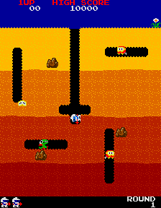
Figure 1 Dig Dug (1982)
One of the first game to use destructible environments as a secondary mechanic was Space Invaders (Taito 1978).
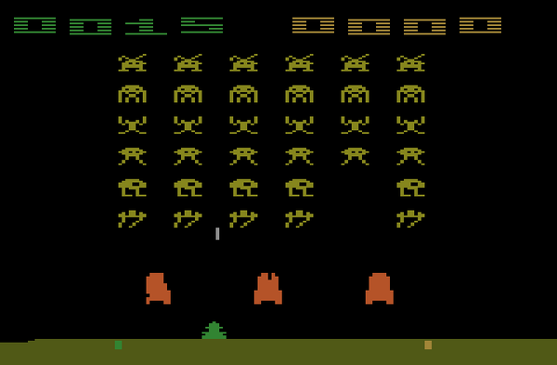
Figure 2 Space Invaders (Taito 1978)
Space Invaders featured destroyable shields that altered gameplay by providing cover for the player as long as there was a pixel in between a projectile and the player. Players shot through the shield providing safe stationary place to shoot the alien invaders. These shields are a secondary mechanic because the game is completely playable without them; however, they offer a significant advantage.
The most well known game with destructible environments as a secondary mechanic is Super Mario Brothers and the subsequent sequels (Nintendo 1985).
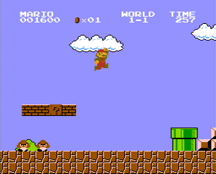
Figure 3 Super Mario Brothers (Nintendo 1985)
Players can alter the environment by breaking blocks and could use the breaking of blocks tactically to redirect enemies or escape danger. The brick breaking is secondary to the primary gameplay of platforming and stomping on enemies.
When the first person shooter came along, destructible objects were a leap forward in enhancing immersion in games. Not only does the player experience the game world from the same perspective as reality, but explosions and bullets cause damage to the environment just like real life. Over the years, designers came up with many ways to use destruction as game mechanics to make their products better. All uses of destruction in games generally fall into three categories: destruction as a primary mechanic, destruction as a secondary mechanic, and destruction as a tertiary mechanic.

Primary Mechanic

Red Faction (Volition 2001) pioneered a Geo-Mod technology, which allowed for believable terrain deformation using weapons. For the first time in a first person shooter, players could blow apart walls and create new paths through the level to this extent. The destructible environment was a way to gate the player by creating obstacles along the primary path; however, with every piece of terrain destructible it was possible to dig around gameplay areas using explosives. It was difficult to keep players on the story path because they could go in any direction they liked. In the end, without more guidance through the play experience, the game felt gimmicky and uninteresting after a while, giving credence to the idea that there needs to be more than just destroyable cover in a game.
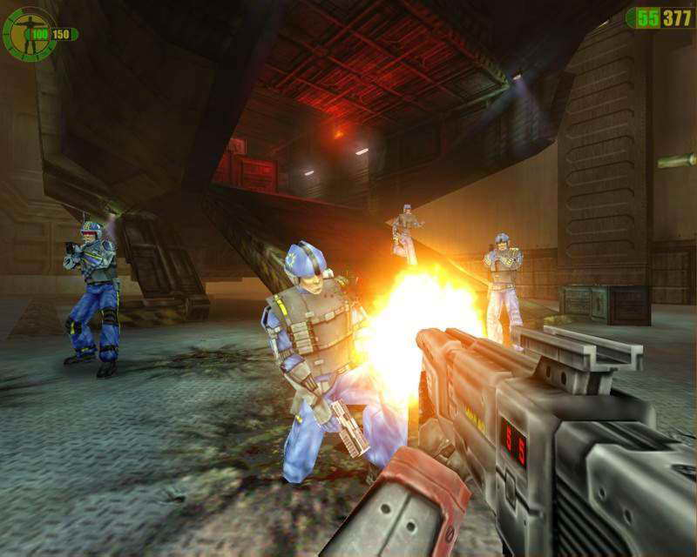
Figure 4 Red Faction (2001)

Secondary Mechanic

Red Faction 2 (Volition 2002) came out the next year with a dramatic change in course. While the first game was in caves, allowing players to tunnel through the terrain to an objective, the second game takes place in the city and only a few elements are destructible in order to get a more linear flow. This new focus meant the story and direction of travel for the player feels easier, but only by losing the destruction mechanic of the game, converting Red Faction into a normal shooter.
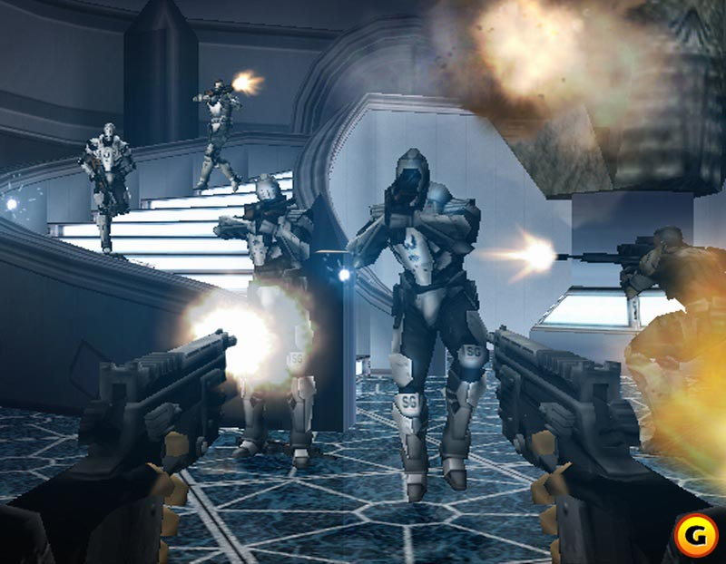
Figure 5 Red Faction 2(2002)
Another, more recent example of destructible environments used for additional gameplay purposes is Bulletstorm. This sci-fi themed first person shooter asks users to defeat enemies in complicated and spectacular ways. Players earn more points for killing enemies using the environment, including using destructible environment features. Exploding objects like explosive red barrels litter the landscape and players use them to apply damage to enemies. The game is playable without using these features, however they enhance the game by providing an easier way to defeat enemies for a greater number of points.
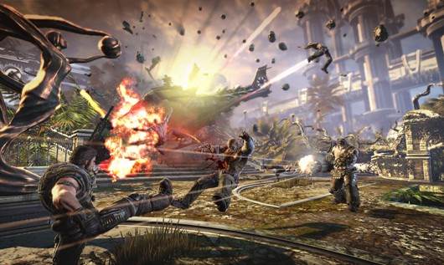
Figure 6 Bulletstorm

Tertiary Mechanic

Mercenaries 2: World in Flames (2008) touts its world as completely destructible, however, the destruction has little to no effect on gameplay. Every building, every car, every tree can be destroyed; however the primary mechanic is to destroy enemies. The buildings are fun because there is collateral damage when participating in the story; however, the gameplay would remain unchanged if every object in the game were static.
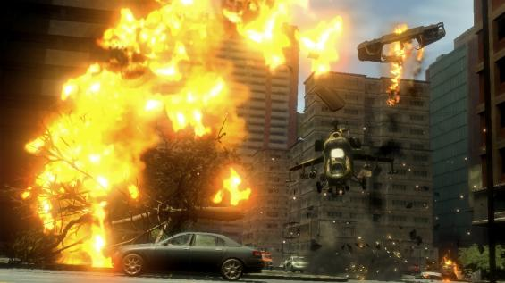
Figure 7 Mercenaries 2: World in Flames (2008).
Combining Mechanics
The way to come up with rules for destructible environments is easiest when looking at examples that combine all three mechanics, taking what works and what does not.
Red Faction Guerrilla (2009) managed to merge the three mechanics into their product. The destructible environments in this case are an obstacle because completing objectives to progress through the game requires destruction using the primary mechanic, it is a secondary mechanic game because rubble from destroying buildings crushes enemies, and the explosions and impressive visuals make the game visually stimulating as well. Even the starting location can be broken down to its nuts and bolts.

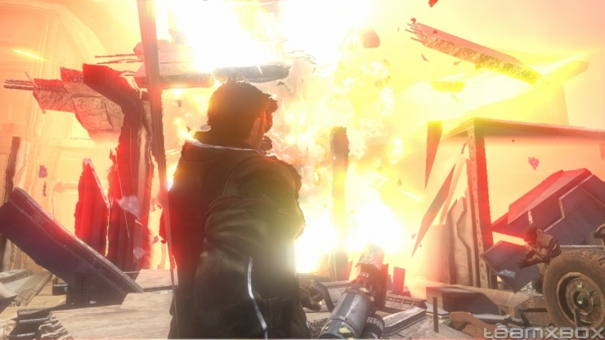
Figure 8 Red Faction: Guerilla (2009)

Visibility

The first rule of destructible environments is the amount of effort in communicating an objects’ destructibility is proportional to its importance in player progression. In Red Faction: Guerilla every man-made structure can be destroyed, so when destruction is involved as part of the objective there are clear waypoints and markers indicating the target of destruction. The effort shown in communicating the target directly relates to its importance. For example, in several missions the player has to take out a key facility held by enemy forces. Players receive a map waypoint, a trail on the ground to follow to the target, and hovering indicators over the buildings indicating they are key structures. Along the way, players may encounter other destructible buildings, but since they are not mission critical, nothing demonstrates their destructibility.
In another situation where the player must take out a number of enemies entrenched in a building, the player could enter the building and take them out, or he could use destruction as a secondary mechanic to complete the goal. By placing explosive chargers, players cause the building to collapse from explosive damage, crushing the enemy inside. In this case, the building’s destructibility remains un-communicated because it is not necessary to player progression to apply destruction, only another way of accomplishing a task.
This rule backfires in certain situations in Red Faction: Guerilla where a destructible object lacks clear communication and blocks player progression. In a hostage situation, the player has to rescue hostages from the top room of a silo only accessible by a ladder. If the player shoots and destroys the ladder, the mission is impossible to complete. One could argue that since every man made structure in the game is destructible, the player should know it is possible to destroy the ladder, however it is just as easy to point the finger back at the developer. It should not be the player’s responsibility to worry about breaking the critical path. It is the developer’s responsibility to get the player to the end of the game to enjoy all of the created content.

Utility

The utility rule states that destructible objects with a gameplay purpose are more fun than objects destroyed with no apparent purpose. In Red Faction: Guerilla every man made structure can be destroyed and as a result players can collapse buildings on top of enemies or destroy cover which allows easier targeting. Red Faction: Guerilla applies this rule to the entire game, crafting many situations where the player can use destruction to gain an advantage. Even the combat is adjusted to allow for stronger and more numerous enemies because there are so many ways to gain an advantage using destruction.
Red Faction: Guerilla learned from its predecessor, Red Faction II, that this rule can make or break a game based on destruction. The original Red Faction was a feast of destruction, allowing the player to tunnel through the scenery. This is a nightmare for creating a linear game, so in the sequel the designers seemed to make the decision to limit the destruction by including no destructible terrain and more indestructible materials. Red Faction II lost much of what originally made the series unique and instead turned into a conventional shooter with some destructible pillars and walls, most of which had little to no gameplay purpose. One user on Gamespot.com who gave Red Faction II a score of 4.0 out of 10 had this to say about destruction in Red Faction II.
The much touted Geomod system from the first game is back, but whether or not it comes into play seems to be entirely arbitrary. Some walls you can blast holes in. Some identical looking walls you can't. Some walls you can blast the crap out of to no avail, but when you shoot some nearby explosive barrels then suddenly the wall decides to crumble. The problem is that RF2 is too much of a linear, restrictive game to allow Geomod to truly become a part of the gameplay. Instead it is simply used where, in most games, a simple scripted "wall blowing up" sequence would have done the trick. (Stuckboy, 2010).

Believability

The believability rule states destructible objects should explode or fall apart in a way that matches the player’s expectations. This does not mean everything should fall apart completely realistically, but destructibles should avoid inconsistencies and there should at the very least be a “Hollywood” level of believability in the destruction. Cars exploding from gunfire, things with cracks breaking apart when blasted, and destroying a weak support causing collapse are some examples. No game has matched Red Faction: Guerilla for destructible believability so far. Since everything is destructible, there are no inconsistencies and buildings fall apart just as they would in reality.
To see an example of a violation of the visibility rule, one can examine Battlefield: Bad Company (Dice, 2008). The game touts realistic destruction and indeed cover crumbles due to damage and certain buildings collapse with applied damage. However, larger multi-story buildings have large load-bearing indestructible walls. A player intending to destroy the building can blast away at the building all day long and still be staring at those infuriating indestructible walls. This kind of inconsistency can break immersion.
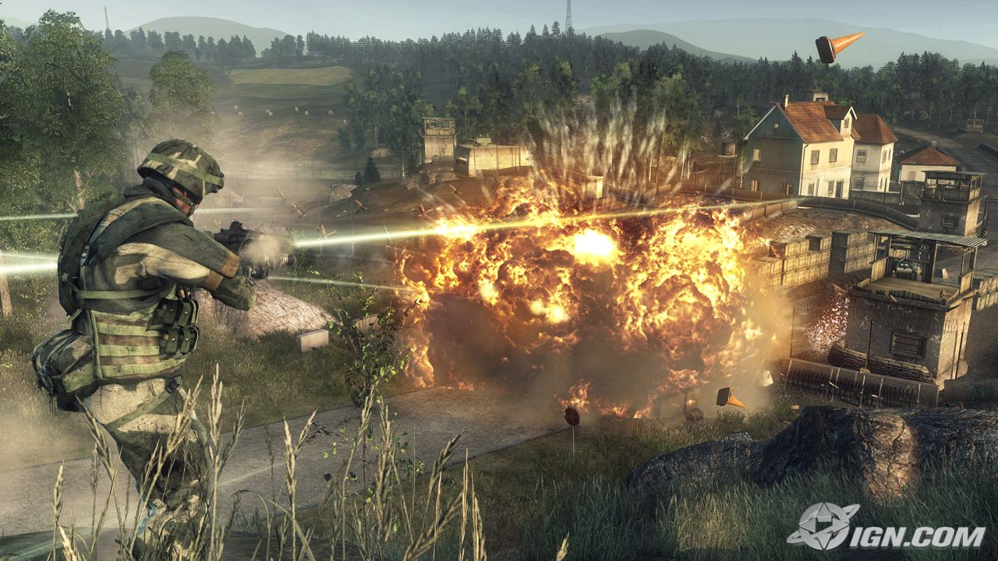
Figure 9 Battlefield: Bad Company

Destruction in Gears of War

In the single player Gears of War, campaign there are two ways destruction comes into play. The first is in a puzzle sequence involving an enemy called a Berserker. The player has to play bullfighter, causing the enemy to charge blindly at the player who dives out of the way, sending the hapless behemoth crashing through walls allowing the player access to new rooms. In this sequence designers use destructibles as a new primary mechanic to the game: using a Berserker to take down obstacles. The player receives hints in the cinematic that the Berserker can take down walls and support pillars and a waypoint indicating a wall is weak. The player has to put the puzzle together and figures out how to use the Berserker to destroy the obstacle. This Berserker scene is an application of the visibility rule. The designers gave the player clues on how to achieve the primary mechanic task, destroy the wall with a berserker, using a variety of communication methods because the player needs to learn them in order to progress through the rest of the game.
The second way Gears of War uses destruction is through destructible cover. Throughout the game, the player encounters wooden crates, couches, pianos, and wine casks that fall apart when they take damage. If an enemy is taking cover behind destructible cover, the player may destroy it, forcing the enemy to stand up. Now exposed, the enemy is an easy target.
Destructible cover is a secondary mechanic. Using or destroying this cover is not a requirement to complete the game, however it adds an additional tactic the player may utilize to take down enemies. Destructible cover adds an additional dimension to combat that players might find fun because it takes something the player knows, cover, and adds a twist. This is a successful application of the utility rule.
The Gears sequels make greater use of destruction and the technology is there to create new destructible objects; however destruction was not a major theme in the overall Gears of War single player campaign.

Summary

By analyzing tactical and play vandalism along with the different philosophies designers use, destruction for use with primary mechanics, destruction as a secondary mechanic, and destruction for visual effect, three rules for creating compelling gameplay become clear.
First, the amount of effort in communicating an object’s destructibility is proportional to its importance in player progression. While the other mechanics also need clearly defined destructible objects, unclear objects blocking the player path violate the trust of the player by delaying forward progress for a non-gameplay purpose. Players must know what is breakable and what is not or frustration ensues. Communicating breakable structures could be anything from cracks on a wall indicating weak structural integrity, a shimmering glow providing a more direct hint, or even a material or object that stands out such as a wooden wall in a concrete bunker. Cinematics also can show an object’s destructibility by zooming in or showing an object being destroyed, giving the player the idea to try it themselves.
If destructible objects in a game are a secondary or primary mechanic, as in a way to pass an area easier or as an option to solve a puzzle, these objects provide a greater sense of satisfaction and fun than objects that are purely visual. If players destroy a wall causing the ceiling to fall in, the player expects the ceiling to do damage to enemies. Seeing the damage apply to enemies makes the player feel clever, while seeing it do no damage can make the player feel cheated.
Lastly, when it comes to believability in destruction, objects should explode or fall apart in a way that matches the player’s expectations. This means that a wall with cracks in it explodes outward when hit by an explosion and every similar cracked wall flies apart in the same way.
From these ideas the three rules are born:
- Visibility - The amount of effort in communicating an object’s destructibility is proportional to its importance in player progression.
- Utility – Destructible objects with a gameplay purpose provide a greater sense of satisfaction and fun than objects that are purely visual.
- Believability – Destructible objects should explode or fall apart in a way that matches the player’s expectations.

Chapter 3: Methodology
Destructible environments are extremely popular right now, however there is very little literature discussing best practices in design. This thesis investigated the effectiveness of three design rules when producing games and levels with destructible environments. The hypothesis stated that players who encounter and react to destructible features that follow the three tenets have more fun than those who did not.
- Visibility - The amount of effort in communicating an object’s destructibility is proportional to its importance in player progression.
- Utility – Destructible objects with a gameplay purpose provide a greater sense of satisfaction and fun that objects that are purely visual.
- Believability – Destructible objects should explode or fall apart in a way that matches the player’s expectations.
The hypothesis expected players to enjoy features that follow the rules and that rule violations would be noticed and commented on. Players would become frustrated with the lack of direction when seeing the visibility rule violated. Destruction with no apparent purpose violated the utility rule and would frustrate players enough so that they avoided destructible objects. A complete lack of believability when something collapsed when it should not or did not explode when it should would cause players to take note of those features and make a comment.
The level to test this hypothesis, built in Gears of War, had three sections with objects that increase in difficulty of understanding. It started with a basic exploding barrel that blew up a wall, and ended with the player understanding that a statue hit with explosives crushes an enemy. Scattered throughout the level were also obstacles that disobeyed the rules and if the player noticed these features their level of fun would decrease compared to other players who did not notice the rule-breaking feature. If the hypothesis is correct, players that reacted to objects that follow the rules increases their level of fun in each section, while players who notice objects that break the rules causes disappointment.
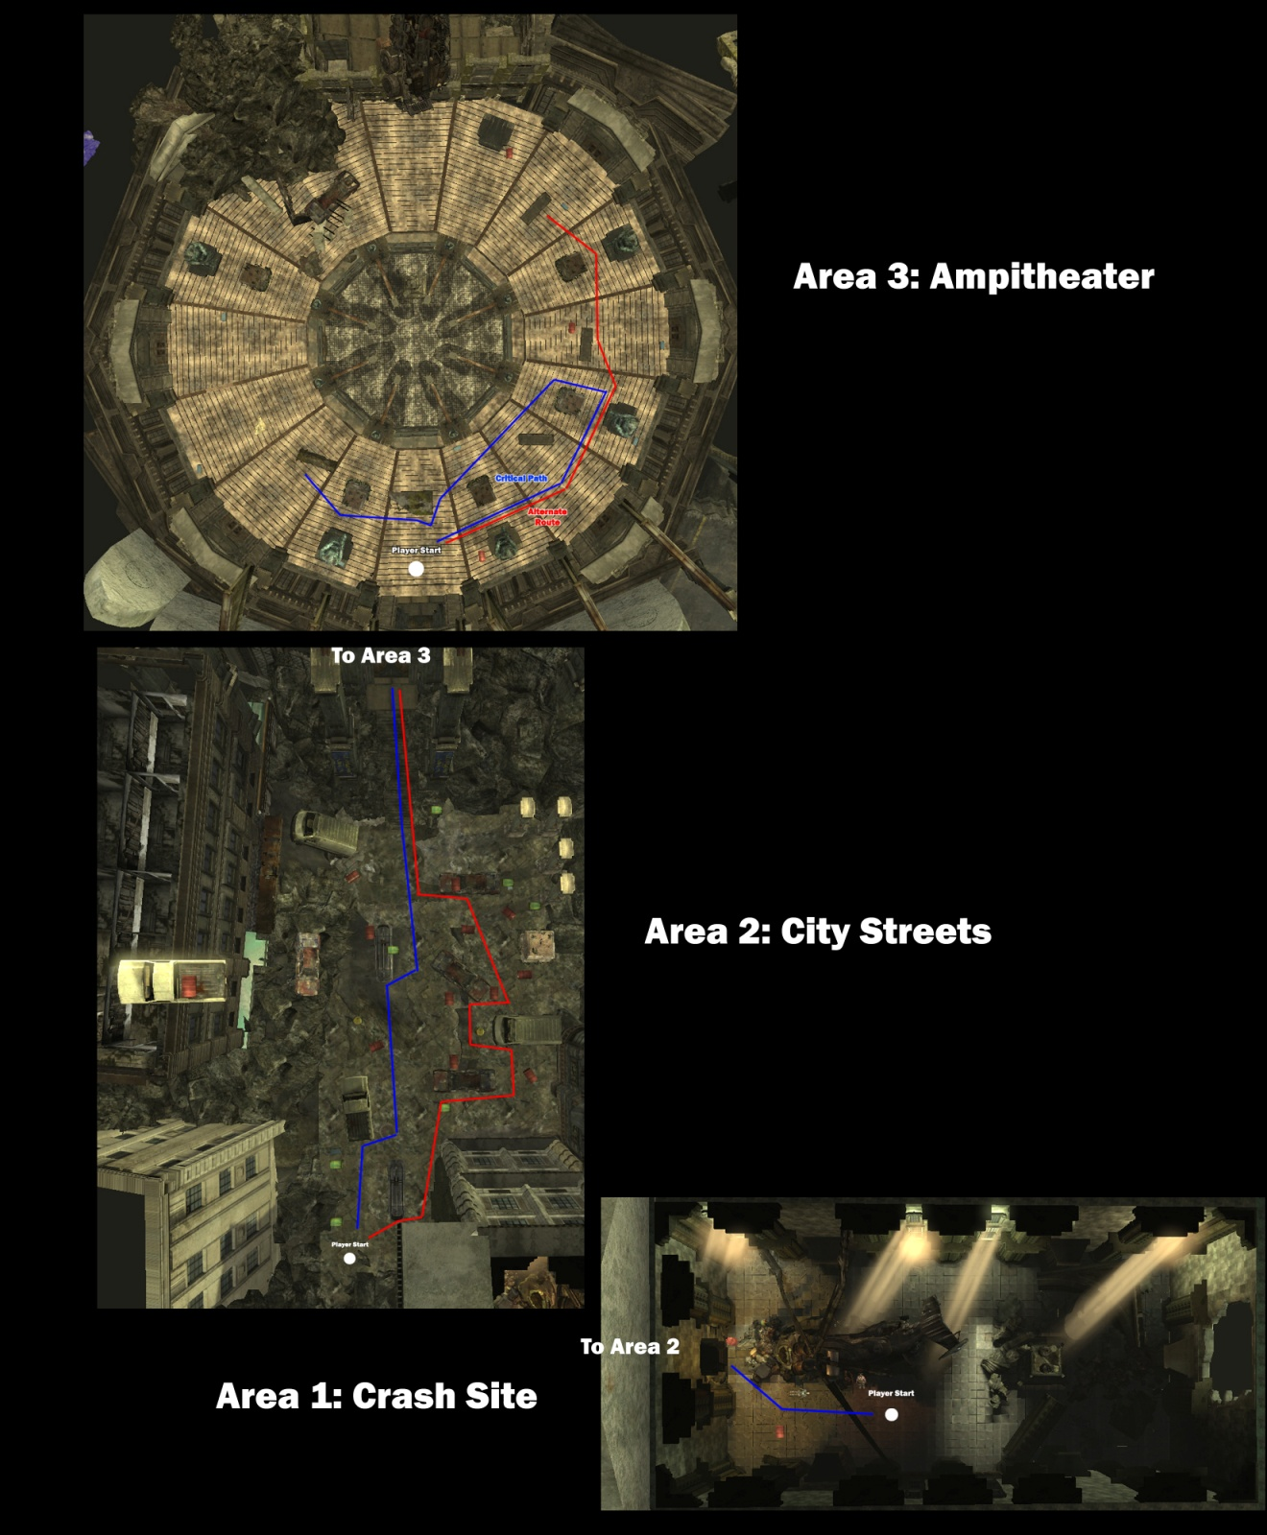

The thesis relied on the results of 24 playtesters playing the same level. Testers completed a survey to provide their opinions of how fun and difficult each of the three sections was and what key destructible objects they noticed and how each destructible element individually made the player feel. The surveys revealed what objects were noticeably good, noticeably bad and what just was not noticeable.
The level had three sections, a temple with a crashed helicopter, a street scene, and a fight inside a circular amphitheater. Each section had tests for all three rules; however each had a different rule emphasis. The crash site was a test of how much communication is required for players to overcome a critical path blocker when it is just a room with a destructible wall, no combat, and no other distractions. The city streets section tested explosions and how the player used the utility of explosive objects. The Amphitheater tested the utility of physics based destruction and if players enjoyed physics believability. Players used explosives to knock things over which crushed and killed enemies.
The three rules can each apply to the same object; however the level had some more noticeable tests of each rule. There were two major visibility tests. The first was a cracked wall the player could blow apart using explosives. This wall was at the very start of the level in a non-combat area so the player could get used to the idea of destruction and possibly take the idea to the next two areas. The wall was clearly cracked and there were red explosive barrels next to it. The second major test took place in Area 2, a broken street scene littered with explosive barrels. The test here was a door with no visible deformations. The only clue given is an objective stating that players must breach the door to the amphitheater and some grenades nearby. This was a test of an object that goes against the rules of visibility and whether it was enough to be noticed by players.
The utility tests took place throughout the level using a variety of destructible features. These tested whether the player could recognize if a destructible object was going to be useful destroying enemies and if useless destruction is annoying. Explosive barrels littered the area to provide a way to breach the first chamber and were a constant throughout the level. In this way, players immediately associated their destruction with utility so when enemies appeared the destructibles were the obvious targets. The second exploding object in this level was a bombed out car that explodes when the engine takes damage. The third is a statue that fell over when it takes explosive damage and can crush enemy soldiers. The final test was a metal sign that held up a precariously perched six wheeled gas tanker. When the sign was shot, the tanker crashed down and crushed the enemy, ending the level.
Testing the effect of objects that did not conform to the utility rule occurred in the city streets area. Pillars and planters in this area blew up but did nothing to help the player. The biggest inconsistency was in the final area where the player faces a large boss enemy. The player could destroy pillars that caused debris to crash through the floor in a way that suggested doing this enough times kills the boss. It never does, and players who felt cheated would feel the need to comment and express their frustration.
To test believability, destructibles rested near red herring objects that did not behave as expected to test when players spotted inconsistencies. The primary test involves having two different types of barrels, red and green. Red barrels explode, while the green barrels are inert. When placed side by side players question the consistency of destructible barrels. In other tests, pillars and planters crumbled from explosive damage in one area but stayed solid in another. Certain types of cars exploded with damage; however cars of a different type in the same scene remained intact.
The hypothesis expected objects that follow the rules to make the level more enjoyable while objects that disobeyed the rules might confuse the player. The hypothesis also expected testers that observed a greater number of objects that played by the rules would post higher fun scores.

Level Abstract: Hail to the King
Quick Summary
In this single-player map, players take on the role of Marcus Fenix who has just crash landed into an old government building. His goal is to make it outside and wait for extraction.
The level has three areas, each a testing the tenets of destructible level design.

Gameplay Overview

General Game Flow
Players start in a dark enclosed chamber requiring the use of explosives to break out. The player proceeds to a street with lots of exploding barrels and cars to test the utility premise mentioned above. The third area is a large circular amphitheater with statues the player can destroy to create cover from enemy fire, but also crush enemy forces. The player then faces an end boss and can either fight it directly or find a way to use destruction to defeat it.

Major Elements
- Blowing open walls
- Using destroyed objects for a tactical advantage
- Seeing things explode
- Using explosives to take out enemies
- Watching things fall apart
- Seeing a truck roll over and smash the end boss.

Major Objectives
- Escape the crash site
- Defeat Locust Forces (possibly with the help of explosives)
- Breach the Amphitheater Doors
- Defeat more Locust forces, then a grenade launching Boomer (possibly with the help of destructible environments).

Technical Overview

Campaign
Name: Hail to the King
Level Position in campaign: Second level in the campaign after a sequence in a pilotable helicopter.

Mission Location
- Setting – The COG have engaged the Locust at Snake Belly Canyon. Pilot Bonesaw Krenshaw engaged the enemy but artillery knocked out his engine and he went in for a crash landing. Instead of splattering into the side of the canyon, the chopper burst through a wall into a long forgotten cavern containing the ruins of a human city buried decades ago by locust excavations in the area.
- Time of Day: Sunset
- Season: Fall
- Weather: Cloudy

Items/Powerups
Ammo Boxes
Grenades
Locust Pistol
Torque Bow

Difficulty
7/10 – The combination of puzzle and combat elements create a challenging level.

Mission Metrics
- Play Time: 10 minutes
- Physical Length/Area (include units) – Central area: 500 Feet Square.
- Visual Themes
- Government Building – The player starts in what was once a council chamber. In the center is a crashed helicopter surrounded by small fires. The fires illuminate a rubble-strewn room with high ceilings and ornate statues. One of the four walls looks like it could be weak.
- City Streets – From the street the player can see decayed, half-destroyed city block in the immediate vicinity and in the distance, the player can see entire building hanging from the edges of cliffs or piles of rusting cars. The resulting cave in that that buried the city turned everything around and upside down.
- Amphitheater – Imagine the capitol dome of a long abandoned house of congress. Large statues stand in a circle all the way around the chamber. Light pours in from above bathing the area in a dusky red light.

Details

Theme/Mood
Theme: The level is about shifting power. The player starts on foot in nearly pitch black conditions and slowly recovers that power by gaining more powerful weapons and becoming the master of destruction.
Mood: The mood shifts from decaying and decrepit and then climaxes in a fantastic and brightly lit scene with a ruined amphitheater.
Nothing in the world is sacred. All bets are off and the player has to think outside the box. Putting the player in a position to change the environment immediately drives the point home.

Special Character/Vehicle Needs
- King Raven Helicopter
  - Need a crashed helicopter for the beginning area and another for the final cut scene.

Gameplay Mechanics
- Prerequisite Skills
  - Aiming
  - Reloading
  - Taking Cover
  - Gears of War secondary combat abilities (swat turn, chainsaw, curb stomp)
  - Grenade Tossing
- Skills Learned
  - Blowing up destructible walls.
  - Using explosive objects to kill enemies from a distance.
  - Creating cover using destroyed structures.

Story
- Introduction
  - The player wakes up in the remains of a crashed helicopter, not knowing how he got there or what to do next he blindly ventures forth into the sunken city to seek rescue.
- In-Game
  - Marcus uses his usual “subtle” style and blasts a hole through the wall to access the next chamber.
  - Marcus faces down two waves of locust forces using explosive barrels and cars to aid in their destruction. The final wave contains a Theron Guard which is a true test of whether the player can use the destruction to his benefit and gives the player the option of picking up the Torque Bow, the best weapon in the game for triggering destructible features with explosive damage.
  - Marcus enters an amphitheater and faces down two more waves of grunts, using collapsing statues to crush his enemies. Another Torque Bow is immediately available to the player who can use it to efficiently destroy exploding destructible features.
  - All of a sudden, a Boomer bursts through a door on the lower level. Marcus sees a metal sign barely holding up a gas tanker suspended from rubble above the Boomer. Marcus shoots the sign and the tanker rolls over the hapless enemy.
- Extro
  - After the boomer's defeat, a helicopter suddenly drops down through the hole in the amphitheater ceiling to come to Marcus's rescue.

Visual References

Models/Architecture
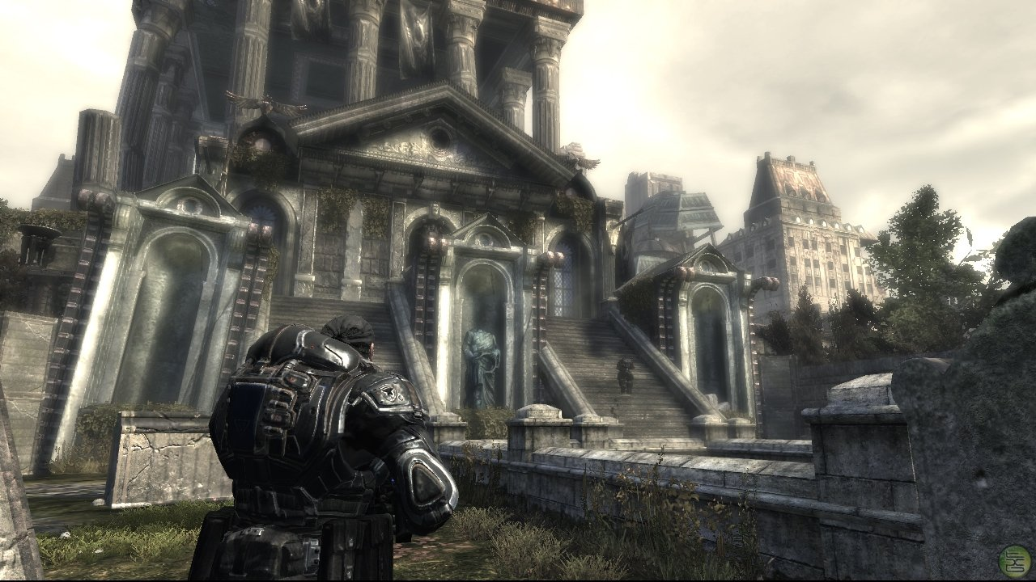
Figure 10 An example of the architecture in Gears of War.

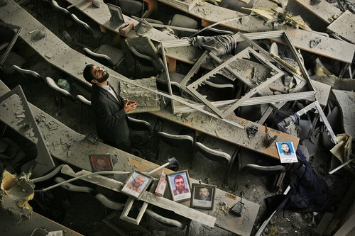
Figure 11 An example of what a ruined council chamber might look like.
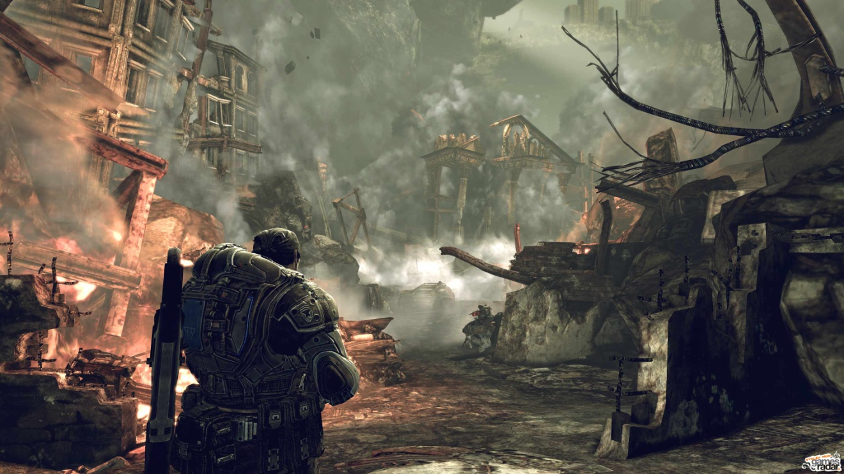
Figure 12 An example of what a sunken city looks like.

Textures/Lighting
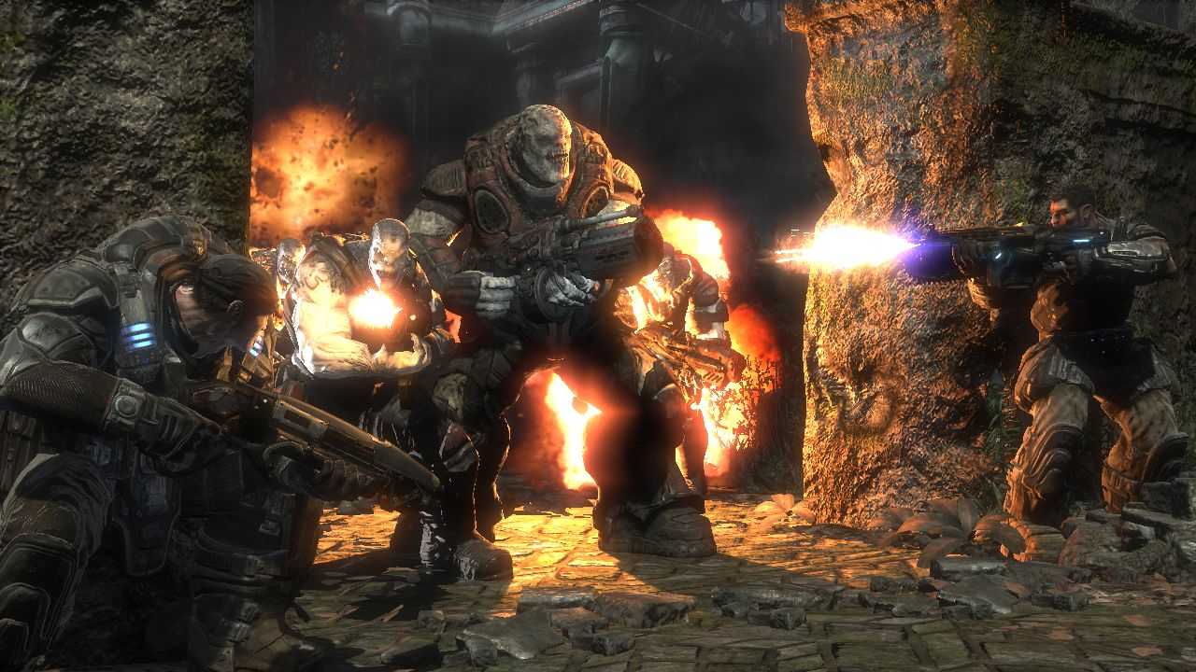
Figure 13 Typical stonework found in Gears of War.
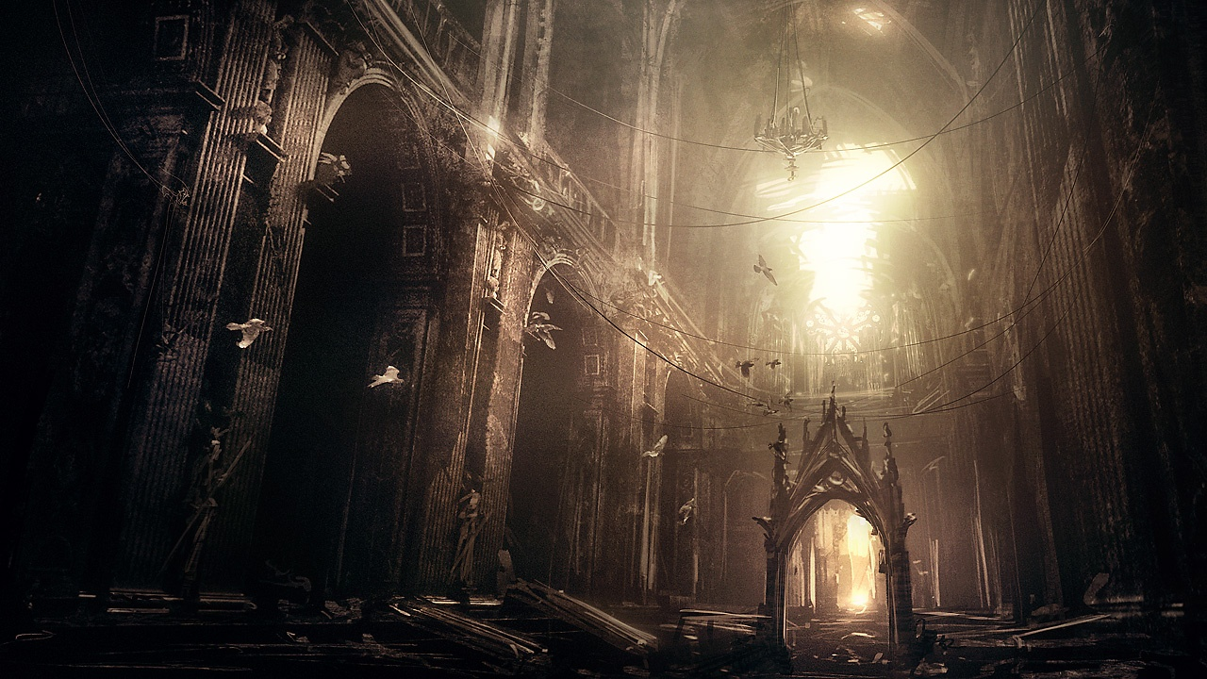
Figure 14 An example of the lighting scheme found in the central chamber.
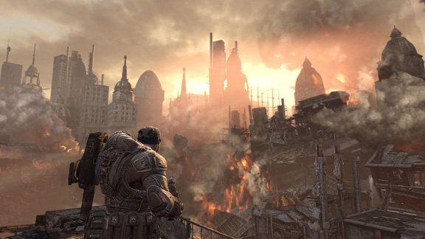
Figure 15 An example of the lighting scheme for the exterior.

Characters/Vehicles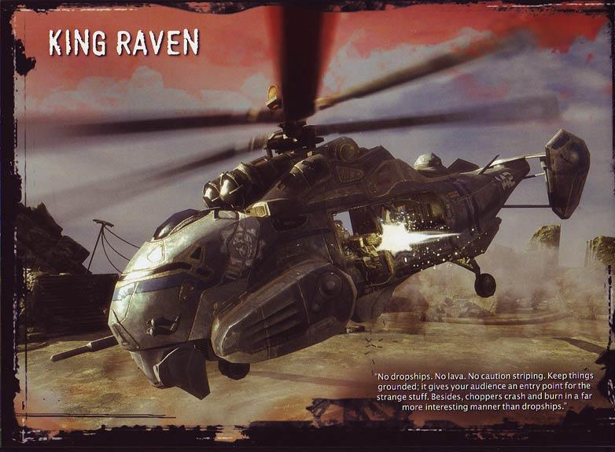
Figure 16 King Raven Helicopter.

Maps

Area 1: Crash site

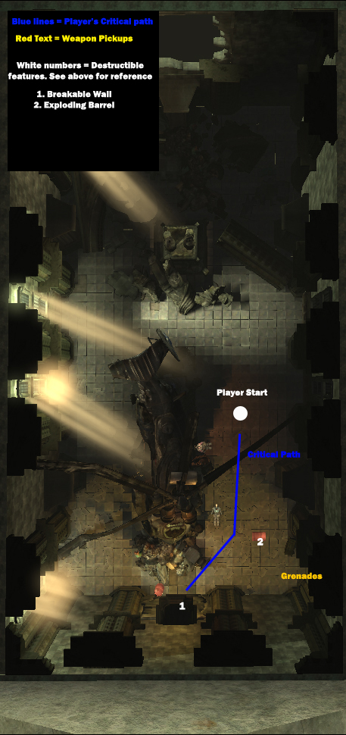
Figure 17 Area 1: Crash Site
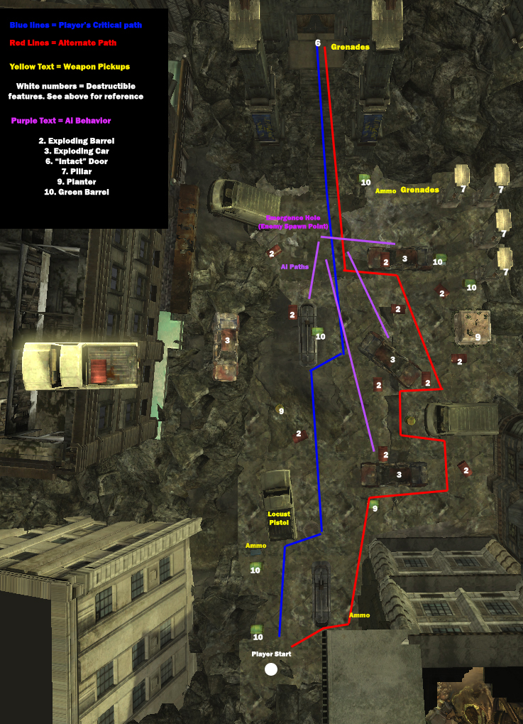
Figure 18 Area 2: City Streets

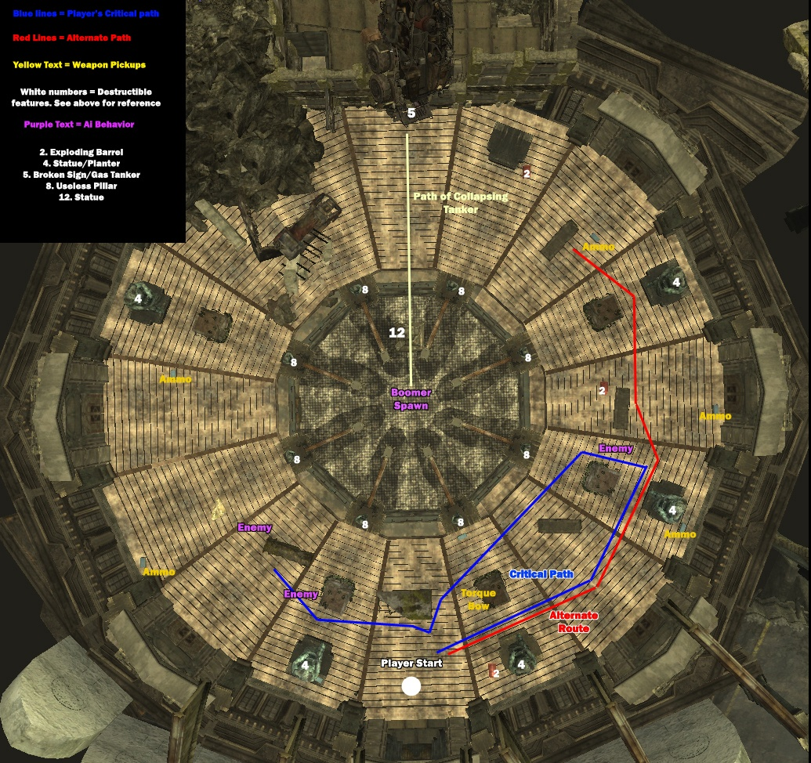 Figure 19 Area 3: Amphitheater

Destructible Test Features
Destructible features fall into three categories: destructibles that follow the rules, destructibles that break the rules and red herring features that are not destructibles but as though they are. Red herrings test the believability rule.

Destructible Features that follow the rules
- Red Barrels
Tested Rules - Visibility, Utility
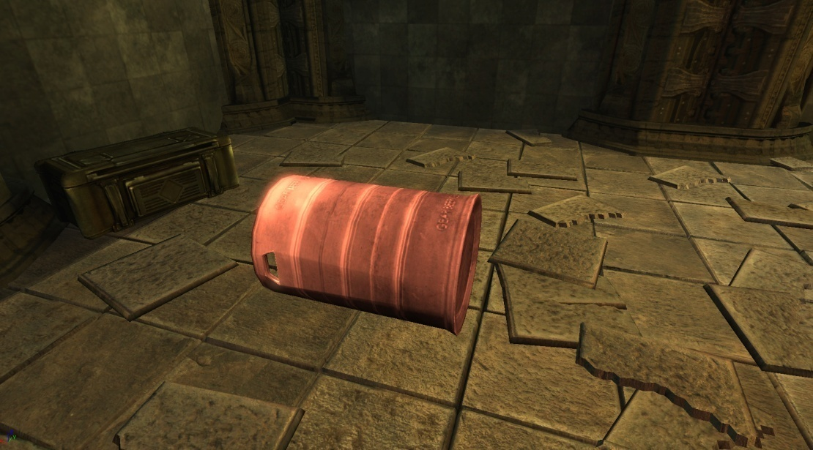
Figure 20 Red Barrels
Red Barrels take damage from weapons fire and explosions. Upon taking a certain amount of damage, they explode and do damage to anything within a 5 meter proximity. Red barrel explosions can spread to other destructible objects.

- Broken Wall
Tested Rule - Visibility
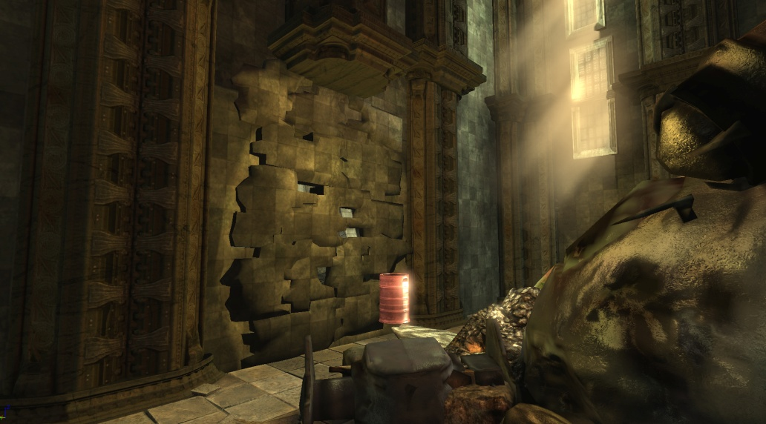
Figure 21 Cracked Wall
The cracked wall in Area 1 blocks the critical path and only an explosion can blast it apart, either a red barrel or grenade blast. When it takes enough damage, the pieces of the wall blow backwards out of the room. Players learn it is destructible by the way it looks and a zoom in during a cut scene. The cracked wall does no damage.

- Burnt out Car
Tested Rules - Visibility, Utility, Believability

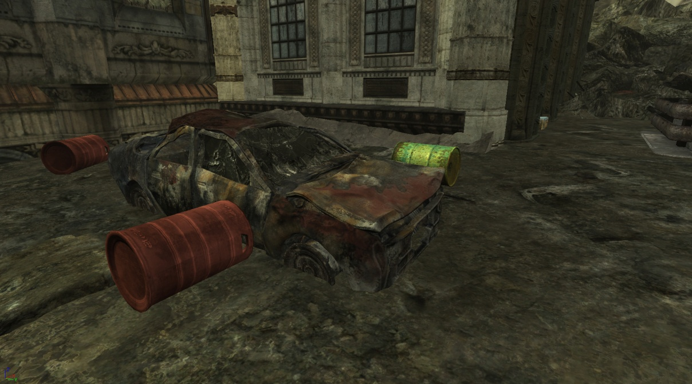
Figure 22 Burnt Out Car
The burnt out cars in Area 2 explode when the engine takes damage from a projectile or takes explosive damage. The explosion has a delayed reaction. After the hood of the car takes enough damage, the car catches fire. After 3 seconds, the front of the car explodes applying damage to enemies, the player and other destructibles. A cut scene shows the destructibility of the car.

- Statue/Planter
Tested Rules – Utility, Believability
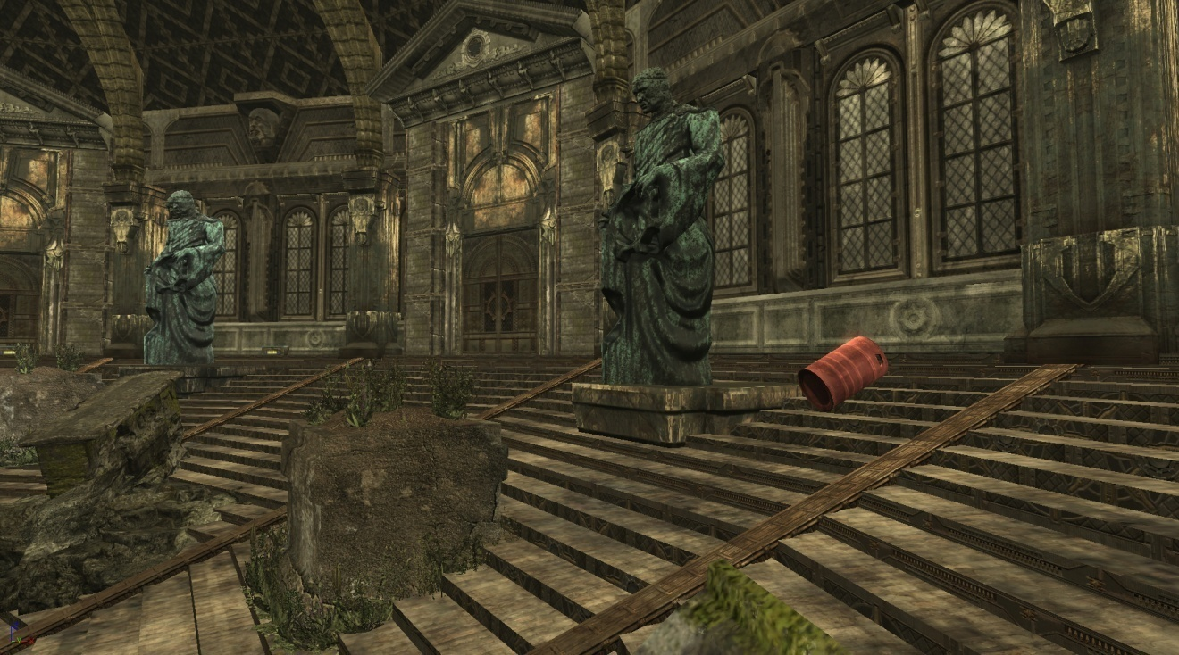
Figure 23 Statue and Planter
In this feature in Area 3, hitting the statue with explosive damage causes it to collapse onto the planter. Anything in the path of the statue as it falls and anything taking cover on the planter takes massive damage. The planter is indestructible until the statue falls on it and provide a cover “bait,” meaning that npcs see it as an obvious piece of cover and are drawn to take cover behind it, which makes the player want to use the statue to crush them with the statue.

- Broken Sign/Gas Tanker
Tested Rule - Visibility, Utility,

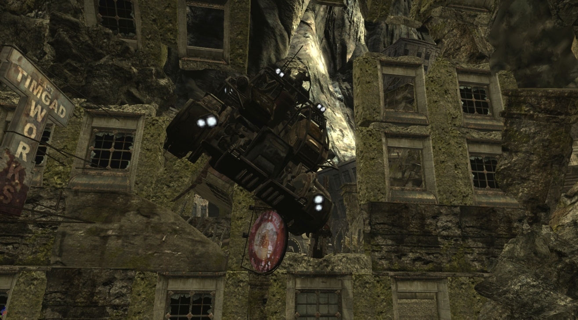
Figure 24 Tanker
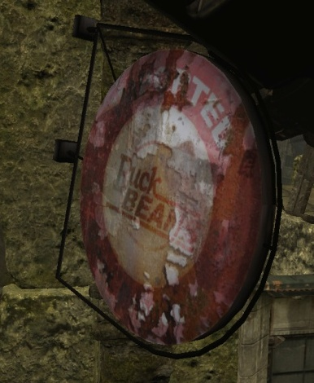
Figure 25 Weak Sign
In the final sequence of the level in Area 3, the player has the option of shooting the sign, which causes the tanker to destabilize and come crashing down onto the end boss. After a cut scene highlighting the boss and the tanker, the sign starts glowing to communicate that this is destructible.

Destructible Features that break the rules
- “Intact” Door
Tested Rules - Visibility, Believability

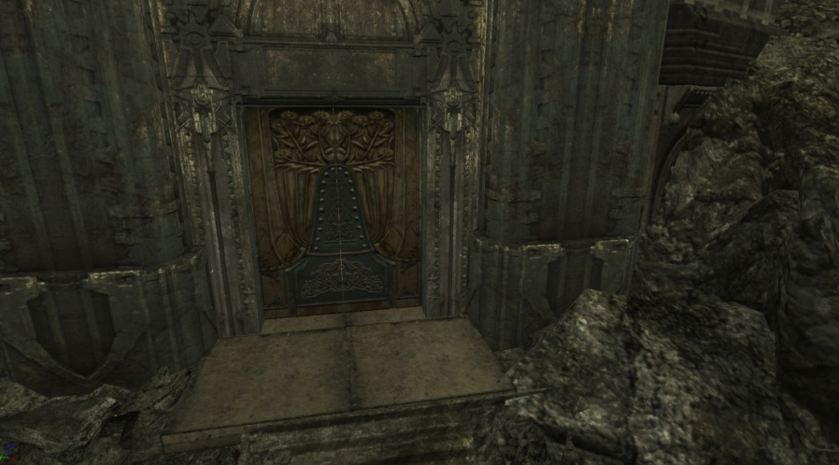
Figure 26 Intact Door
This door at the end of Area 2 blasts apart from explosives. The reason this door is a red herring feature is that it does not appear to be destructible at first glance. There are clues, such grenades lying on the ground nearby, a glowing effect on the door and some pop up text, however there is nothing on the texture of the door that serves as an indicator. This tests the first rule of destructible level design because it tests the absolute least amount of communication needed to get through a critical path obstacle.

- Pillar
Tested Rule - Believability

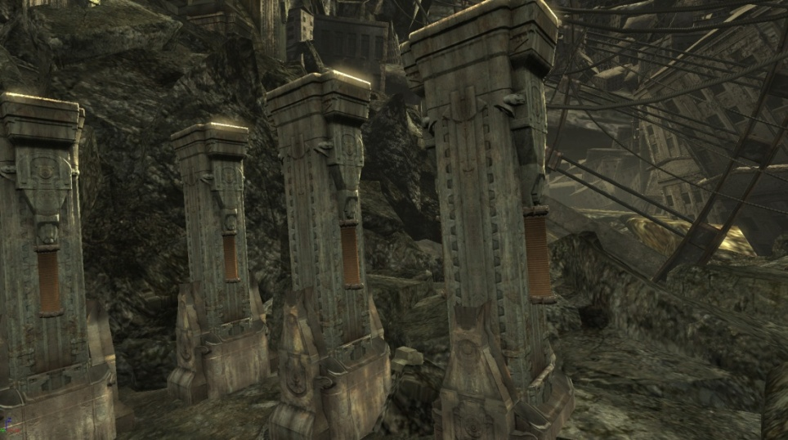
Figure 27 Pillars
These pillars in Area 2 are purely visual. When they take explosive damage, they fly apart everywhere, spewing dust and debris, but it has no effect on the environment. These pillars look virtually identical to other indestructible pillars around the level. These are placed to test if players notice when pillars do not react consistently to damage.

- Useless Pillar
Tested Rule – Utility
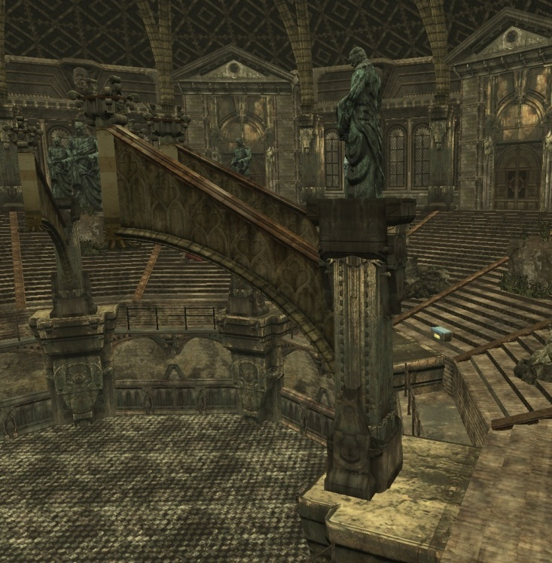
Figure 28 Useless Statue

When the pillars in Area 3 take explosive damage, the attached arch and statue fall into the pit, smashing through the floor. This gives the illusion of utility. It appears as though taking out multiple pillars could serve to defeat the boss, however the pillars do nothing. This is a test of whether shooting an object with an expected utility outcome that does nothing can possibly be frustrating.

- Planter
Tested Rule - Believability

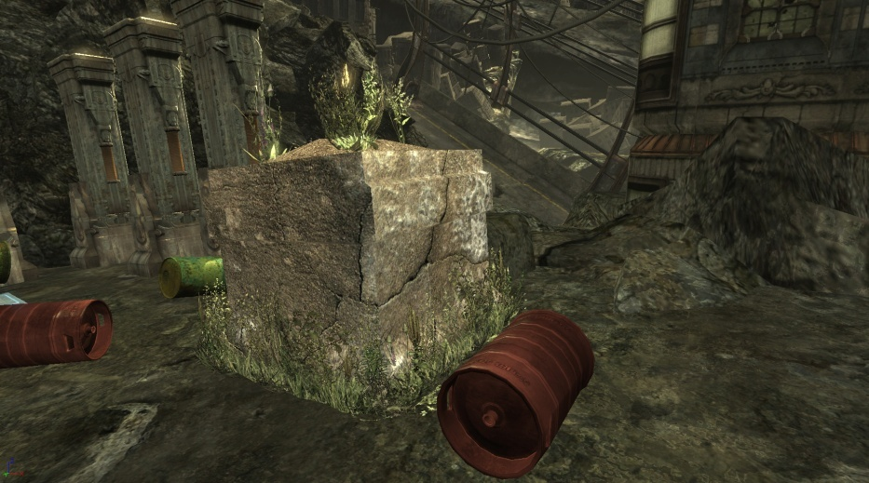
Figure 29 Planter
This planter in Area 2 blasts apart due to explosive damage. There are identical planters in the third area that only blast apart when the player shoots a statue which collapses on top of it. This is to see if the inconsistency causes players to take note and possibly become frustrated.

Red Herring Features

- Green Barrels

Tested Rule - Believability

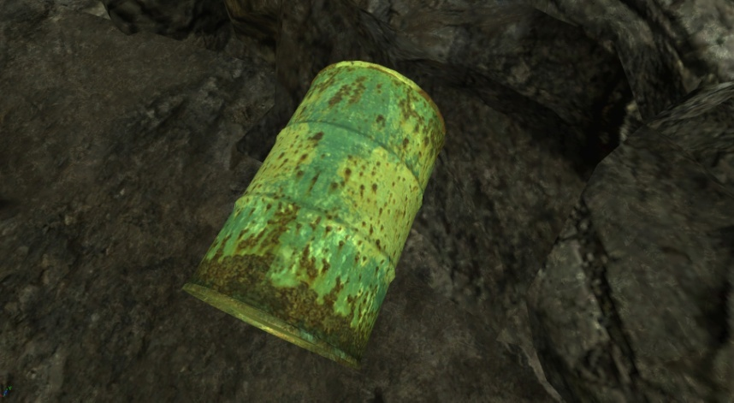
Figure 30 Green Barrel
Green Barrels are inert, unlike their red counterparts. This is to see if the color indication alone is enough to differentiate between the two barrels and if players find shooting a barrel expecting it to explode noteworthy. The player encounters green barrels at the start of the second area after learning how red barrels work.

- Intact Cars
Tested Rule - Believability

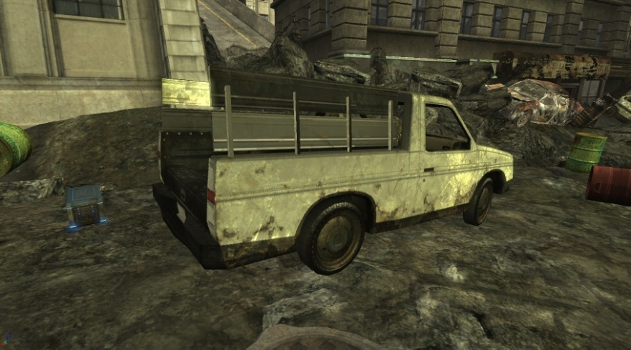
Figure 31 Pickup Truck
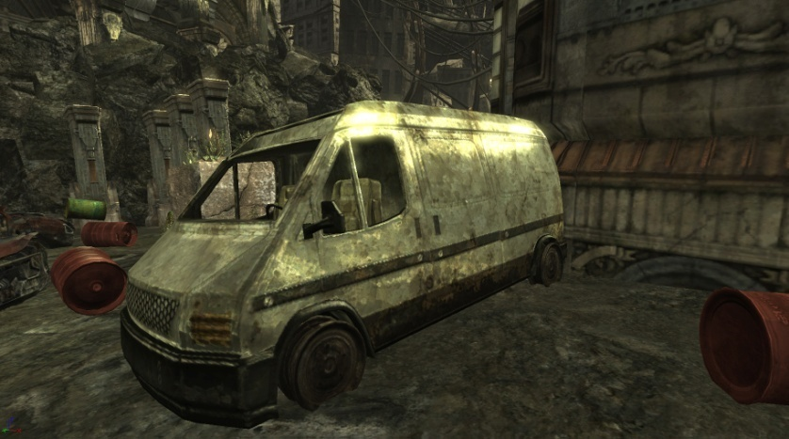
Figure 32 Van
Intact vehicles in Area 2 are a counterpoint to the exploding vehicles. These provide a static piece of cover. This tests if the visual distinction between the white cars is clear enough so the player uses them as stable cover.

- Statue
Tested Rule – Believability
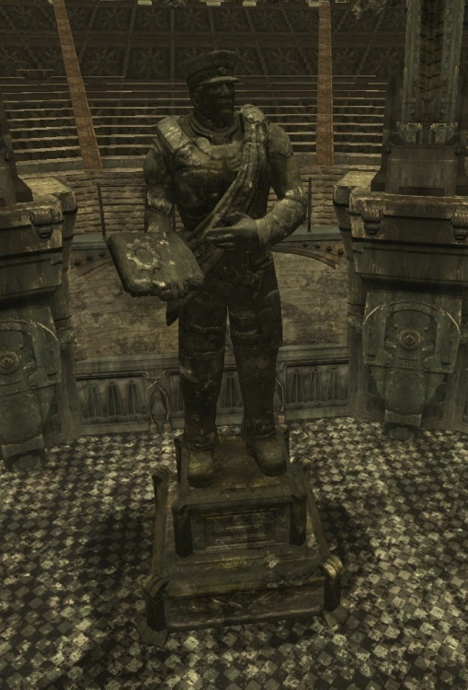
Figure 33 Statue
This statue in Area 3 appears in a destroyed state in Area 1, but becomes indestructible later on in the level. This is a test to see if having an indestructible statue contrary to prior experience is noteworthy.

- Water Cooler Moments
  - The player climbs out of a burning helicopter then smashes through a wall
  - The player watches pillars and debris fall all around.
  - The player sees massive amounts of explosions.
- Challenge Highlights
  - Players have to solve the puzzle and get out of the chamber
  - The player has to survive two waves of enemies. Destructible features make this area easier.
  - Players must carefully take out three grunts in good cover.
  - Players must then take out the boss, a Boomer wielding a rocket propelled grenade launcher. The player may choose to dispatch him with conventional weapons while moving from cover to cover, take the easier and more entertaining route of shooting a target which causes a chain reaction that crushes the boomer.
- Objectives
  - Escape the crash site
  - Defeat Locust Forces (possibly with the help of explosives)
  - Breach the Amphitheater Doors
  - Defeat more Locust forces, then a grenade launching Boomer type enemy (possibly with the help of destructible environments.
- Skill Tests
  - Player has to use logic and creativity help solve the problem of getting out of the chamber.
  - The player has to decide where to use explosives to kill the maximum number of enemies at the same time.
  - The player has to move through cover and think about how best to take out the entrenched grunts
  - The player has to think about how best to take out a very powerful , grenade wielding Boomer.

Data Collection and Procedures

Testers consisted of volunteers who signed up on a time sheet and from mass emails. They each received an email reminder of the testing time and location the day of the test. The testing took place in a room away from distractions either in the Guildhall at SMU or elsewhere. In either case, the testers sat in front of a 24-inch LCD display to play the level and used their choice of gaming mouse and keyboard or Xbox 360 controller. The laptop contained a copy of Gears of War. Testers who had not played Gears of War had the chance to look at the manual and received a verbal description of the game mechanics, but since most testers had played first person shooters, a minimal amount of instruction was required. Before the level play test began, testers filled out a questionnaire in the form of a Microsoft Word document. Testers described their game playing habits, demographic information, favorite game genres and experience with Gears of War.
Upon arriving, the test administrator marked the name of the participant and prepared to track the players' time to complete the level's three sections, as well as record the number of times the testers died.
The administrator sat at a laptop behind the large monitor the player used which displayed a cloned image of the tester's monitor to watch the tester’s progress in an unobtrusive way. The tester took control to load the game, started the level, then passed control to the player while they tracked the times and deaths.
Once the play testing was complete, the test administrator had the testers fill out a post-test survey in a Microsoft Word document.
The pre-test survey (see Appendix A) covers multiple demographics, including gender, average weekly hours spent playing games (prior to attending graduate school), age, and game genre preference. Testers wrote down their Bartle-type assessment. If they had not ever taken the Bartle test, testers were presented with a link which led to a website where players could test themselves with a simple survey.
The post-test survey consisted of three parts: a quantitative test to see how well the testers understood the different kinds of destruction, a quantitative look at how fun and challenging the level was using a Likert Scale, and qualitative questions about what made the level fun and an assessment of what other mitigating factors could have led to a players success or poor performance.
The true false questions helped identify features that the player noticed or did not notice and gathered further qualitative information about why they did or did not see the destructive object or how they reacted to it.
By cross referencing the good features and bad features it is possible to see if the negative elements were enough to frustrate the player and if the positive elements tended to increase the amount of fun the testers had.
By taking the positive and negative noticed features and comparing that directly with the time it took to beat the level or how much fun they had, it is possible to see if there is a direct relationship between the ease of use of the destructibles, competition time and fun.

Sample Test Questions
The test subjects responded with the following information, and more:
Demographic:
Age
Gender
Favorite game genres
Average hours per week playing video games
Bartle-Type
Quantitative:
On a scale from 1-5, with 1 being easy and 5 being impossible, how would you rate the task to defeat the locust?
Did you ever find yourself shooting at an object expecting it to explode or fall apart and it did not?
Were you able to use the explosive objects to fight the enemy?
Did you use the collapsing statues to defeat any of the enemies?
Did you shoot the glowing sign?

Qualitative:
What was your solution to breach the door?
Did you notice that destructible features were a major part in helping you complete the objectives?
If you noticed the glowing sign, what did this indicate to you?
What does a red barrel generally indicate to you

A full sample survey is located in the Appendix A.

Summary
This thesis focuses on guidelines for level designers when creating levels with destructible environments.
- Visibility - The amount of effort in communicating an object’s destructibility is proportional to its importance in player progression.
- Utility – Destructible objects with a gameplay purpose provide a greater sense of satisfaction and fun than objects that are purely visual.
- Believability – Destructible objects should explode or fall apart in a way that matches the player’s expectations.
By having all testers play the same level in Gears of War, and comparing how much fun they had to their reactions to various destructive features, we can see if features that followed the rules made the level fun and destructibles that disobeyed the rules caused frustration. 24 testers each played the level and filled out surveys with thoughts about key features in the level and pointing out areas that frustrated them.

Chapter 4: Results
All 23 participants completed an identical survey and each played through the same short level testing the three rules of destructible level design.

- Visibility - The amount of effort in communicating an object’s destructibility is proportional to its importance in player progression.
- Utility – Destructible objects with a gameplay purpose provide a greater sense of satisfaction and fun than objects that are purely visual.
- Believability – Destructible objects should explode or fall apart in a way that matches the player’s expectations.

The survey consists of both objective and subjective questions about destructible features around the level.

Demographics

Table 1 Participant Age

Participants ranged in age from 20 to 36 with no predominance for any particular age.

Table 2 Participant Gender

The study’s gender ratio is not consistent with the gaming population as a whole which is closer to 40% Female (May, 2011). However, the female participant across the board filled out demographic and survey data similar to the 96% of male participants.
For this reason gender is not a factor in the rest of the demographic data points shown below.

Table 3 Experience with Gears of War

The surveys show the majority of participants completed Gears of War. This is important for normalcy bias analysis. Since every single tester completed at least part of the Gears of War campaign, they are familiar with the game mechanics and have an idea of how combat works so they have the tendency to use guns they feel are more powerful over more practical weapons to the situation, such as the pistol, which is better at shooting barrels at long range. Those who finished the campaign one or more times learned a dominant strategy when dealing with enemies that may not lend itself well to destructible environments. A player who loves getting close to enemies and taking them down with the shotgun may become frustrated as an errant blast sets off an explosion and kills them. This data did not have a profound effect on testing overall; however while observing the participants, only 3 people used a pistol to shoot at barrels in Area 2 as opposed to the shotgun.

Table 4 Game Genres Played Most Often

Table 5 What is your favorite game genre

This question asks the players’ favorite game genre and the data shows a predominance towards first person shooters and action/adventure games, with strategy and role playing games close behind. The question was asked because preference of genre could mean more exposure to destructible objects. Shooter games tend to have more destructible objects and action adventure games often have puzzles that introduce new game mechanics which means players of this genre can adjust to new situations on the fly. The action/adventure players seemed to use destructibles more, however when looking at the overall fun each player had, the people who enjoyed action adventure games only had 3 percent more fun than the RPG players so the effect on the results was not very important.

Table 6 How many hours a week do you play games

The chart shows on average testers play about 10 to 15 hours a week. For participants who happened to also be Guildhall students, this question reflects the number of hours they played games before the Guildhall. This question gauged the likelihood that players encountered destructible features in their gaming careers, and also to see if this would have an effect on what communication methods were more effective. The one area where this had an impact on testing was regarding destructibility of red barrels. As most the players had a relatively high level of game experience, this provides evidence that red barrels are a destructibility universal among all gamers.

Table 7 When playing first person shooters do you prefer singleplayer or multiplayer?

This data shows a fairly even split between those who prefer playing a first person shooter single player or multiplayer. This question determines if those who prefer single player respond better to destructible environments. The results show there is a link between testers enjoying single player campaigns over multiplayer using and understanding destructibles and better than multiplayer testers. For more detail, see the discussion section.

Table 8 Bartle Gamer Type

Looking at this chart, the population breakdown is similar to the average among all gamers. According to GamerDNA.com which offers a Bartle test, out of 700,000 participants, explorers made up the most of that population at 39 percent (GamerDNA, 2011). This means the participant population in this test is fairly representative of the gaming public.
Cross referencing Bartle gamer type with test results, there was little difference between the groups on any questions. The only observable difference was in two situations. When explorers found themselves in an area with no combat and told to find a way, they took longer to explore the environment to discover a solution. They tended to linger over the artistic features of the area and take in all the clues before taking action.
The only other indication of difference between the player types is Killers with Gears of War experience tended to die more often and find the level less fun because they would tend to rush in and accidentally shoot explosive barrels and kill themselves. The person with the most recorded deaths was a killer and two of the killers took double the average time to complete the level because they painstakingly moved around cover to get a good angle to take out enemies from close range rather than take them out from a distance with destructibles.

Survey Question Results

Area 1: Crash Site

Table 9 How did you break down the wall?

In Area 1, players encounter a wall that looks cracked. Players receive grenades and there is a red explosive barrel leaning against the wall. During testing players predominantly chose to shoot the red barrel. To further highlight that the barrel and the wall was important, the opening cutscene zooms in on the wall, indicating a gameplay significance. This question determines how players would tackle the obstacle and if the red barrel was a good communication cue. The expectation was the majority of players would choose environmental destruction over using a weapon. Players ended up either shooting the red barrel or using a grenade. Several players mentioned they tried kicking down some side doors but in the end, they went back to one of those two ways of completing the objective. This seems to indicate the red barrel communicates destructibility well.

Table 10 Was the objective in this area clear?
If not why not

Possibly b/c I wasn’t paying attention, and/or am not used to having to destroy walls in GoW to advance, but a point of interest might have helped
"Escape the room" is a bit vague.
Possibly b/c I wasn’t paying attention, and/or am not used to having to destroy walls in GoW to advance, but a point of interest might have helped
Table 11 If the objective was not clear, why not?
This question checked if giving the player the objective “Escape the Chamber” in conjunction with the cutscene and the colored barrel helped players solve the puzzle. According to the visibility rule of the thesis, these communication clues help the player see the critical objective more clearly, which is very important when dealing with destruction. In all, 86 percent said the objective was clear which indicates the visibility rule has merit in this situation.

Table 12 When did you first notice?

This question determined how much the initial cutscene helped players understand what it took to escape the chamber which could indicate the visibility rule is accurate. The thesis says the vast majority of people would see what was required to breach the chamber with the combination of different communication techniques. Players predominantly said yes, however the percentage that did not immediately spot the escape route was higher than the percentage of people above who did not find the objective clear. This could indicate that some players require additional clues aside from cutscenes, such as exploration or a glowing indicator on the wall. This is due to a something observed throughout testing that could be termed as “Cinematic Detachment.”
Cinematics can be a useful tool, however many players tended to not pay as much attention as they do when they have control of their character. For this reason, several players had to look around the chamber themselves before deciding to destroy the wall.

When did you first notice?
Cutscene
After I had realized there was no doorway out.
Not until after exhausting all other ideas.
If so, when did you first notice? After I looked around for more guns and ammo maybe about a minute or two in the game.
After exploring the room and seeing the cracks.
Almost right away
First noticed it through the very first appearance of them during the opening cinematic.
I looked around for a few seconds, then saw the cracks
After inspecting the area maybe 20 seconds into the level
During the cut scene
In the cutscene
When I walked around the level and saw the barrel by it then I noticed the cracks in the wall.
Cutscene
During the intro matinee sequence.
During the opening cinematic.
After exploring the rest of the room and discovering that none of the doors were kickable
During the first cutscene
Table 13 When did you first notice the cracks in the wall?
This question determined if the destruction of the wall was purposeful as opposed to random attacks. The thesis says level designers mindful of the visibility rule make a critical path-blocking feature very clear and players respond by passing the obstacle with more ease. While 96 percent of players found the cracks in the wall to be a good indicator of destruction, 4 percent did not. This could indicate a need for redundancy in communicating an object’s destructibility, however all testers passed the obstacle, so perhaps that is not necessary. Players who did not see the cracks and blasted apart the wall learned from the experience and could apply it to other features later in the level.

Table 14 Were the cracks in the wall enough to indicate the wall was weak and could be destroyed?

This question discerned if players would prefer a more obvious method of communication other than cracks in the wall. The visibility rule says a player encountering a critical path blocker needs clear visual cues. In this situation the player is in a non combat room, there’s a cinematic showing the cracks in the door and red barrel is resting against the wall, and there are no other interesting things in the room. This was enough for 83 percent of participants but the remaining 17 percent thought it was not enough. Note that all participants passed the obstacle, so the communication was enough for everyone to pass, but maybe not enough to allow 100 percent of players to immediately get that the wall was destructible.

Table 15 Did you notice the red barrel?

Table 16 Did red barrels help you complete the objective

What does a red barrel indicate to you?

Explosive Object
If you shoot it, it will explode
Something I can roll over a precipice to squash an enemy.
That they explode. But honestly these barrels were not red enough for me to think that. These seem more of a rust or brown color.
Explosions
Cool Aid... Explosive barrel
Most likely an explosion will occur
Something explosive.
Explode mode
Explosive
That the barrel is explosive
Filled with magical exploding liquid.
Explosive or fire
Explosions!
It's Explosive
Explosive
That it explodes if shot at.
That it is hazardous, possibly explosive.
Shooting it will cause it to explode.
Boom!
That they explode.
Table 17 What does a Red Barrel indicate to you?
These barrel-related questions served to find out of coloring a barrel red is enough to indicate destructibility based on gaming conventions. The expectation was that among all testers, each with first person shooter experience, they would immediately identify the red barrel as explosive.
The surveys indicate red barrels are very close to being a destructible environment universal among people that play first person shooters. Every single respondent indicated the red barrels explode or served some sort of gameplay purpose. This is a clear indicator that red barrels are a powerful tool in the level designer’s arsenal when it comes to first person shooters.

Table 18 How Fun was Area 2
This is the data collected on how much fun participants had in this area. This is what is used to check against relationships between destructible features and fun. Most testers found Area 1 to be fun, with an average of 3.4 out of 5.

Table 19 How Difficult was Area 1

This is the data collected on how difficult participants this area. This is what is used to check against relationships between destructible features and fun. Most testers found Area 1 to be challenging, rating the are 2.6 out of 5.

Area 2: City Streets

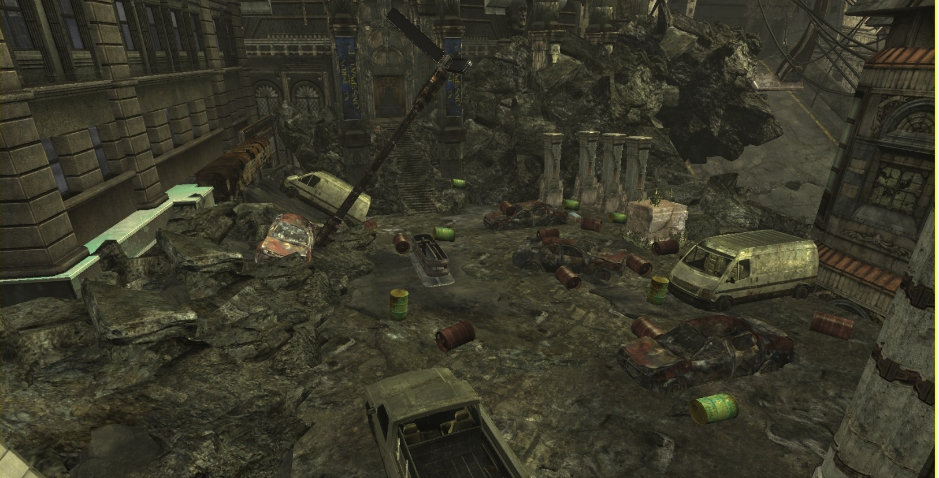
B
G
A
H
D
C
IO
E
F
Figure 34 Area 2: City Streets

Table 20 List objects you think are destructible in Area 2

Table 21 List the Objects you think are destructible in Area 2 by participant

This question was asked to find what objects players thought were destructible to see if the communicated importance desired by the designer matched what the players actually noticed. The blue units on the graph shows show items the player thought were destructible and actually were destructible. The red units show when a player thought an item was destructible when it actually was not. In general, the more important objects, those that block the critical path or objects that provide a gameplay use, were noticed the most. This indicates the first rule could be true: that the amount of communication necessary is proportional to importance.
The breakdown of how noticeable objects were in the area meets expectations with a few exceptions. The red barrel was most noticeable, when it technically was not the most important object in the scene. The door technically should have been the most noticeable because it blocks the critical path, but it ranked a close second. The margin between the two is very close and may have not statistical significance, since the Red Barrels appeared in the previous area, and not a single player had their progression halted by the door.
What was not expected was how many people misidentified static objects as destructible. Looking at the objects identified by participant, it appears certain players thought static cars were destructible, most likely because some cars in the scene blew up so one can presume all cars explode when enough damage is applied. They also indicated the green barrels’ destructibility. Green Barrels are physics objects so they react to damage and move around, which could be misinterpreted as destructibility.
These negative responses indicate perhaps the level designer has an additional communication responsibility: communicating static objects are indeed static. If the player encountered this level as part of a campaign, they would have likely encountered static vehicles and features in previous levels and there would be less confusion about what is static, but since this level introduces all objects at once, players have no idea what to expect.

Table 22 Did the opening cinematic convey that the wrecked cars can be set off like explosives
If Not Why Not?
All I noticed was that the barrel was exploding
I probably wasn’t paying enough attention.
I guess I just did not make the connection. It seems kind of obvious looking back but I guess I did not feel threatened enough to feel I needed help from exploding stuff and thus did not file it away.
I thought that that the barrel was the one that made the car explode
Thought the barrel was exploding, not the car
It appeared as though it was the Red Barrel Exploding, not the car.
I assumed the cinematic meant something, but once the Locust appeared I was totally focused on killing them with a gun or shooting a barrel. In retrospect, it seems that the enemies could all be killed by triggering some sort of environmental hazard.
It looked like the barrel was exploding and the car was just setting on fire
Table 23 If the opening cinematic did not convey that the wrecked cars can be set off like explosives, why not?
This question attempted to discover if using a cinematic as a communication technique works when trying to communicate an object blows up when another explosion interacts with it. The opening cinematic in Area 2 shows a barrel falling onto a car causing the barrel to explode and the car to catch fire and then explode. This asks players to make a logical leap by saying “If red barrels explode and cause damage, and the barrel exploding on a car causes it to explode, then cars that take any damage from explosions or weapons fire will explode.” The expectation was players would identify the car as destructible, however 43 percent of testers did not get this information from the cinematic. The comments indicate several did not make the logical leap that the car was flammable and explosive. This could indicate that level designers should never assume players will make a logical leap if they want to clearly indicate an object’s destructibility. Showing all the ways the car can take damage and explode would have raised understanding dramatically.

Table 24 How easy was using explosions to defeat enemies

This question asked how difficult it was to use explosive elements to defeat enemies to see if the utility of the explosions was helped or hindered by their placement and how much damage it takes for them to blow up. The expectation was players would find it easy to use explosions, however 35 percent of participants found it challenging. The player starts the level with a shotgun, a weak pistol, and grenades. All but three players used the shotgun and grenades exclusively. This may be related to the normalcy bias discussed earlier. In designing the level, the idea was the shotgun would be for when enemies ambush the player or when players want to rush their position and the pistol would be ideal for taking out destructibles from a distance. If the players started the level only with the pistol, the results may have been vastly different since they would need to take careful aim and consider their surroundings.

Table 25 Did you ever find yourself shooting at an object expecting it to explode or fall apart and it did not

If so, describe how it felt

Green Barrels; "oh these don't explode"
Green Barrel - Confusion
Mild Disappointment
Disappointment
Both inquisitive and a relief because I was near the green barrels and I didn’t want to die by my own shots or enemy shots.
Confused as to why the green barrels did not explode into acid or whatnot
Tried to shoot the green barrels. They did not explode. I thought maybe they were poison because of the color association.
Tried shooting the doors, but they didn’t open. Thought I might have to drop an explosive from a hanging car like the cinema, but didn’t see anything. Decided to try the grenades and that worked.
Annoyed
I tested the green barrel to confirm that they did not explode. The green color can indicate a poison/toxin, so I shot one to be sure.

Table 26 If so, describe how it felt
This question checked to see if players found anything that broke the believability rule. The expectation was the lack of utility for the exploding pillars would disappoint players, but it turned out the green barrels were the only believability breaking destructible object people actually noticed. Of the testers, 48 percent found an object that violated the believability rule when it did not act as expected and, of those, all mentioned the green barrel. The comments indicate the green barrel should have responded in a similar way to the red barrel. Players thought it would explode with acid, causing corrosive damage. The green barrels are the original assets from Gears of War and they simply act as background set pieces, however put them in the context of a destructible environment and people begin to associate color with destructibility. In the context of the Gears campaign green barrels have no significance, but since a red barrel explodes green barrels grew in significance.

Table 27 Was the objective to breach the amphitheater clear and straightforward

If not why not

I had no idea that the door was to the amphitheater
But I did remember that the cinematic said something about breaching the door so after a bit of hesitation I was able to guess that I needed to do something to the door to progress
There wasn’t a POI pointing towards the door, however I surmised that the door was the amphitheater door and noticed I could see through the doors between a small slit between the doors.
I initially approached the door because it made sense to do so with the stairway leading as a guide. However, when I attempted to shoot it nothing happened so I descended the stairs and looked around for another exit. I almost thought there wasn’t one, but I decided to attempt destroying the door again with a grenade and then the game provided a tip stating that the door was made of wood.
Table 28 If the objective to breach the amphitheater was not clear and straightforward, why not?

Was there anything that indicated the door could be destroyed?

Grenades Nearby
Not until it started to glow
Not really, but I would have tried anyway just because it looked like a path.
The expectation was set by the previous use of exploding environmental objects up to this point. However that was the only apparent clue, and maybe not obvious for novice players.
The door was flashing.
However, at that point it was apparent just due to the theme of the level
Table 29 Was there anything that indicated the door could be destroyed?

What was your solution to breach the door?

Toss grenade at it.
First, I attempted to kick it down (X button), then I shot it, melee’d it, and tried to stick it with a grenade (I don’t remember if that was in the original gears). Then I threw a grenade at it.
Grenade
I threw a grenade at it.
Shoot it
Grenades
Grenade, kind of a hard throw
grenade
Other than the objective telling me to ‘breach’ the door, which usually meant explosives, I used a grenade.
Threw a grenade at it. First grenade bounced off and confused me.
Shot the door with the crossbow
Throw a grenade at the door
Grenade
Used a grenade on it
Grenade
Use the torque Bow
Grenade
Shot it with a Torque Bow
Dropping a grenade on the step and retreating like hell.
I threw a grenade.
Throw a grenade at it
Table 30 What was your solution to breach the door

The above four questions related to the door and sought to find out how clear the objective was to breach the amphitheater to see if there was enough visibility. After defeating the Locust forces, the player must destroy a doorway that appears to be intact. Communicating the destructibility of the door used a combination of the layout of the area guiding the player towards the door, the placement of grenades nearby indicating their potential use on the door and a bit of logic on the part of the player to use what they learned from the destructible wall in Area 1.
Testing indicated that, with all of these communication methods, 26 percent of players did not feel there was enough communication to indicate the object’s destructibility. Everyone managed to pass this obstacle, so in the end the communication was enough. However, the play time results for the overall level, found below, show the players who did not get the communication elements took longer to complete this section. This could lead to frustration if the player was in a combat situation while at the same time having to figure out what to do to get past a critical path blocking destructible feature. However in this case since it was presented more as a puzzle, players are more willing to invest more time in solving the problem before getting too frustrated.

Table 31 Did you notice the door glowing at any point

If so, what did this indicate to you?

"go here"
That this was the door to the amphitheater
That the door was important
Interactivity with the player
“DO SOMETHING HERE”
A point of interest
To me, the glowing door meant something to focus on, an objective.
That I had to go through it, and there was someway to get it open.
It could be destroyed
That this was a major objective that I should interact with.
That it was an object to interact with.
That the door was interactive.
Indicated it was destructible (I’d already reached that conclusion before it glowed)
Table 32 If you noticed the door glowing , what did this indicate to you
A glowing object is another gaming trope that testing indicates is nearly universal. This question checks if this is true, and of the 57 percent of players who noticed the door glowing, all of them indicated the door was important and those who recognized the context of the level realized that it indicates destructibility. Those that did not notice the glow blew up the door before it started glowing. The door starts out with a normal appearance, but after a minute, the glow activates, providing an additional cue to lead the player to the door. As a result, every single player passed the door, but only 36 percent did so without the door glowing.

Table 33 How fun was Area 2
This data reflects how much fun players had in this section. The data serves to show if destructible features had an effect on the fun in this area. Players in general had fun in this area and more than a third rated this area as very fun or extremely fun. On average players rated the fun level of this area at 3.5 out of a possible 5.

Table 34 How Difficult was Area 2

This data reflects how difficult players found Area 2 in order to discover if destructible features had an effect on the how difficult the area was. Players in general found this area easy. On average players rated this area’s difficulty as 2.6 out of a possible 5.

Area 3: Amphitheater

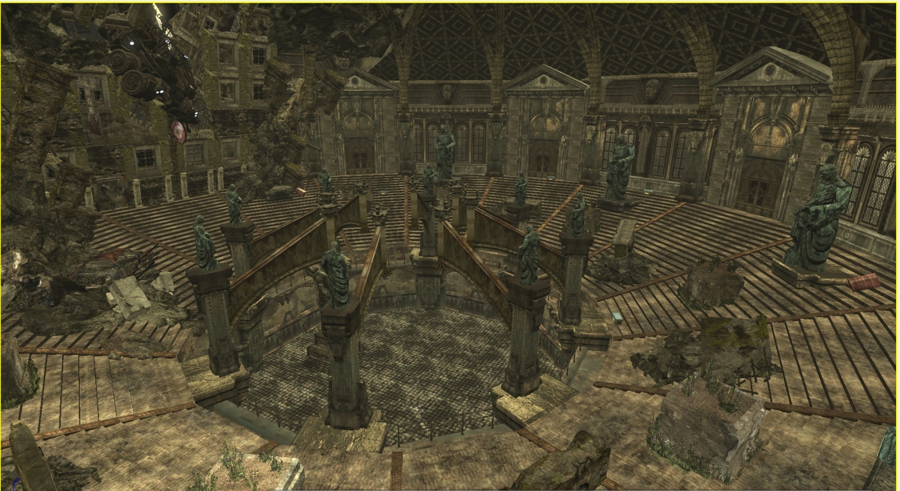
A
G
D
E
B
C
F
Figure 35 Area 3 Amphitheater

Table 35 List the objects you think are destructible in Area 3

Table 36 List the Objects you think are destructible in Area 3 (By Participant)

This question was asked to find what objects players thought were destructible to see if the communicated importance desired by the designer matched what the players actually noticed. In general, the more important objects, those that block the critical path or objects that provide a gameplay use, were noticed the most. This indicates the first rule could be true: that the amount of communication necessary is proportional to importance.
The breakdown of how noticeable objects were in the area meets expectations with a few exceptions. The pillar was indicated as destructible by many participants, however during observation of the testing only one of the testers actually tested its destructibility. Similar pillars appeared in Area 2, so previous experience with these pillars was enough to communicate destructibility.
As far as misidentification of features, it seemed to meet expectations. In the cinematic, players noticed that the tanker was swinging precariously and some tried to shoot it instead of the red target. The small statues in the scene are indestructible, but they look similar to the large statues that collapse and so many participants marked it as destructible. This indicates there is something to the believability rule, as players expect similar objects at different scales to behave the same way.
These negative responses indicate that the players are learning about destructibles as they go and by the end those who misidentified more destructibles become more discerning and misidentify fewer features. This indicates that previous experience with an object helps people avoid misidentifying more things, however on the opposite side, fewer testers had 100 percent accuracy when identifying destructibles in Area 3 than Area 2. This is mainly due to one particular statue labeled as “D”. This smaller statue is identical to the larger statue that is destructible so players become confused about this particular item. This is evidence of the believability tenet, that players require consistency in their destructible objects, as well as evidence of the visibility rule. One could communicate an object’s destructibility very well, but if there is an indestructible object with the same look and appearance, it is going to negate some of the communication.

Table 37 Did the opening cinematic show statues can be knocked over with an explosion

This question checked the cinematic disconnect in this section. Players watch a piece of flaming debris fly in the air and hit an explosive barrel which knocks down a statue and crushes the enemies. This was to see if the player could make the logical connection that explosions knock over statues, whether the damage comes from a barrel, a grenade, or some other weapon. The hope was that between the previous cinematics and what the player experienced, the logical connection would be made simpler. However, the cinematic disconnect caused players to not think the statue was destructible in the same way. The data shows a fourth of participants not realizing the statue could be destroyed. Depending on the desire of the level designer, this may be perfect. Since this is a utility feature that makes the game easier and not something blocking the critical path, this could be the desired communication level. For those that want more communication a glow or less of a logical leap is required.

How did you defeat the enemies and complete the objective?

Dropped a statue on one, shot the others
I shot them all
Sticky grenades, my pistol, and the dropping car.
I killed the grunts by dropping statues on them and killed the boomer by shooting him with the exploding arrows
Destroying environmental object and shooting enemies.
I realized quickly these enemies had heavy HP, so I used cover to block enemy fire and shoot from a distance (even with a shotgun).
A group with statues, another with the torque bow.
Used grenades
If I had no explosives on me, I’d charge them with the shotgun, and shoot them from behind cover. If I had explosives and a torque bow, I’d try to shoot the cover they are on, or a statue.
Shotgun + head
Melee the Locust , then shot I the bullseyes of the truck
used the statues. Knocked over statues with grenades.
I shot them
Sneak up and shoot them close up with the shotgun
Knocked over a statue and shot at the locust.
With Bullets
Eventually used explosive to knock over statue
I just shot them normally.
Normal weapons, use of cover.
I shot minor Locust with the crossbow and killed the big one with the vehicle.
I knocked over statues to kill them
Table 38 How did you defeat the enemies and complete the objective
This was a test to see who had used the statue to destroy enemies in their own words. Most of the responders used conventional means to take out the enemies, however a few used the environment. This seems to indicate communication plays a large part in the player’s decision because 100 percent of participants who noticed the statues fall down due to explosive damage used them to take down enemies. Likewise, 100 percent of players who did not notice the nature of the statue in the cinematic used conventional methods.

Table 39 Did you use the collapsing statues to defeat any of the enemies?

This chart shows that the majority of players did not use the statues to kill enemies. The level was completely playable without using them, however, the expectation was that they would be used to a greater degree. Only a 39 percent of players managed to use the statues to destroy enemies. Given that there is a cinematic devoted to this feature, these results were unexpected. Giving the statue a glow, a point of interest, or a showing its destructibility in game may have communicated destruction better.

Table 40 Did the falling statues make completing the objective easier?
This chart indicates that those who used the statues found the objective to be much easier. The question was a check to see if people who used the statues got the expected utility out of it, and indeed they did. Every responder who said they used the collapsing statue found it useful.

Table 41 Was the objective to defeat the boomer clear and straightforward?

How did you defeat the boomer?
Shot it a lot, that didn't work, dropped the jeep on it.
I knocked the car onto him
Dropped the car.
Shot him with the exploding arrows
By destroying the load bearing sign
I was about to shoot the sign above, but got killed.
I ran a car over him
Torque Bow to the face
Shot him in the head with the torque bow.
Dropping a car on him
Dropping the truck on him
Picked up a torque bow and shot the sigh holding up the truck
Dropped the car on him
Shot the target to drop the car onto the boomer
Shot the sign to bring down the car
Hit the glowing sign
I shot down the vehicle that crushed him.
Dropped the vehicle on him.
By causing the vehicle to fall.
Released the Junker.
I dropped the car on him
Table 42 How did you defeat the Boomer
This question determines how the players defeated the Boomer boss at the end. Results showed 12 participants used the provided glowing sign to trigger the collapse of the tanker that crushed the boss. Everyone else found the torque bow and shot the Boomer directly. The visibility level of this object was very high. It was pointed out in a cinematic and there was a constant glow showing that the sign was destructible. According to the visibility rule in the thesis this would be an obvious destructible and the results show that to be true with 84 percent of participants noticing the feature.

Table 43 Did you shoot the glowing sign

If so, how did you notice it? Did it have a purpose?
I knew it was a target object. Didn't respond to hammerburst at first so I ignored it for a while
I saw it in the cutscene. I assumed it was being shown to me for a reason.
It was made apparent with the Gears of War Point of interest look at icon.
It was glowing
I saw the sign in the very first cinematic… I assumed it might let the car drop on top of the boomer, but after missing once, I chose just to shoot the boomer in the head with the torque bow.
Glowing, looked like it was holding up the car.
It seemed logical. The sign coloration drew my attention immediately.
I knew I had to knock the car off. I wasn’t sure if the sign would do it or not.
Cinema gave a huge hint.
It glowed during the cinematic. It was holding up the car so shooting it would make the car give way.
It was glowing and looked like a target with a precarious vehicle hanging above it, so I shot it.
Cinematic, and thought I was supposed to shoot it to release the vehicle
I knew that I wanted to shoot down the vehicle, and the fact that the sign was glowing clued me in that shooting the sign was the method to do that.
Yes, twice. Once before it was activated, as it looks like a target. Once the target was ready (during the Boomer phase), I shot it again.
I assumed it had some purpose since it was glowing (nothing else was that I noticed) and it was located directly below the vehicle teetering on the edge of a hole.
Indicated it was destructible (I’d already reached that conclusion before it glowed)
Table 44 Did you notice the glowing red sign? Did it have a purpose?
These questions showed the effectiveness of the glowing sign. This was the penultimate communication test. It had a cinematic pointing it out, it had a constant glow, and it had a point of interest guiding the player’s view to that location. The thesis anticipated this particular feature would get lot of attention. The surveys indicate 71 percent of participants used the sign to take down the boomer. In the written responses, several testers said they saw the sign, knew what it did, and chose to take down the boomer by conventional means anyway. Taking those two responses into account, the percentage of people who recognized the destructibility of the sign was 85 percent.

Table 45 How fun was Area 3
This data shows how much fun players had in Area 3 in order to discover if destructible features had an effect on how much fun players had in this area. More than 80 percent of players rated this area fun to very fun. On average players rated the fun level in this area 3.6 out of 5.

Table 46 How Difficult was Area 3

This data reflects how difficult players found Area 3 in order to discover if destructible features had an effect on the challenge level of the area. Players in general found this area challenging. On Average players rated the difficulty of Area 3 at 2.5 out of 5.

Overall

Table 47 Average Time taken to complete each area

Table 48 Time taken to complete each area for each tester

As the testers played through the level, the observer marked down completion times in each section for each player. This observation data served to check if whether the player noticed good or bad destructible features had an effect on completion time. It turns out that time is not a clear indicator of a player’s understanding of destruction and how much fun they had. There are too many factors to consider, such as Bartle Player Type and experience with Gears of War. Observation showed explorers had a tendency to spend more time in Areas 1 and 2 because they wanted to explore the environment and stopped to pick up every ammo or weapon pickup. Experienced Gears of War players tended to score very long times on Areas 1 and 2 because a dominant strategy for Gears of War is to rush in and take out enemies at close range. In the test level, an errant shotgun blast sets off explosives which can kill the player. This meant repeated playthroughs were necessary for players very skilled at Gears of War gameplay who did not consider the destructible features before proceeding.

Table 49 Number of deaths in each area (average)

Table 50 Number of deaths in each area per tester
This chart shows the number of deaths suffered by each player. This was an attempt to see if there was a link between the number of deaths and if players used destructible features. There is a positive relationship between certain testers who did not use destructible features and the number of deaths these testers experienced. However, among those who died two or more times in Area 2 and Area 3, 70 percent had played Gears of War multiple times and are likely to experience a great deal of normalcy bias. As stated before, normalcy bias caused players with a lot of Gears of War experience, to use previously learned tactics in the testing scenario. A dominant strategy in Gears is to rush headlong into enemies and take them out at close range. This tactic is not conducive to destructible environments which requires distance from the destructible, strategy and timing. The presence of normalcy bias seemed to cause larger number of deaths in areas with lots of destructibles that could kill the player such as in Areas 2 and 3.

Table 51 How fun was this level
This question was a general gauge of how players enjoyed the level overall. The majority of testers found the level fun or better, which reflects the comments written by the participants about what they enjoyed about the level. On average players rated the fun of this level as 3.4 out of 5.

Table 52 How difficult was the level overall?
This question attempted to gather data on how difficult players felt the level played. The majority of players found the level easy. Players rated the level an average of 2.5 out of 5 in difficulty.

Table 53 Did you notice that Destructible features were a major part in helping you complete the objective

If so, when?
From the beginning
I thought it was just exploding barrels
When I had to destroy the amphitheater door.
I guess in the theater when blowing up the statues. I did blow up some cars but it was by accident and did not realize it was the focus of the level.
Immediately, during the first cut scene
When they gave me a shotgun to fight long range...
Level intro
I understood that destructible cover and explosive features are part of the design, but I didn’t seem or felt I needed to use them. How ever , playing it, and testing the features, are fun.
during the very first encounter
With the red barrels at the beginning
When I had to destroy the first wall to get out of the first chamber.
Opening Cinematic
When I entered the courtyard area and saw it littered with red barrels.
Yes, in the city street area
From the beginning
Either when destroying the first wall or immediately thereafter when the cut scene showed additional explosive elements
When I blew up the first door and saw the field littered with red barrels
Table 54 When did you notice destruction was a theme
The questions about destruction being a theme attempts to discover that if having a variety of destructible features can convey a theme of destructibility which can help the player recognize communicated features quicker. Results show more than half of the testers recognized destruction as a theme.

Table 55 Did you enjoy watching things blow up?

This question was a control question to see if anyone disliked destruction, which would tend to skew the participants responses. All but one tester enjoyed watching things blow up. That tester had multiple issues with communication. The tester was annoyed by a feature that violated the believability rule and was disappointed at the lack of communication of the destructible statues in Area 3.

Table 56 Were there frustrating moments in the level?

If so where
Yes, final section. Cover felt a bit odd, and it wasn't clear how to beat the Boomer at first since shooting it didn't seem to work.
I got killed by a statue during a cutscene. I kept getting blown up by a car I was trying to take cover behind.
The beginning, trying to escape.
Boomer Killed me after cinematic
The door outside and a pylon in the amphitheatre didn’t destruct as easily as I’d hoped.
I typically play Gears very aggressively, and charge enemies for close-combat kills. However, I realized quickly the enemies had heavy HP and this was frustrating, since it was not what I was expecting.
Long range for shotgun, lack of cover, although locust where pretty bad?
Nah only when I wanted to pick up a torque bow and got hit by the boomer.
Initial combat was frustrating due to lack of cover and no Lancer, and getting in close with the shotgun got me killed.
Yes. The theron guard that emerges is challenging.
The first big fight, where I didn’t know how to control the character, and the bug at the start of the 3rd part.
Shot gun doesn’t have good range, so had to modify and sneak up to get close to the enemies
In the cathedral… did not know how to kill enemies at first.
Once I tried blowing open the amphitheatre door with a barrel and it glitched out of existence. Not a design issue though.
I wasn’t quite sure if the door was destructible at first so I ran around. It would have been cool if I could have destroyed it with the shotgun. I was also a bit rusty with the controls but once I got a bit more comfortable it was easier.
Table 57 Frustrating moments in the level
These two questions allowed the player to vent about any frustration they felt in the level and point to any destructible features mishandled in the eyes of the player. About 64 percent of players felt there were frustrating moments in the level and nearly every frustrating moment relates to the three rules. Of the players who commented that they had combat difficulties, every problem would have been easily overcome if they had seen and used the utility destructible features.
Players frustrated by critical path blockers did not receive adequate communication of destruction. As discovered earlier in the thesis, 11 players saw destruction that did not meet their believability expectations and made a note of it.

Table 58 Were you able to destroy enemies with destructible objects.

Did it make the experience more satisfying?
Just barrels. Yes, it made it more satisfying.
Yes, particularly the vehicle which defeated the boomer.
It made up for the lack of long range fire power
It does enhance the game play experience.
Barrels made it much more satisfying
When I used it, yes.
Yes!
Not really.
Yes. It wasn’t so easy that I felt ripped off, or too hard that I didn’t want to use them. They were just available enough to complement the normal action, and in spots where I needed them.
Somewhat. I was so occupied with protecting myself that I wasn’t always looking for alternative other than shooting directly at the enemy or a red barrel.
Yes, it made me feel clever and strategic
Table 59 Did destruction make the experience more satisfying?
Over 90 percent of players indicated at one point or another they used destruction to defeat enemies. Comments indicate the barrels were the feature players liked the most. This suggests that players tend to fall back on previous knowledge gleaned from other games or even earlier in the game, or perhaps the abundance of barrels and their ease of use made them more popular.

What did you like about the level?
Blowing things up and knocking them over was a nice gimmick.
I liked getting the torque bow. Easily killing guys with barrels was nice.
The shooting…
A nice short and sweet level with lots of explosions. I think the theater part would have been more fun if there had been more guys to kill. Overall a fun experience.
Cinematics were well placed and conveyed the objectives well, didn’t enjoy fighting from the same cover during most fights. Needs more moving around.
Destructible objects and environments were interesting. Using the vehicle to kill the boomer was fun.
Destructible environments, when I noticed it.
Hit and run the boomer
Thoroughly enjoyed all of the explodable objects in the level. I didn’t really use them as much as I would have liked though. I think if I played the level a second time I probably would have tried to explode more objects and see their effectiveness in killing Locust.
I enjoyed most the chain reaction of barrels that would detonate and eventually gib the enemy.
The car-kills-boomer part was really cool, though the POV was a bit weird.
Also the abundance of exploding barrels in section fun was cool, I’d rather kill things quick, then grinding them down.
The cinematic were cool specifically the helicopter dropping from the ceiling and also when the Boomer was trampled by the hanging jeep in First Person, very cool.
The ending was pretty fun.
Liked that I had to find a way to kill the enemies. Ended up having to sneak around and get them with the shotgun.
Blowing up stuff and watching the enemies blow themselves up.
Pretty basic level, not much special that I could tell.
I liked the destructible environment theme of the level. The courtyard area was littered with all kinds of explosives and I felt that it would be really fun to make use of some of the stuff.
Using barrels at range to gib Theron Guards is always satisfying. Interactions with the destructible objects.
The destructible environments were a nice addition. I would have utilized them more if I was more comfortable with the controls.
It was straightforward and simple, with clear objectives
Table 60 What did you dislike about the level
This question gathered the general impressions of the participants about the level to see how many mentioned destruction as one of the main things they enjoyed about the level. A total of 60 percent of responders mentioned destruction as something they liked about the level. This could indicate destructible objects that obey the rules outshine objects that disobey the rules.

What did you dislike?
Wasn’t clear to me that cars blew up on their own, especially with so many of the explosive barrels already around.
In the final area, second wave of drones popped up behind me, and the cover felt kind of awkward—was exposed at first. And Boomer was a pain. Hammershot, etc.
I had a really hard time understanding that the cars could blow up. I think it would be a good idea if you put a “y” button objective on the amphitheatre door. It would have been nice to be able to go back into the first room to grab some more grenades.
Put warning icons on the barrels.
The first area might be frustrating for some who do not play games as much and you might want to try and highlight the wall some more.
Collision volumes could be cleaned up and tightened up a bit. The shotgun isn’t super useful during the exterior conflicts if they are attacked from the pickup truck. Enemy difficulty was unexpectedly high.
The final part I would put more long-ranged weaponry or more cover to sneak up for close combat.
More cover or make the cover feel more “complete”. I felt that cover wasn't really safe.
Less grenades would have probably caused me to use the explosive objects more.
To really convey the use of only explosives… and destructible terrain, I’d force the boomer to only take a certain damage type that the ‘car’ or other falling debris’ could cause on him… likewise for some other enemies… ensure the only way to kill them is by destroying the environment if possible.
More cover in the initial fight, a longer-ranged weapon.
The amphitheater door was difficult to know that I needed to blow up instead of just open fire.
The Theron Guard that emerges during the second encounter might be too much.
More accurate gun besides the Shotgun and weak pistol, before the longbow.
Give the player a different weapon than the shotgun.
Not really just cover nodes being wonky.
Put a barrel behind the pillars to make it obvious they can be knocked over with explosives.
Perhaps give me a little more time before being attacked to look around and decide what I think I can use and how best to use the environment to my advantage. Really fun level though.
Think the explosions for the vehicles should have been a bit larger than the barrel explosions, because when the barrel fell on the car in the city streets area I just thought it exploded normally and did not affect the car.
The addition of a longer ranged weapon may have made it a bit more accessible; the shotgun wasn’t very useful.
POI on the first destructible wall, something to reduce the lag
I would have preferred some weapons besides the starting pistol and the shotgun. It would have been easier to hit exploding objects if I could hit them from a distance in the second area
Table 61 What did you dislike about the level?
What the players disliked related primarily to three things: having longer range weapon to be more effective in combat, better communication about utility objects, and the difficulty of the enemies. Every single one of these issues could be resolved with more communication. Someone suggested putting a warning label on barrels to make them even more obviously destructive and better communicating that cars explode. This could be fixed with art changes and more scripted communication like cinematics. For those requesting long range weapons, this would not be an issue if they understood how to use destructible features effectively. If they did, they would know the pistol was a far more effective weapon to set off explosives. If destructibility was better communicated, they would not have this issue. As far as enemy difficulty, again if destruction was better communicated and the player knew from experience that using destructibles against enemies is a viable strategy, then fewer people would have had issues with the difficulty of the enemies.

Chapter 5: Discussion
In order to test whether a level with destructible features becomes more fun with destructible features that follow the rules of visibility, utility and believability, testers played through a single level filled with destructible features. Some destructible features followed the rules and others disobeyed the rules. The results of the thesis focuses on these destructible features testing the three tenets. By comparing the results to how much fun each player had in each area, positive relationships between good and bad destructibles and fun become apparent. The results section looks at the questions in the survey related to visibility, utility and believability versus fun and breaks down any positive relationship between the destructible features and how much fun or how difficult different participants found a section of the level.
Before getting into the tenets, a comparison between the demographic data, fun levels and difficulty levels is required to see if any of the testers’ traits had an effect on the study.

Demographics

Due to the homogenous nature of the particpants, mostly male gamers with experience with Gears of War, there were very few links between demographics and their effect on fun or opinions of destructible features.
For example there was only one female participant in the study and her opinions did not differ from her male counterparts in a way that could not be explained by any number of other factors such as gamer type, experience with Gears of War or proclivity towards first person shooters.
Experience with Gears of War is a possible major influence on a player’s decision when it comes to destruction because it can introduce normalcy bias where the player comes to exhibit a certain way of thinking and tends to fall back on that knowledge when presented with new information. However, the only pronounced effect of experience on testing was that play times tended to last longer for skilled players who preferred to engage the enemy melee style and accidently triggered explosives. With a larger sample size made up of people who had not played Gears of War, one might see more clearly the affect of normalcy bias on the avid Gears of War players versus players who were experiencing the game for the first time.
Comparing Bartle Gamer type with the results showed no obvious trends, though in certain situations their tendencies would shine through. In Area 1, a few more explorers chose to search the room before blowing up the wall and escaping the chamber. Killers found the combat and the level easier overall, but took longer to complete Areas 2 and 3 because, based on observation, they would rush in and become overwhelmed a few times before stepping back and using destructibles.
A more diverse group of testers would help make these differences more pronounced, then it would be more apparent which groups prefer what kind of destructible objects , but the results vary so wildly between questions in this study it is difficult to find a significant relationship between gamer type and the results overall. While it cannot be said demographics are not a factor, the following results show a minimum of demographic influence.

Results
Looking at the results of the surveys, there were many positive relationships between the effect of the three tenets of visibility, utility and believability on the amount of fun certain players who had a positive experience with destructibles had in the level and the difficulty level vs. those who did not experience the destructibles. There were no negative relationships that would outright disprove the rules and there were several questions that produced results consistent with the thesis. This section contains some of the stronger associations, divided up by the rules they best illustrate. The visibility rule proved to have some of the strongest results.

Visibility Rule
The visibility rule relates to communication.

Visibility - The amount of effort in communicating an object’s destructibility is proportional to its importance in player progression.
The positive relationships are strongest with the destructible walls in Area 1 and the destructible sign in Area 3.

Table 62 Fun Level vs. Recognition of Destructible Wall In Area 1

Table 63 Fun Level vs. Recognition of Destructible Wall (Average)

In this first area, the players who did not recognize the wall as destructible did not find the area as fun and found it more difficult. Only two people actually did not notice the cracks, and all players managed to pass the obstacle, so while the data points to an inclination that lack of visibility of the destructible had an effect on fun, this effect was not as strong as anticipated in this case. The expectation was players would get a great amount of enjoyment from seeing the destructible wall and feeling clever when they find the solution to destroying the wall while those who did not find the solution would find the area unsatisfactory. The evidence of this was not as strong as the thesis predicted, though a difference of .84 shows an association.

Table 64 Difficulty Level vs. Recognition of Destructible Wall in Area 1

Table 65 Difficulty Level vs. Recognition of Destructible Wall (Average)
The thesis predicted those who recognized and understood destructible objects would have an easier time progressing through a level, however in the case of this first puzzle, indications point to something else going on. While the sample of people who did not recognize the destructibility of the wall due to the visible cracks in the wall was small and so the results are not as strong, they had less difficulty in this section than those who recognized the destructibility of the wall immediately by looking at the cracks in the wall. This could have something to do with visibility of the barrel. Those who did not notice the cracks said they shot the red barrel, which means that they were able to focus on the red barrel as a clue to solve the puzzle and finish the puzzle with more ease than those who had to look around the room and find the cracks themselves. This points to the power of a destructible barrel as a communication tool.

Table 66 Did those who saw the cars caused explosive damage have more fun in Area 2?

Table 67 Did those who saw the cars caused explosive damage have more fun? (Average)

Here we can see a positive relationship between players who saw cars could do explosive damage to enemies and how much fun those players had. While there is no guarantee that the player used cars instead of exploding barrels which are present in the same area, players who were confused by the car’s explosiveness had less fun and marked down that they had a hard time distinguishing the difference between explosions caused by barrels and explosions from cars. Said one participant, “It wasn’t clear to me that cars blew up on their own, especially with so many of the explosive barrels already around.”
While a direct link between the exploding cars creating more fun is unclear, the negative seems to be clearer. As predicted by the visibility rule, players confused by a lack of communication or confusion caused by mishandled communication had less fun.

Table 68 Did those who saw the cars caused explosive damage find Area 2 easier?

Table 69 Did those who saw the cars caused explosive damage find Area 2 easier?

There was also a link between those who saw cars caused explosive damage and how difficult players found the Area 2. The thesis suggests that in order for secondary mechanic objects like the exploding car to be used by players, their destructibility needs to be communicated. The results show that those who knew cars exploded on average rated the area between very easy and easy while those who did not notice the cars found the area to be easy to challenging. While there were other factors at play that could have made the area easier, and it is unknown whether players actually used the cars to destroy enemies over the available exploding barrels in this area, there is a strong relationship that says the visibility of the utility object led players to have more fun overall. This suggests players who think there are a plethora of destructible objects enjoy exploring all of those options to take out enemies. Adding to player choice can enhance a player’s experience, so by following the visibility rule, players notice more options to complete the objective and the number of player choices increases.

Table 70 Did those who used the tanker to destroy the enemy have more fun in Area 3 (Average)?

Table 71 Did those who used the tanker to destroy the boomer have more fun in Area 3?

The tanker truck in Area 3 was the major visibility test of this area. The tanker falls under the category of secondary mechanic destructible because using it provides another tactic in defeating an enemy. Players face off in Area 3 against a grenade launching boomer. They can either take it out with conventional weapons, or they can shoot a load bearing sign supporting a large truck. Shooting the sign causes the truck to roll down and crush the boomer. The load bearing sign used a great deal of communication techniques. It was pointed out in a cinematic, it glowed and it had a point of interest marker which automatically focuses the player’s attention on the sign. As a result, 82 percent of players chose to shoot the sign as opposed to using conventional weapons.
The graph shows that in actuality the four people who used the Torque bow to defeat the boomer had a higher average level of fun compared to the other 19 people who used the tanker to take down the Boomer. Considering disparity between the two populations and the slim margin of .18 between the fun levels of the two groups, this is not a very strong result. However we do learn something from these findings. The four people who used weapons on the Boomer used the torque bow, one of the more unique and exciting weapons in Gears of War. It fires an exploding arrow which detonates upon penetration into a surface. It requires careful aim and creates a powerful explosion that takes out even the most powerful enemies. This kind of skill test to take out a Boomer from long range with this weapon might very well be as entertaining as or more entertaining than using a destructible. The collapsing tanker was the most obvious way to defeat the boomer, however some players take pleasure in trying to do things their own way and make their own fun, which is ironically what widespread destruction is supposed to simulate.

Table 72 Did those who used the tanker to destroy the boomer find Area 3 easier?

Table 73 Did those who used the tanker to destroy the enemy find Area 3 more difficult?
While only four people chose to not use the tanker to destroy the boomer, there is a slight connection between difficulty and the use of of a visible destructible. The thesis suggests that an object clearly indicating destructibility that offers an easier way to complete a task makes the level easier. Area 3 is extremely easy if one can see the destructible features, especially at the end with the glowing sign which uses a variety of communication methods to highlight destructibility. On average the players who used the tanker to kill the boomer found Area 3 to be easier than those who did not, however the margin is slim because those who chose an almost equally fun method of using an exploding crossbow bolt to kill the Boomer. Aiming and shooting at the glowing target and aiming and shooting at a large enemy require the same basic gameplay actions.

Utility
The utility rule is based on using destructible objects for gameplay purposes and how they add extra fun to a level.

Utility – Destructible objects with a gameplay purpose provide a greater sense of satisfaction and fun than objects that are purely visual.
The test results show a link between people who used destructible objects to destroy enemies and how much fun those players had compared to those that did not use destructible objects.

Table 74 Did those who used the environment to achieve the goal find Area 1 more fun.

Table 75 Did those who used the environment to achieve the goal find the area more fun (Average)
According to the thesis, players who used the environment to pass the cracked destructible wall would have more fun than those who used conventional ordinance. These graphs show a trend for users who used the barrels to have more fun than those who used a grenade. This is an indicator that players who used the environment for a gameplay purpose have more fun. While the thesis predicted more fun would be had by players who used utility features, not how much more fun, the utility rule is accurate. However, a greater connection was expected. The reason may be that both methods of destruction provided the same result: the wall blasted apart and the player proceeded through the level. For both methods there was a visual payoff and gameplay proceeded as normal. If instead of a wall to be destroyed, a door was placed on one side of the room the player could open instead, the fun ratings in this area for those who chose to take the door would have been far lower than those who chose to use the environment. However in this test cake there wasn’t enough gameplay or visual difference between the two methods of destruction to create much of a difference.

Table 76 Did those who used the environment to have an easier time breaking down the wall in Area 1?

Table 77 Did those who used the environment to achieve the goal find the goal easier to understand? (Average)

Players using the barrel found the level slightly easier than those who used a grenade, though not by very much. However, the difference suggests that in a puzzle situation where the player has to destroy a wall, those who choose to use the barrel take longer to see it, comprehend the significance, and finally use the barrel because it requires more logical steps than throwing a grenade at the wall. This could lead to more players finding the level difficult.

Table 78 Did players who used the environment to destroy enemies have more fun in Area 2?

Table 79 Did players who found explosives easy to use have more fun? (Average)

The gap between the fun ratings of those who chose to use explosives to pass the objective and those who did not is small but there is a difference. Perhaps under slightly different circumstances and with a larger sample of testers the results would show a stronger relationship. Things that influence fun are the aesthetics of the environment, the flow of the level, enjoyment of cinematics and the fun of the Gears of War gameplay; all of which could have played a part in increasing player fun independent of the destructible features.

Table 80 Did players who found explosives easy to use find Area 2 easier?

Table 81 Did players who found explosives easy to use have more find the level easier? (Average)
In the above charts, we see that more than 50 percent of respondents said it was challenging to use the environment to take out enemies. Cross-referencing this information with how much fun and how difficult this section was, environment had less of an effect on fun and difficulty than anticipated. The level should have provided a difficult challenge to players and, while not forcing the player to use destruction, it was strongly encouraged.
The effect explosive destructibles had on difficulty was more pronounced, however still not very strong. The thesis says those who saw useful destructibles will have an easier time defeating the level because they gain an advantage compared to those who did not see useful destructibles. The anticipated result was that players who did not use destructibles to defeat enemies would find the level next to impossible, however since the majority of players had Gears of War experience, the difficulty curve turned out to be far less intense than anticipated. Still, among the testers, those who posted the highest difficulty scores did not use the environment to take out enemies. Looking at their comments, players that found the level so difficult had one or more negative comments about how the destruction confused them. Not being able to recognize and use the destructible features made the level more difficult for them.
I typically play Gears very aggressively, and charge enemies for close-combat kills. However, I realized quickly the enemies had heavy HP and this was frustrating, since it was not what I was expecting.
The door outside and a pylon in the amphitheatre didn’t destruct as easily as I’d hoped.
Initial combat was frustrating due to lack of cover and no Lancer, and getting in close with the shotgun got me killed.

Table 82 Fun level for those who used the statues to defeat enemies vs. those who did not

Table 83 Fun level for those who used the statues to defeat enemies vs. those who did not (Average)

The results of these two charts indicates that people who used the statues to defeat enemies tended to have more fun than those who did not. The difference is very small so it could mean there are other mitigating factors in the area that happen before or after the player encounters the statues. It could be that the final destructible event with the tanker smashing the boomer buoyed the numbers or the players found the combat or the setting entertaining.

Believability
Believability – Destructible objects should explode or fall apart in a way that matches the player’s expectations.
Believability relationships were most pronounced when looking at players who found features that were not believable that lowered fun ratings. The thesis suggest that players that find features that do not meet their believability expectations find the level less fun because they may possibly become confused.

Table 84 Players in Area 2 who noticed a feature that was not believable vs. fun levels

Table 85 Players in Area 2 who noticed a feature that was not believable vs. fun levels (average)
The thesis expected features that are not believable to cause players to have less fun due to confusion and frustration. The data indicates players who saw a destructible not acting in a believable fashion had less fun in Area 2. The margin between the two groups is not has wide as the thesis would prefer. This likely has to do with the visibility rule. The believability rule tests primarily appeared in the level as background objects not along the critical path. If a critical path blocker did not respond to explosions when an identical blocker experienced earlier in the level did, players would recognize more evidence of the believability rule.

Overall
The overall results check and see if a combination of the three tenets made for a good play experience. The results show this to be the case, however not at a definitive level.

Table 86 Players who noticed the destruction theme and their fun and difficulty levels (Average)
This question asks if destructibility as a theme was detectable and if that had an effect on the players’ enjoyment of the level. The premise is that if players notice a destructible theme, the visibility, utility and believability rules are working to enhance the player experience beyond the normal gameplay. There is a positive relationship between those who noticed destruction as a theme and an increased amount of fun over players who did not notice the theme. Registering there was a theme had a negligible effect on the level’s difficulty rating. This could be due to the fact that players do not necessarily translate a destructibility theme to understanding of destructibles. One can appreciate that things in the level explode, however theme does not help very much in making the logical leap to use those features for utility purposes. Also, normalcy bias also plays a part in creating a resistance to the destructibility theme. Destructible features are not part of the themes of brutal, close quarters combat found in Gears, so players might resist attempts to add destructibility as an overall theme for a Gears of War level.

Table 87 Players who had frustrating moments and their fun and difficulty ratings.

This graph compares the fun levels of those who commented about frustrating destructibles versus those who found none. The thesis says that destructibles with a lack of believability decrease the amount of fun a player has in a level and the results show a difference in fun ratings between those who found believability problems and those who did not. The feature many players noticed were green barrels, which players expected to explode with corrosive green acid when shot because red barrels explode. This pointed out another aspect of the visibility rule; previous experience with a destructible object tends to color one’s future encounters with destructibles. As stated previously, those green barrels are standard Gears of War assets, but placed side by side with red barrels their significance is exaggerated and miscommunication occurs.
The quantitative data shows that testers who played through the level and discovered the good destructible features found the level to be more fun and less challenging.
While the results point towards the validity of the thesis, the weight of other factors in the levels such as combat flow, and the combination of different destructible elements could have had an effect on the results. The combat in Area 2 was deliberately difficult to encourage players to use destructible features to take out enemies and make the level easier. A difficult enemy could lead to some players feeling panicky and making quick decisions, which is a state non conducive to using destructible features as a strategy. The believability rules testing lacked efficacy because the believability testing features where either minor set pieces along the critical path or they were set off in the background. If the player encountered these obstacles more, then testing may have indicated a clearer link between believability and fun.
In every case, the graphs came out as expected, whether substantial or not, and at the very least the thesis showed some positive relationships, so the possibility exists further testing with a different set of test parameters could produce even more positive results.

Limitations
The very problem this thesis attempts to address had an effect on the ability to test the thesis in a more meaningful way. Players who noticed positive features, easily broke down obstacles and used destructibles to defeat enemies said they liked the level. Players who did not use the environment to kill enemies or took a long time to take down a blocking obstacle along the critical path did not have as much fun. Creating two different versions of the level would have been ideal; however, the way destructible features work in Gears of War would mean creating two wholly different levels because the destructibles are so ingrained into the level and require so much scripting. Removing one element would mean possibly redesigning every element. Adding or removing a door would mean creating a new destructible feature with new geometry and game models, designing the scripting, scripting the physics and then effectively communicating the feature is destructible. The two different versions of the level would have been a better testing platform, but after doing all the changes necessary to make a “good” version and a “bad” version, the two levels would have been too dissimilar to be a good comparison and it would have taken an exorbitant amount of time.
Gears of War uses destruction very rarely, so players with a significant amount of Gears of War experience tended to not use destructibles to their full benefit. For example, tester 5 claimed that Gears of War was his favorite game and had completed multiple playthroughs, yet he posted the worst times out of all the testers and rated the fun level low. In the survey he said he never used destructibles because he had an expectation for how a Gears of War level plays which was not conducive to destructible objects. Tester 6 wanted to rush in and engage in close quarter combat with the enemy, which would often get him killed by explosive barrels. The destruction mechanics required players to have a slight amount of patience that traditional Gears of War players are not required to possess. Using destructible objects to defeat enemies requires a little bit more strategy. Maneuvering the enemy into the right position to use an explosive barrel requires a good vantage point and timing. Gears of War players are used to flying between cover and performing gruesome melee attacks. This level tends to put explosives out of the reach of the player, forcing the player to shoot from a distance.

Conclusion
As game engines become more and more powerful, the quality and quantity of environmental physics keep pace. Destructible environments are part of many upcoming releases; however, just because the tools are there to create a fully destructible world, without guidance on how to use destructible assets to keep the player on the critical path it remains a gimmick instead of an expected standard in games.
This thesis sought to prove that by following three key tenets in destructible level design, visibility, utility and believability, objects in a level that follow these rules make a level more fun for players who experience them while players that do not experience them positively would have less fun and sometimes find the level more difficult.
- Visibility - The amount of effort in communicating an object’s destructibility is proportional to its importance in player progression.
- Utility – Destructible objects with a gameplay purpose provide a greater sense of satisfaction and fun that objects that are purely visual.
- Believability – Destructible objects should explode or fall apart in a way that matches the player’s expectations.

The results were showed some positive relationships between the rules and the level of fun, just not as strong a relationship as the thesis predicted. The participants who noticed and utilized destructible features that followed the rules had better play times, had more fun and had an easier time progressing than those who noticed features that did not follow the rules. The most striking results came from the visibility tests in Area 1, the utility test involving the red barrels in Area 2, and the believability tests in Area 2. Each showed an important result showing the thesis could be accurate. As a result of testing, some new facts came to light about implementing features that follow the rules.
- Cinematics are not always the best tools to communicate destructibility because of a possible Cinematic disconnect.
- Normalcy bias must be overcome first if destructibles are a new part of the game in order for players to use destructibles effectively and make fully informed gameplay decisions.
- Players don’t particularly notice destructibles that break the believability rule unless they are involved in primary or secondary destructibility mechanics.

At the very least the results did not disprove the thesis, so perhaps future studies with different test parameters could make the relationship between good destructibles and fun much stronger.
While the test results could not prove the three tenets positive, the visibility rule came the closest to having proof. Communicating whether an object is destructible, whether it does damage and what kind of damage it takes to destroy it was at the core of every destructible feature. For the first rule, visibility, the rule calls for designers to build destructibles that are clearly visible if they are going to block the critical path. So how much visibility is required to make a player see that a wall or a door is destructible? These methods include
- Showing an object’s destructibility with a cutscene
- Adding a waypoint marker on the HUD
- Showing textures showing visual signs of structural distress
- Story cues (Dialogue)
- Sound (Creaking or crumbling noises)
- The color of an object
- Giving an object a glow effect to indicate an object’s significance
These features used either individually or in concert communicate destructibility. For example, if a destructible is blocking the critical path, a cut scene, on-screen tips, and a visible glow gets the player through it. In a puzzle area context, the clues can be more subtle and in an action context, the destructible should light up like a neon sign to get the player’s attention and avoid frustration.
All of these methods are tools designers may use to communicate an object's destructibility, and a possible are of future study could be to discover which methods are the most effective. The test results show that communication is not universal. While a cutscene showing a statue reacting to an explosion means to one person that the statue can take destructive damage, to another player seeing something destroyed in a cut scene means they should not attempt to do so in the game when they are in control because it they assume that it was only possible in a cinematic. A glowing door in the context of a destructible themed level to one player means the door is destructible. To another player it means the door is interactive and they will attempt to operate it like a conventional door and become frustrated.
The visibility tenet is also the most important rule because it trickles down into the tenets regarding utility and believability. To get utility out of a destructible to take down an enemy, the amount of visibility should be proportional to how big an impact on the level it has. Red barrels are a universal sign for explosion and can merely sit there and the communication is enough. However, features that can make a portion of the level significantly easier, such as the sign holding up the tanker that kills the Boomer in the test level, should glow or be pointed out.
Finally, for purely visual destructible features, communication is necessary, but not in an overt way. Destructibles close to gunfire and explosions have an increased likelihood of coming in contact with things that trigger destruction, so that the player sees the feature’s destructibility. For this reason, the visibility tenet was changed to its current state. In the initial proposal, the visibility rule only related to how much visibility players need to overcome primary mechanic obstacles, but in constructing the methodology, the tenet changed so it includes the potential to relate to all three mechanics and all three rules.
Visibility (Old) – Always clearly indicate destructible objects key to player progression.
Visibility (New) - The amount of effort in communicating an object’s destructibility is proportional to its importance in player progression.

The new tenet more accurately relates to the other two tenets. The other two tenets needed to be updated after testing was complete so they more accurately represent the communication aspect.

Utility (Old) – Destructible objects with a gameplay purpose provide a greater sense of satisfaction and fun that objects that are purely visual.
Utility (New) – Destructible objects with a gameplay purpose provide a greater sense of satisfaction and fun that objects that are purely visual if those objects are clearly communicated.

Believability (Old) – Destructible objects should explode or fall apart in a way that matches the player’s expectations.
Believability (New) – Destructible objects should explode or fall apart in a way that matches the player’s expectations set by the designer using proper communication.

If a study on these three tenets took place in the future, it would behoove the author of the study to build an engine from scratch or use a game with destructible environments as an integral part of the game, unlike Gears of War. Other studies could focus on the visibility rule by discovering the most minimally invasive way to communicate something is destructive, yet allow the player to understand a destructible with 100 percent accuracy so the designer’s time is not wasted.
Future research could also delve into questions raised by testing the three techniques. If levels should always clearly indicate destructible objects, how can this lead the player through the level while still providing interesting choices? In regards to gameplay, how much destructible cover breaks game flow and turns the level into a demolition simulator? How realistic is too realistic when destroying a building when players are accustomed to Hollywood style explosions and physics?
As computer hardware improves and more and more games use destroyable environments, these tenets of visibility, utility and believability become increasingly important. By proving these three laws to design by, future games may avoid some of the major pitfalls in destroyable levels.

References

Goldstein, Arnold P. 1996. The Psychology of Vandalism. New York. Plenum Press.
Caillois, Roger. Translated by Meyer Barash. 2001. Man, Play and Games. Illinois. First Illinois Paperback
Bateman, Chris. 2011. “The Joy of Ilinx”; Only a Game. http://onlyagame.typepad.com/only_a_game/2006/05/the_joy_of_ilin.html(accessed July 16, 2011).
Anonymous. 2009. “Destructible Environments”; Giant Bomb. http://www.giantbomb.com/destructible-environment/92-243/ (accessed June 9, 2009).
Anonymous. 2011, “Bartle Test of Gamer Psychology”; GamerDNA. http://www.gamerdna.com/quizzes/bartle-test-of-gamer-psychology (accessed August 24, 2011).
Stuckboy. 2011. “Coming straight off the back of Red Faction, I was expecting more from this sequel.”; Gamespot. http://www.gamespot.com/pc/action/redfaction2/player_review.html?id=749949&tag=player-reviews%3Bcontinue%3B1 (Accessed August 18, 2011).
Cameron, Tyler. 2009. “History 101: Destructible Environments in Video Games”; Gamernode. http://gamernode.com/columns/75-tyler-cameron/8110-history-101-destructible-environments-in-videogames/index.html (accessed June 26, 2011).

Teixeira, Jose. 2010. “Explosions? Yeah we got those”; People Can Fly blog, http://www.peoplecanfly.com/blog/2010/12/explosions-yeah-we-got-those/ (accessed June 26, 2011).

Whiteside, Jasen. 2008. “Destruction: Part 1”; Red Faction News Blog, http://www.redfaction.com/content/destruction-part-1-0 (accessed June 26, 2011)Hague, James. 2009. “Importance of Destruction: An Interview with James Hague” A quote found on Red Faction News Blog, http://www.redfaction.com/forums/topic/4361 (accessed June 26, 2011)

May, Lori. 2011. “Female Gamers + FPS Genre: Ladies Speak Up”. FPSguru.com, http://www.fpsguru.com/features/54/Female-Gamers-%2B-FPS-Genre-Ladies-Speak-Up.html (accessed August 5, 2011).

Games
Taito Corporation. 1978. “Space Invaders”; Arcade.
Nintendo. 1985. “Super Mario Brothers”; Nintendo Entertainment System.
Namco. 1982. “Dig Dug”; Arcade.
Volition Inc., 2001. “Red Faction”; PC, Playstation 2. THQ
Volition Inc., 2002. “Red Faction 2”; PC, Playstation 2. THQ
Volition Inc., 2009. “Red Faction Guerrilla”; Xbox 360, Playstation 3. THQ
Paradigm Studios., 2008. “Mercenaries 2: World in Flames”; Xbox 360. Electronic Arts.
People Can Fly., 2006. “Gears of War”; Xbox 350, PC. Electronic Arts.
Dice., 2008. “Battlefield: Bad Company”; Xbox 360. Electronic Arts.
People Can Fly. 2010. “Bulletstorm”; Xbox 360, Playstation 3, PC. Electronic Arts.

Appendix A: Sample Survey Document

Pre-Test Survey

Name:
Age:
Gender:
Email:
Phone Number (Optional):

Please rate your experience with Gears of War (1 being anwhere from 1-5 hours to 5 being completed the game multiple times)
1-5 hours__________________________Finished Once____________________Finished Multiple Times
1 2 3 4 5

Highlight the games genres you play the most often”
First Person Shooter
Third Person Shooter
Strategy
RPG
Casual
Action/Adventure
Puzzle
Social

What is your favorite game genre?
First Person Shooter
Third Person Shooter
Strategy
RPG
Casual
Action/Adventure
Puzzle
Social

How many hours a week do you play games (before Guildhall in the case of Guildhall students)
0 1-5 6-10 10-15 16-20 20+

If you play First Person Shooters, do you enjoy multiplayer / singleplayer more?

Multiplayer Singleplayer

What Bartle Player type are you? (If you don’t know you can take a test here.)
Achiever
Explorer
Killer
Socializer
---------------------STOP HERE AND PLAY THE LEVEL-----------------
AREA 1: Crash Site

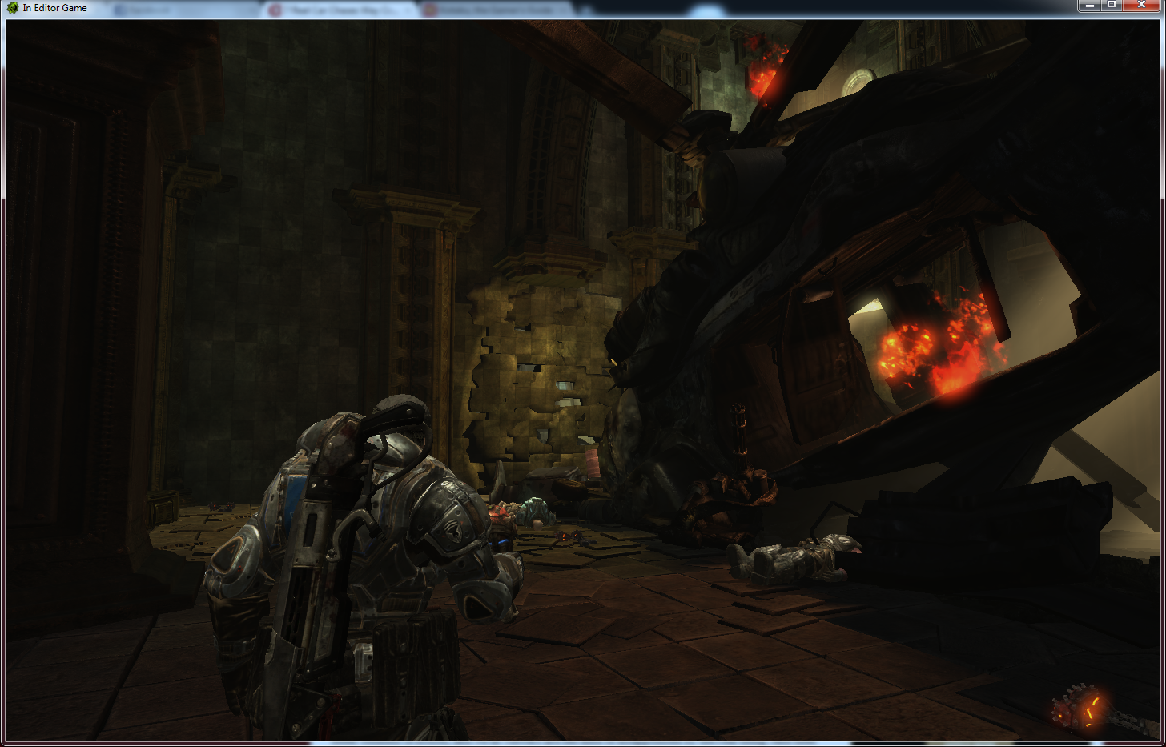

How did you break down the wall?

Was the objective in this area clear? Yes / No
If not why not?

Was it immediately apparent what was required to escape the chamber? Yes / No

Did you notice the cracks in the wall? Yes / No
If so, when did you first notice?

Were the cracks enough to indicate the wall was weak and could be destroyed?
Yes / No

Did you notice the Red barrel? Yes / No
Did it help you complete the task? Yes / No

Have you seen red barrels in other games before? Yes / No
What does a red barrel generally indicate to you?

How fun would you rate this section on a scale from 1-5, with 1 being no fun and 5 being extremely fun?
1 2 3 4 5

How would you rate the difficulty of this section on a scale from 1-5, with 1 being easy and 5 being impossible?
Easy Hard Impossible
1 2 3 4 5
AREA 2: City Streets

Please write down the letters of the objects in this scene that can be destroyed.
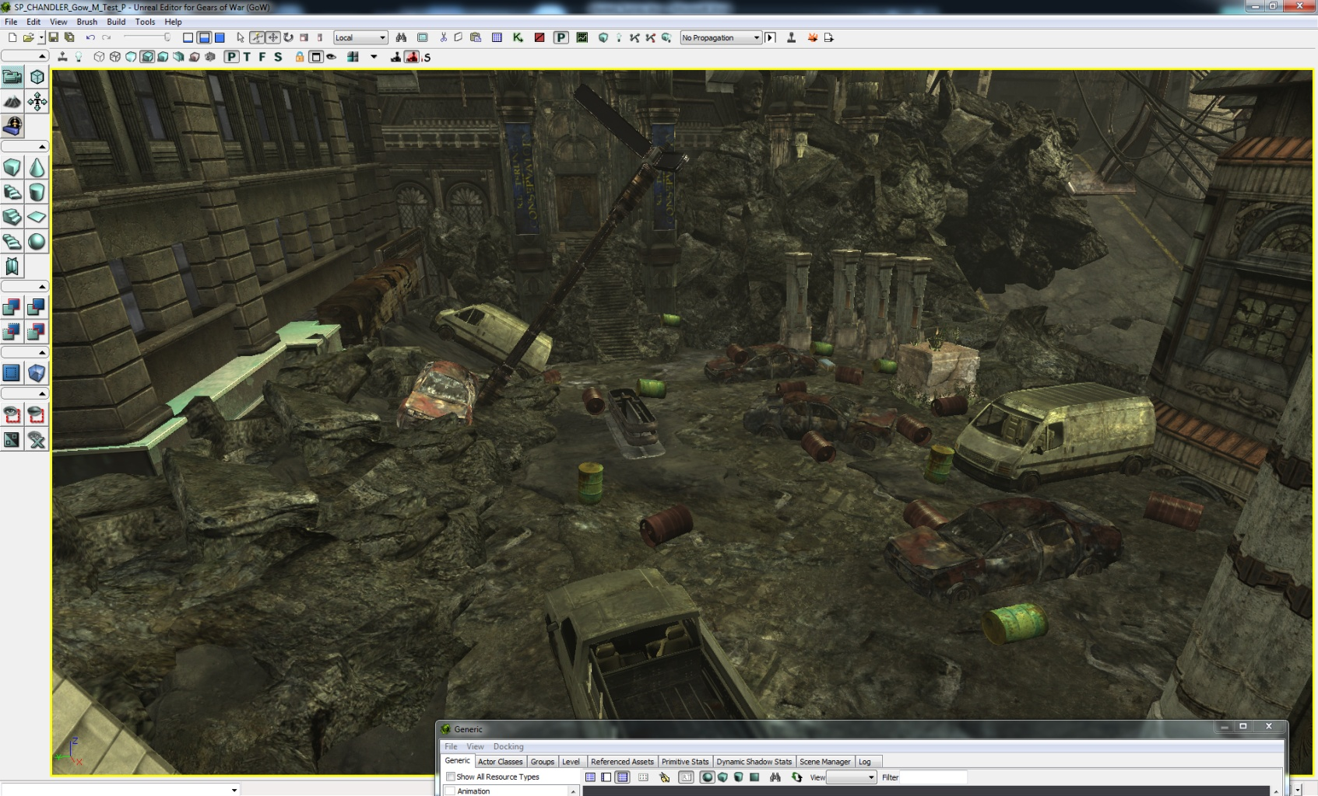
D
A
B
H
C
IO
G
E
F
Letters:

Was the objective to defeat the Locust clear? Yes / No
If not why not?

On a scale from 1-5, with 1 being easy and 5 being impossible, how would you rate the task to defeat the locust?
Easy Hard Impossible
1 2 3 4 5

Did the opening cinematic convey that the wrecked cars can be set off like explosives? Yes / No
If not, why not?

Were you able to use the explosive objects to fight the enemy. Yes / No
If so, was this easy / challenging/ impossible?

Did you ever find yourself shooting at an object expecting it to explode or fall apart and it did not?
Yes / No
If so describe what you felt when it did not react as anticipated?

Was the objective to breach the amphitheater clear and straight forward? Yes / No
If not why not?

Was there anything that indicated that door could be destroyed? Yes / No

What was your solution to breach the door?

Did you notice the door glowing at any point? Yes / No
If so, what did this indicate to you?

How fun would you rate this section on a scale from 1-5, with 1 being no fun and 5 being extremely fun?
No Fun Somewhat Fun Extremely Fun
1 2 3 4 5

How difficult would you rate this section on a scale from 1-5, with 1 being easy and 5 being impossible?
Easy Hard Impossible
1 2 3 4 5
AREA 3: Ampitheater

Please write the letters of the objects that can be destroyed below the image.
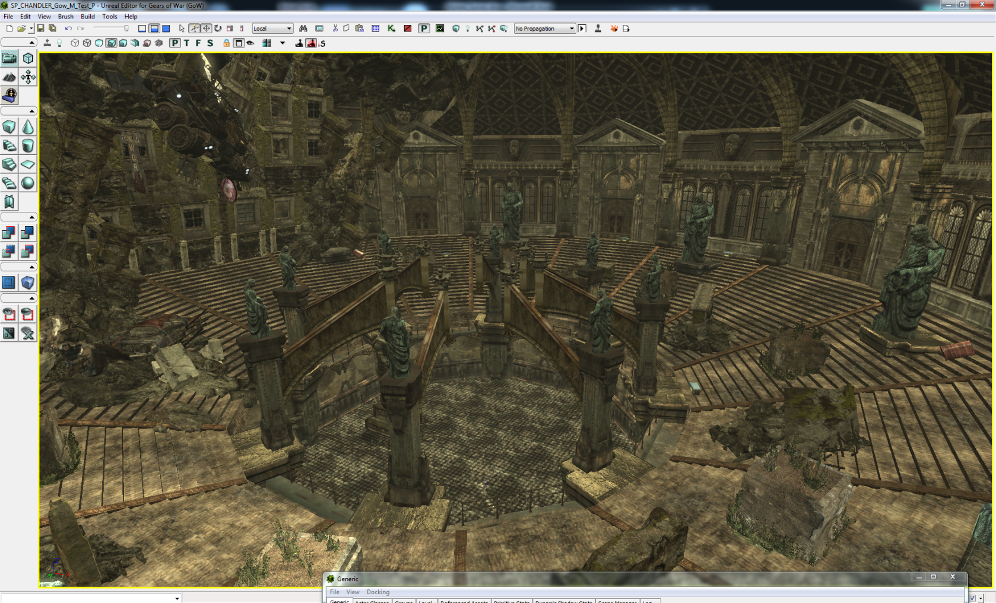
B
C
D
E
G
A
- B
F
Letters:

Was the objective to defeat the locust forces clear and straight forward? Yes / No
If not why not?

How would you rate the task to defeat the enemies on a scale from 1-5, with 1 being easy and 5 being impossible?
Easy Hard Impossible
1 2 3 4 5

Did the opening cinematic convey that the statues could be knocked over with an explosion?
Yes / No

How did you defeat the enemies and complete the objective?

Did you use the collapsing statues to defeat any of the enemies? Yes / No

Did the falling statues make completing the objective easier? Yes / No

Was the objective to defeat the Boomer clear and straight forward? Yes / No
If not why not?

How did you defeat the Boomer?

Did you notice that the central pillars fell when hit with explosives? Yes / No
If so, did they help you complete your objectives? Yes / No

Did you shoot the glowing sign? Yes / No
If so, how did you know notice it? Did you know it had a purpose?

How fun would you rate this section on a scale from 1-5, with 1 being no fun and 5 being extremely fun?
No Fun Somewhat Fun Extremely Fun
1 2 3 4 5
How difficult would you rate this section on a scale from 1-5, with 1 being easy and 5 being impossible?
Easy Hard Impossible
1 2 3 4 5

Overall Level Questions

How fun would you rate this level on a scale from 1-5, with 1 being no fun and 5 being extremely fun?
No Fun Somewhat Fun Extremely Fun
1 2 3 4 5

How difficult would you rate this level on a scale from 1-5, with 1 being easy and 5 being impossible?
Easy Hard Impossible
1 2 3 4 5

Did you notice that destructible features were a major part in helping you complete the objectives? Yes / No
If so, when did you first realize this?

Did you enjoy watching things blow up? Yes / No

Were there any frustrating moments in the level?
If so, where?

Were you able to use the destructible objects to defeat enemies? Yes / No
If so, did it make the experience more satisfying?

What did you like about the level?

Is there anything you can think of that should be changed to make the level easier or less frustrating in a particular area?

Appendix B: Testing Results

Pre-Test Survey

Name: Tester1
Age: 24
Gender: Male

Please rate your experience with Gears of War (1 being anwhere from 1-5 hours to 5 being completed the game multiple times)
1-5 hours__________________________Finished Once____________________Finished Multiple Times
1 2 3 4 5
Highlight the games genres you play the most often”
First Person Shooter
Third Person Shooter
Strategy
RPG
Casual
Action/Adventure
Puzzle
Social

What is your favorite game genre?
First Person Shooter
Third Person Shooter
Strategy
RPG
Casual
Action/Adventure
Puzzle
Social

How many hours a week do you play games (before Guildhall in the case of Guildhall students)
0 1-5 6-10 10-15 16-20 20+

If you play First Person Shooters, do you enjoy multiplayer / singleplayer more?

Multiplayer Singleplayer

What Bartle Player type are you? (If you don’t know you can take a test here.)
Achiever
Explorer
Killer
Socializer
---------------------STOP HERE AND PLAY THE LEVEL-----------------
AREA 1: Crash Site
How did you break down the wall?
Shot barrel with pistol
Was the objective in this area clear? Yes / No
If not why not?

Was it immediately apparent what was required to escape the chamber? Yes / No

Did you notice the cracks in the wall? Yes / No
If so, when did you first notice?
Cutscene
Were the cracks enough to indicate the wall was weak and could be destroyed?
Yes / No

Did you notice the Red barrel? Yes / No
Did it help you complete the task? Yes / No

Have you seen red barrels in other games before? Yes / No
What does a red barrel generally indicate to you?
Explosive object

How fun would you rate this section on a scale from 1-5, with 1 being no fun and 5 being extremely fun?
1 2 3 4 5

How would you rate the difficulty of this section on a scale from 1-5, with 1 being easy and 5 being impossible?
Easy Hard Impossible
1 2 3 4 5

AREA 2: City Streets
IO
H
G
B
A
C
E
F
D
Please write down the letters of the objects in this scene that can be destroyed.
Letters:
D
A
B
H
C
IO
G
E
F
A, B, D, E, F, I
Was the objective to defeat the Locust clear? Yes / No
If not why not?

On a scale from 1-5, with 1 being easy and 5 being impossible, how would you rate the task to defeat the locust?
Easy Hard Impossible
1 2 3 4 5

Did the opening cinematic convey that the wrecked cars can be set off like explosives? Yes / No
If not, why not?
It seemed that it was just the red barrel that had exploded.
Were you able to use the explosive objects to fight the enemy. Yes / No
If so, was this easy / challenging/ impossible?

Did you ever find yourself shooting at an object expecting it to explode or fall apart and it did not?
Yes / No
If so describe what you felt when it did not react as anticipated?
Green barrels; “oh, these don’t explode.”
Was the objective to breach the amphitheater clear and straight forward? Yes / No
If not why not?

Was there anything that indicated that door could be destroyed? Yes / No
Grenades nearby
What was your solution to breach the door?
Toss grenade at it.
Did you notice the door glowing at any point? Yes / No
If so, what did this indicate to you?
“go here”
How fun would you rate this section on a scale from 1-5, with 1 being no fun and 5 being extremely fun?
No Fun Somewhat Fun Extremely Fun
1 2 3 4 5

How difficult would you rate this section on a scale from 1-5, with 1 being easy and 5 being impossible?
Easy Hard Impossible
1 2 3 4 5
AREA 3: Ampitheater
B
A
G
F
C
D
E
Please write the letters of the objects that can be destroyed below the image.
E
A
C
D
G
F
Letters:
B, C, D, G
Was the objective to defeat the locust forces clear and straight forward? Yes / No
If not why not?

How would you rate the task to defeat the enemies on a scale from 1-5, with 1 being easy and 5 being impossible?
Easy Hard Impossible
1 2 3 4 5

Did the opening cinematic convey that the statues could be knocked over with an explosion?
Yes / No

How did you defeat the enemies and complete the objective?
Dropped a statue on one, shot the others
Did you use the collapsing statues to defeat any of the enemies? Yes / No

Did the falling statues make completing the objective easier? Yes / No

Was the objective to defeat the Boomer clear and straight forward? Yes / No
If not why not?

How did you defeat the Boomer?
Shot it a lot, that didn’t work, dropped the jeep on it.
Did you notice that the central pillars fell when hit with explosives? Yes / No
If so, did they help you complete your objectives? Yes / No

Did you shoot the glowing sign? Yes / No
If so, how did you know notice it? Did you know it had a purpose?
I knew it was a target object. Didn’t respond to hammerburst at first, so I ignored it for awhile.

How fun would you rate this section on a scale from 1-5, with 1 being no fun and 5 being extremely fun?
No Fun Somewhat Fun Extremely Fun
1 2 3 4 5
How difficult would you rate this section on a scale from 1-5, with 1 being easy and 5 being impossible?
Easy Hard Impossible
1 2 3 4 5

Overall Level Questions

How fun would you rate this level on a scale from 1-5, with 1 being no fun and 5 being extremely fun?
No Fun Somewhat Fun Extremely Fun
1 2 3 4 5

How difficult would you rate this level on a scale from 1-5, with 1 being easy and 5 being impossible?
Easy Hard Impossible
1 2 3 4 5

Did you notice that destructible features were a major part in helping you complete the objectives? Yes / No
If so, when did you first realize this?
From the beginning
Did you enjoy watching things blow up? Yes / No

Were there any frustrating moments in the level?
If so, where?
Yes, Final section. Cover felt a bit odd, and it wasn’t clear how to beat the Boomer at first since shooting it didn’t seem to work.
Were you able to use the destructible objects to defeat enemies? Yes / No
If so, did it make the experience more satisfying?
Yes
What did you like about the level?
Blowing things up and knocking them over was a nice gimmick.
Is there anything you can think of that should be changed to make the level easier or less frustrating in a particular area?
Wasn’t clear to me that cars blew up on their own, especially with so many of the explosive barrels already around.
In the final area, second wave of drones popped up behind me, and the cover felt kind of awkward—was exposed at first. And Boomer was a pain. Hammershot, etc.

Pre-Test Survey

Name: Tester 2
Age: 22
Gender: Male

Please rate your experience with Gears of War (1 being anwhere from 1-5 hours to 5 being completed the game multiple times)
1-5 hours__________________________Finished Once____________________Finished Multiple Times
1 2 3 4 5
Highlight the games genres you play the most often”
First Person Shooter
Third Person Shooter
Strategy
RPG
Casual
Action/Adventure
Puzzle
Social

What is your favorite game genre?
First Person Shooter
Third Person Shooter
Strategy
RPG
Casual
Action/Adventure
Puzzle
Social

How many hours a week do you play games (before Guildhall in the case of Guildhall students)
0 1-5 6-10 10-15 16-20 20+

If you play First Person Shooters, do you enjoy multiplayer / singleplayer more?

Multiplayer Singleplayer

What Bartle Player type are you? (If you don’t know you can take a test here.)
Achiever
Explorer
Killer
Socializer
---------------------STOP HERE AND PLAY THE LEVEL-----------------
AREA 1: Crash Site

How did you break down the wall?
I shot a barrel.
Was the objective in this area clear? Yes / No
If not why not?
“Escape the room” is a bit vague.

Was it immediately apparent what was required to escape the chamber? Yes / No

Did you notice the cracks in the wall? Yes / No
If so, when did you first notice?
After I had realized there was no doorway out.
Were the cracks enough to indicate the wall was weak and could be destroyed?
Yes / No

Did you notice the Red barrel? Yes / No
Did it help you complete the task? Yes / No

Have you seen red barrels in other games before? Yes / No
What does a red barrel generally indicate to you?
If you shoot it, it will explode.

How fun would you rate this section on a scale from 1-5, with 1 being no fun and 5 being extremely fun?
1 2 3 4 5

How would you rate the difficulty of this section on a scale from 1-5, with 1 being easy and 5 being impossible?
Easy Hard Impossible
1 2 3 4 5
AREA 2: City Streets

Please write down the letters of the objects in this scene that can be destroyed.
D
A
B
H
C
IO
G
E
F
Letters:
B E I A
Was the objective to defeat the Locust clear? Yes / No
If not why not?

On a scale from 1-5, with 1 being easy and 5 being impossible, how would you rate the task to defeat the locust?
Easy Hard Impossible
1 2 3 4 5

Did the opening cinematic convey that the wrecked cars can be set off like explosives? Yes / No
If not, why not?
All I noticed that the barrel was exploding.
Were you able to use the explosive objects to fight the enemy. Yes / No
If so, was this easy / challenging/ impossible?
No, pretty easy.
Did you ever find yourself shooting at an object expecting it to explode or fall apart and it did not?
Yes / No
If so describe what you felt when it did not react as anticipated?

Was the objective to breach the amphitheater clear and straight forward? Yes / No
If not why not?
I had no idea that the door was to an amphitheatre.
Was there anything that indicated that door could be destroyed? Yes / No
Not until it started to glow
What was your solution to breach the door?
First, I attempted to kick it down (X button), then I shot it, melee’d it, and tried to stick it with a grenade (I don’t remember if that was in the original gears). Then I threw a grenade at it.
Did you notice the door glowing at any point? Yes / No
If so, what did this indicate to you?
This was the door to the amphitheater
How fun would you rate this section on a scale from 1-5, with 1 being no fun and 5 being extremely fun?
No Fun Somewhat Fun Extremely Fun
1 2 3 4 5

How difficult would you rate this section on a scale from 1-5, with 1 being easy and 5 being impossible?
Easy Hard Impossible
1 2 3 4 5
AREA 3: Ampitheater

Please write the letters of the objects that can be destroyed below the image.
E
B
A
C
D
G
F
Letters:
A G D
Was the objective to defeat the locust forces clear and straight forward? Yes / No
If not why not?

How would you rate the task to defeat the enemies on a scale from 1-5, with 1 being easy and 5 being impossible?
Easy Hard Impossible
1 2 3 4 5

Did the opening cinematic convey that the statues could be knocked over with an explosion?
Yes / No

How did you defeat the enemies and complete the objective?
I shot them all.
Did you use the collapsing statues to defeat any of the enemies? Yes / No

Did the falling statues make completing the objective easier? Yes / No

Was the objective to defeat the Boomer clear and straight forward? Yes / No
If not why not?

How did you defeat the Boomer?
I knocked the car onto him.
Did you notice that the central pillars fell when hit with explosives? Yes / No
If so, did they help you complete your objectives? Yes / No

Did you shoot the glowing sign? Yes / No
If so, how did you know notice it? Did you know it had a purpose?
I saw it in the cutscene. I assumed it was being shown to me for a reason.

How fun would you rate this section on a scale from 1-5, with 1 being no fun and 5 being extremely fun?
No Fun Somewhat Fun Extremely Fun
1 2 3 4 5
How difficult would you rate this section on a scale from 1-5, with 1 being easy and 5 being impossible?
Easy Hard Impossible
1 2 3 4 5

Overall Level Questions

How fun would you rate this level on a scale from 1-5, with 1 being no fun and 5 being extremely fun?
No Fun Somewhat Fun Extremely Fun
1 2 3 4 5

How difficult would you rate this level on a scale from 1-5, with 1 being easy and 5 being impossible?
Easy Hard Impossible
1 2 3 4 5

Did you notice that destructible features were a major part in helping you complete the objectives? Yes / No
If so, when did you first realize this?
I thought it was just exploding barrels.
Did you enjoy watching things blow up? Yes / No

Were there any frustrating moments in the level?
If so, where?
I got killed by a statue during a cutscene. I kept getting blown up by a car I was trying to take cover behind.
Were you able to use the destructible objects to defeat enemies? Yes / No
If so, did it make the experience more satisfying?
Just barrels. Yes, it made it more satisfying.
What did you like about the level?
I liked getting the torque bow. Easily killing guys with barrels was nice.
Is there anything you can think of that should be changed to make the level easier or less frustrating in a particular area?
I had a really hard time understanding that the cars could blow up. I think it would be a good idea if you put a “y” button objective on the amphitheatre door. It would have been nice to be able to go back into the first room to grab some more grenades.

Pre-Test Survey

Name: Tester 3
Age: 22
Gender: Male

Please rate your experience with Gears of War (1 being anwhere from 1-5 hours to 5 being completed the game multiple times)
1-5 hours__________________________Finished Once____________________Finished Multiple Times
1 2 3 4 5
Highlight the games genres you play the most often”
First Person Shooter
Third Person Shooter
Strategy
RPG
Casual
Action/Adventure
Puzzle
Social

What is your favorite game genre?
First Person Shooter
Third Person Shooter
Strategy
RPG
Casual
Action/Adventure
Puzzle
Social

How many hours a week do you play games (before Guildhall in the case of Guildhall students)
0 1-5 6-10 10-15 16-20 20+

If you play First Person Shooters, do you enjoy multiplayer / singleplayer more?

Multiplayer Singleplayer

What Bartle Player type are you? (If you don’t know you can take a test here.)
Achiever
Explorer
Killer
Socializer
---------------------STOP HERE AND PLAY THE LEVEL-----------------
AREA 1: Crash Site

How did you break down the wall? Shot a barrel.

Was the objective in this area clear? Yes / No
If not why not? Yes.

Was it immediately apparent what was required to escape the chamber? Yes / No
No.

Did you notice the cracks in the wall? Yes / No
If so, when did you first notice?
Yes, but not until after exhausting all other ideas.

Were the cracks enough to indicate the wall was weak and could be destroyed?
Yes / No
Yes.

Did you notice the Red barrel? Yes / No
In passing, yes, but not as a target.
Did it help you complete the task? Yes / No
Yes, given a hint.

Have you seen red barrels in other games before? Yes / No
I vaguely recall red barrels in other games, but explosive ones generally have warning icons on them.
What does a red barrel generally indicate to you?
Something I can roll over a precipice to squash an enemy.

How fun would you rate this section on a scale from 1-5, with 1 being no fun and 5 being extremely fun?
1 2 3 4 5
2
How would you rate the difficulty of this section on a scale from 1-5, with 1 being easy and 5 being impossible?
Easy Hard Impossible
1 2 3 4 5
AREA 2: City Streets
3

Please write down the letters of the objects in this scene that can be destroyed.
D
A
B
H
C
IO
G
E
F
Letters: E

Was the objective to defeat the Locust clear? Yes / No
Yes.
If not why not?

On a scale from 1-5, with 1 being easy and 5 being impossible, how would you rate the task to defeat the locust?
Easy Hard Impossible
1 2 3 4 5
3

Did the opening cinematic convey that the wrecked cars can be set off like explosives? Yes / No
No.
If not, why not?
I probably wasn’t paying enough attention.

Were you able to use the explosive objects to fight the enemy. Yes / No
Yes.
If so, was this easy / challenging/ impossible?
Easy, on God Mode.
Did you ever find yourself shooting at an object expecting it to explode or fall apart and it did not?
Yes / No
Yes, a green barrel.
If so describe what you felt when it did not react as anticipated?
Confusion.

Was the objective to breach the amphitheater clear and straight forward? Yes / No
Yes.
If not why not?

Was there anything that indicated that door could be destroyed? Yes / No
Not really, but I would have tried anyway just because it looked like a path.
What was your solution to breach the door?
Grenade.
Did you notice the door glowing at any point? Yes / No
No.
If so, what did this indicate to you?

How fun would you rate this section on a scale from 1-5, with 1 being no fun and 5 being extremely fun?
No Fun Somewhat Fun Extremely Fun
1 2 3 4 5
4

How difficult would you rate this section on a scale from 1-5, with 1 being easy and 5 being impossible?
Easy Hard Impossible
1 2 3 4 5
3
AREA 3: Ampitheater

Please write the letters of the objects that can be destroyed below the image.
E
B
A
C
D
G
F
Letters: B

Was the objective to defeat the locust forces clear and straight forward? Yes / No
Yes.
If not why not?

How would you rate the task to defeat the enemies on a scale from 1-5, with 1 being easy and 5 being impossible?
Easy Hard Impossible
1 2 3 4 5
3

Did the opening cinematic convey that the statues could be knocked over with an explosion?
Yes / No
No, I probably wasn’t paying enough attention.

How did you defeat the enemies and complete the objective?
Sticky grenades, my pistol, and the dropping car.

Did you use the collapsing statues to defeat any of the enemies? Yes / No
No.

Did the falling statues make completing the objective easier? Yes / No
No.

Was the objective to defeat the Boomer clear and straight forward? Yes / No
Yes.
If not why not?

How did you defeat the Boomer?
Dropped the car.
Did you notice that the central pillars fell when hit with explosives? Yes / No
No.
If so, did they help you complete your objectives? Yes / No

Did you shoot the glowing sign? Yes / No
Yes.
If so, how did you know notice it? Did you know it had a purpose?
I was told... At first I was taking headshots.

How fun would you rate this section on a scale from 1-5, with 1 being no fun and 5 being extremely fun?
No Fun Somewhat Fun Extremely Fun
1 2 3 4 5
How difficult would you rate this section on a scale from 1-5, with 1 being easy and 5 being impossible?
2

Easy Hard Impossible
1 2 3 4 5
3
Overall Level Questions

How fun would you rate this level on a scale from 1-5, with 1 being no fun and 5 being extremely fun?
No Fun Somewhat Fun Extremely Fun
1 2 3 4 5
4

How difficult would you rate this level on a scale from 1-5, with 1 being easy and 5 being impossible?
Easy Hard Impossible
1 2 3 4 5
3

Did you notice that destructible features were a major part in helping you complete the objectives? Yes / No
Yes.
If so, when did you first realize this?
When I had to destroy the amphitheater door.
Did you enjoy watching things blow up? Yes / No
Yes.

Were there any frustrating moments in the level?
Yes.
If so, where?
The beginning, trying to escape.

Were you able to use the destructible objects to defeat enemies? Yes / No
Yes.
If so, did it make the experience more satisfying?
Yes.

What did you like about the level?
The shooting…

Is there anything you can think of that should be changed to make the level easier or less frustrating in a particular area?
Put warning icons on the barrels.

Pre-Test Survey

Name: Tester 4
Age: 25
Gender: male

Please rate your experience with Gears of War (1 being anwhere from 1-5 hours to 5 being completed the game multiple times)
1-5 hours__________________________Finished Once____________________Finished Multiple Times
1 2 3 4 5
Highlight the games genres you play the most often”
First Person Shooter
Third Person Shooter
Strategy
RPG
Casual
Action/Adventure
Puzzle
Social

What is your favorite game genre?
First Person Shooter
Third Person Shooter
Strategy
RPG
Casual
Action/Adventure
Puzzle
Social

How many hours a week do you play games (before Guildhall in the case of Guildhall students)
0 1-5 6-10 10-15 16-20 20+

If you play First Person Shooters, do you enjoy multiplayer / singleplayer more?

Multiplayer Singleplayer

What Bartle Player type are you? (If you don’t know you can take a test here.)
Achiever
Explorer
Killer
Socializer
---------------------STOP HERE AND PLAY THE LEVEL-----------------
AREA 1: Crash Site

How did you break down the wall? Used a Grenade

Was the objective in this area clear? Yes / No
If not why not? Honestly I did not see the first objective and forgot how to look it up. But after some exploring I noticed that it was a little different and tried shooting it but then realized how many grenades there were and tried one.

Was it immediately apparent what was required to escape the chamber? Yes / No

Did you notice the cracks in the wall? Yes / No
If so, when did you first notice? After I looked around for more guns and ammo maybe about a minute or two in the game.

Were the cracks enough to indicate the wall was weak and could be destroyed?
Yes / No

Did you notice the Red barrel? Yes / No
Did it help you complete the task? Yes / No

Have you seen red barrels in other games before? Yes / No
What does a red barrel generally indicate to you? That they explode. But honestly these barrels were not red enough for me to think that. These seem more of a rust or brown color.

How fun would you rate this section on a scale from 1-5, with 1 being no fun and 5 being extremely fun?
1 2 3 4 5

How would you rate the difficulty of this section on a scale from 1-5, with 1 being easy and 5 being impossible?
Easy Hard Impossible
1 2 3 4 5
AREA 2: City Streets

Please write down the letters of the objects in this scene that can be destroyed below the image.
A
B
H
D
C
IO
G
E
F
Letters: a b c (d if you mean the green barrel) e f g h i

Was the objective to defeat the Locust clear? Yes / No
If not why not?

On a scale from 1-5, with 1 being easy and 5 being impossible, how would you rate the task to defeat the locust?
Easy Hard Impossible
1 2 3 4 5

Did the opening cinematic convey that the wrecked cars can be set off like explosives? Yes / No
If not, why not? I guess I just did not make the connection. It seems kind of obvious looking back but I guess I did not feel threatened enough to feel I needed help from exploding stuff and thus did not file it away.

Were you able to use the explosive objects to fight the enemy. Yes / No
If so, was this easy / challenging/ impossible?

Did you ever find yourself shooting at an object expecting it to explode or fall apart and it did not?
Yes / No
If so describe what you felt when it did not react as anticipated?

Was the objective to breach the amphitheater clear and straight forward? Yes / No
If not why not?

Was there anything that indicated that door could be destroyed? Yes / No

What was your solution to breach the door? I threw a grenade at it.

Did you notice the door glowing at any point? Yes / No
If so, what did this indicate to you?

How fun would you rate this section on a scale from 1-5, with 1 being no fun and 5 being extremely fun?
No Fun Somewhat Fun Extremely Fun
1 2 3 4 5

How difficult would you rate this section on a scale from 1-5, with 1 being easy and 5 being impossible?
Easy Hard Impossible
1 2 3 4 5
AREA 3: Ampitheater

Please write the letters of the objects that can be destroyed below the image.
E
B
A
C
D
G
F
Letters: a f g

Was the objective to defeat the locust forces clear and straight forward? Yes / No
If not why not?

How would you rate the task to defeat the enemies on a scale from 1-5, with 1 being easy and 5 being impossible?
Easy Hard Impossible
1 2 3 4 5

Did the opening cinematic convey that the statues could be knocked over with an explosion?
Yes / No

How did you defeat the enemies and complete the objective? I killed the grunts by dropping statues on them and killed the boomer by shooting him with the exploding arrows

Did you use the collapsing statues to defeat any of the enemies? Yes / No

Did the falling statues make completing the objective easier? Yes / No

Was the objective to defeat the Boomer clear and straight forward? Yes / No
If not why not?

How did you defeat the Boomer? Shot him with the exploding arrows

Did you notice that the central pillars fell when hit with explosives? Yes / No
If so, did feel it doing anything to help complete your objective? Yes / No

Did you shoot the glowing sign? Yes / No
If so, how did you know notice it? Did you know it had a purpose?

How fun would you rate this section on a scale from 1-5, with 1 being no fun and 5 being extremely fun?
No Fun Somewhat Fun Extremely Fun
1 2 3 4 5
How difficult would you rate this section on a scale from 1-5, with 1 being easy and 5 being impossible?
Easy Hard Impossible
1 2 3 4 5

Overall Level Questions

How fun would you rate this level on a scale from 1-5, with 1 being no fun and 5 being extremely fun?
No Fun Somewhat Fun Extremely Fun
1 2 3 4 5

How difficult would you rate this level on a scale from 1-5, with 1 being easy and 5 being impossible?
Easy Hard Impossible
1 2 3 4 5

Did you notice that destructible features were a major part in helping you complete the objectives? Yes / No
If so, when did you first realize this? I guess in the theater when blowing up the statues. I did blow up some cars but it was by accident and did not realize it was the focus of the level.

Did you enjoy watching things blow up? Yes / No

Were there any frustrating moments in the level? No
If so, where?

Were you able to use the destructible objects to defeat enemies? Yes / No
If so, did it make the experience more satisfying? Yes

What did you like about the level? A nice short and sweet level with lots of explosions. I think the theater part would have been more fun if there had been more guys to kill. Overall a fun experience.

Is there anything you can think of that should be changed to make the level easier or less frustrating in a particular area? The first area might be frustrating for some who do not play games as much and you might want to try and highlight the wall some more.

Pre-Test Survey

Name: Tester 5
Age: 31
Gender: M

Please rate your experience with Gears of War (1 being anwhere from 1-5 hours to 5 being completed the game multiple times)
1-5 hours__________________________Finished Once____________________Finished Multiple Times
1 2 3 4 5
Highlight the games genres you play the most often”
First Person Shooter
Third Person Shooter
Strategy
RPG
Casual
Action/Adventure
Puzzle
Social

What is your favorite game genre?
First Person Shooter
Third Person Shooter
Strategy
RPG
Casual
Action/Adventure
Puzzle
Social

How many hours a week do you play games (before Guildhall in the case of Guildhall students)
0 1-5 6-10 10-15 16-20 20+

If you play First Person Shooters, do you enjoy multiplayer / singleplayer more?

Multiplayer Singleplayer

What Bartle Player type are you? (If you don’t know you can take a test here.)
Achiever
Explorer
Killer(murderer)
Socializer
---------------------STOP HERE AND PLAY THE LEVEL-----------------
AREA 1: Crash Site

How did you break down the wall?

Was the objective in this area clear? Yes / No
If not why not?

Was it immediately apparent what was required to escape the chamber? Yes / No

Did you notice the cracks in the wall? Yes / No
If so, when did you first notice?

Were the cracks enough to indicate the wall was weak and could be destroyed?
Yes / No

Did you notice the Red barrel? Yes / No
Did it help you complete the task? Yes / No

Have you seen red barrels in other games before? Yes / No
What does a red barrel generally indicate to you?

How fun would you rate this section on a scale from 1-5, with 1 being no fun and 5 being extremely fun?
1 2 3 4 5

How would you rate the difficulty of this section on a scale from 1-5, with 1 being easy and 5 being impossible?
Easy Hard Impossible
1 2 3 4 5
AREA 2: City Streets

Please write down the letters of the objects in this scene that can be destroyed.
D
A
B
H
C
IO
G
E
F
Letters:

Was the objective to defeat the Locust clear? Yes / No
If not why not?

On a scale from 1-5, with 1 being easy and 5 being impossible, how would you rate the task to defeat the locust?
Easy Hard Impossible
1 2 3 4 5

Did the opening cinematic convey that the wrecked cars can be set off like explosives? Yes / No
If not, why not?

Were you able to use the explosive objects to fight the enemy. Yes / No
If so, was this easy / challenging/ impossible?

Did you ever find yourself shooting at an object expecting it to explode or fall apart and it did not?
Yes / No
If so describe what you felt when it did not react as anticipated?

Was the objective to breach the amphitheater clear and straight forward? Yes / No
If not why not?

Was there anything that indicated that door could be destroyed? Yes / No

What was your solution to breach the door?

Did you notice the door glowing at any point? Yes / No
If so, what did this indicate to you?

How fun would you rate this section on a scale from 1-5, with 1 being no fun and 5 being extremely fun?
No Fun Somewhat Fun Extremely Fun
1 2 3 4 5

How difficult would you rate this section on a scale from 1-5, with 1 being easy and 5 being impossible?
Easy Hard Impossible
1 2 3 4 5
AREA 3: Ampitheater

Please write the letters of the objects that can be destroyed below the image.
E
B
A
C
D
G
F
Letters:

Was the objective to defeat the locust forces clear and straight forward? Yes / No
If not why not?

How would you rate the task to defeat the enemies on a scale from 1-5, with 1 being easy and 5 being impossible?
Easy Hard Impossible
1 2 3 4 5

Did the opening cinematic convey that the statues could be knocked over with an explosion?
Yes / No

How did you defeat the enemies and complete the objective?

Did you use the collapsing statues to defeat any of the enemies? Yes / No

Did the falling statues make completing the objective easier? Yes / No

Was the objective to defeat the Boomer clear and straight forward? Yes / No
If not why not?

How did you defeat the Boomer?

Did you notice that the central pillars fell when hit with explosives? Yes / No
If so, did they help you complete your objectives? Yes / No

Did you shoot the glowing sign? Yes / No
If so, how did you know notice it? Did you know it had a purpose?

How fun would you rate this section on a scale from 1-5, with 1 being no fun and 5 being extremely fun?
No Fun Somewhat Fun Extremely Fun
1 2 3 4 5
How difficult would you rate this section on a scale from 1-5, with 1 being easy and 5 being impossible?
Easy Hard Impossible
1 2 3 4 5

Overall Level Questions

How fun would you rate this level on a scale from 1-5, with 1 being no fun and 5 being extremely fun?
No Fun Somewhat Fun Extremely Fun
1 2 3 4 5

How difficult would you rate this level on a scale from 1-5, with 1 being easy and 5 being impossible?
Easy Hard Impossible
1 2 3 4 5

Did you notice that destructible features were a major part in helping you complete the objectives? Yes / No
If so, when did you first realize this?

Did you enjoy watching things blow up? Yes / No

Were there any frustrating moments in the level?
If so, where? Boomer killed me after cinematic

Were you able to use the destructible objects to defeat enemies? Yes / No
If so, did it make the experience more satisfying?

What did you like about the level?
Cinematics were well placed and conceyed the objectives well, didn’t enjoy fighting from the same cover during most fights. Needs more moving around.

Is there anything you can think of that should be changed to make the level easier or less frustrating in a particular area?

Pre-Test Survey

Name: Tester 6
Age: 30
Gender: male

Please rate your experience with Gears of War (1 being anwhere from 1-5 hours to 5 being completed the game multiple times)
1-5 hours__________________________Finished Once____________________Finished Multiple Times
1 2 3 4 5
Highlight the games genres you play the most often”
First Person Shooter
Third Person Shooter
Strategy
RPG
Casual
Action/Adventure
Puzzle
Social

What is your favorite game genre?
First Person Shooter
Third Person Shooter
Strategy
RPG
Casual
Action/Adventure
Puzzle
Social

How many hours a week do you play games (before Guildhall in the case of Guildhall students)
0 1-5 6-10 10-15 16-20 20+

If you play First Person Shooters, do you enjoy multiplayer / singleplayer more?

Multiplayer Singleplayer

What Bartle Player type are you? (If you don’t know you can take a test here.)
Achiever
Explorer
Killer
Socializer
---------------------STOP HERE AND PLAY THE LEVEL-----------------
AREA 1: Crash Site

How did you break down the wall?

Was the objective in this area clear? Yes / No
If not why not?

Was it immediately apparent what was required to escape the chamber? Yes / No

Did you notice the cracks in the wall? Yes / No
If so, when did you first notice?
After exploring the room and seeing the cracks.

Were the cracks enough to indicate the wall was weak and could be destroyed?
Yes / No

Did you notice the Red barrel? Yes / No
Did it help you complete the task? Yes / No

Have you seen red barrels in other games before? Yes / No
What does a red barrel generally indicate to you?

How fun would you rate this section on a scale from 1-5, with 1 being no fun and 5 being extremely fun?
1 2 3 4 5

How would you rate the difficulty of this section on a scale from 1-5, with 1 being easy and 5 being impossible?
Easy Hard Impossible
1 2 3 4 5
AREA 2: City Streets

Please write down the letters of the objects in this scene that can be destroyed.
D
A
B
H
C
IO
G
E
F
Letters:
E, H, B
Was the objective to defeat the Locust clear? Yes / No
If not why not?

On a scale from 1-5, with 1 being easy and 5 being impossible, how would you rate the task to defeat the locust?
Easy Hard Impossible
1 2 3 4 5

Did the opening cinematic convey that the wrecked cars can be set off like explosives? Yes / No
If not, why not?

Were you able to use the explosive objects to fight the enemy. Yes / No
If so, was this easy / challenging/ impossible? Somewhat challenging.

Did you ever find yourself shooting at an object expecting it to explode or fall apart and it did not?
Yes / No
If so describe what you felt when it did not react as anticipated?
Mild dissapointment.
Was the objective to breach the amphitheater clear and straight forward? Yes / No
If not why not?

Was there anything that indicated that door could be destroyed? Yes / No
The expectation was set by the previous use of exploding environmental objects up to this point. However that was the only apparent clue, and maybe not obvious for novice players.
What was your solution to breach the door?
Shoot it.
Did you notice the door glowing at any point? Yes / No
If so, what did this indicate to you? That the door was important.

How fun would you rate this section on a scale from 1-5, with 1 being no fun and 5 being extremely fun?
No Fun Somewhat Fun Extremely Fun
1 2 3 4 5

How difficult would you rate this section on a scale from 1-5, with 1 being easy and 5 being impossible?
Easy Hard Impossible
1 2 3 4 5
AREA 3: Ampitheater

Please write the letters of the objects that can be destroyed below the image.
E
B
A
C
D
G
F
Letters: B, G

Was the objective to defeat the locust forces clear and straight forward? Yes / No
If not why not?

How would you rate the task to defeat the enemies on a scale from 1-5, with 1 being easy and 5 being impossible?
Easy Hard Impossible
1 2 3 4 5

Did the opening cinematic convey that the statues could be knocked over with an explosion?
Yes / No

How did you defeat the enemies and complete the objective?
Destroying environmental object and shooting enemies.
Did you use the collapsing statues to defeat any of the enemies? Yes / No

Did the falling statues make completing the objective easier? Yes / No

Was the objective to defeat the Boomer clear and straight forward? Yes / No
If not why not?

How did you defeat the Boomer?
By destroying the load bearing sign.
Did you notice that the central pillars fell when hit with explosives? Yes / No
If so, did they help you complete your objectives? Yes / No

Did you shoot the glowing sign? Yes / No
If so, how did you know notice it? Did you know it had a purpose?
It was made apparent with the look at icon.

How fun would you rate this section on a scale from 1-5, with 1 being no fun and 5 being extremely fun?
No Fun Somewhat Fun Extremely Fun
1 2 3 4 5
How difficult would you rate this section on a scale from 1-5, with 1 being easy and 5 being impossible?
Easy Hard Impossible
1 2 3 4 5

Overall Level Questions

How fun would you rate this level on a scale from 1-5, with 1 being no fun and 5 being extremely fun?
No Fun Somewhat Fun Extremely Fun
1 2 3 4 5

How difficult would you rate this level on a scale from 1-5, with 1 being easy and 5 being impossible?
Easy Hard Impossible
1 2 3 4 5

Did you notice that destructible features were a major part in helping you complete the objectives? Yes / No
If so, when did you first realize this?
Immediately during the first cut scene.
Did you enjoy watching things blow up? Yes / No

Were there any frustrating moments in the level? Yes.
If so, where? The door outside and a pylon in the amphitheatre didn’t destruct as easily as I’d hoped.

Were you able to use the destructible objects to defeat enemies? Yes / No
If so, did it make the experience more satisfying? Yes, particularly the vehicle which defeated the boomer.

What did you like about the level?
Destructible objects and environments were interesting. Using the vehicle to kill the boomer was fun.
Is there anything you can think of that should be changed to make the level easier or less frustrating in a particular area?
Collision volumes could be cleaned up and tightened up a bit. The shotgun isn’t super useful during the exterior conflicts if they are attacked from the pickup truck. Enemy difficulty was unexpectedly high.

Pre-Test Survey

Name: Tester 7
Age: 28
Gender: Male

Please rate your experience with Gears of War (1 being anwhere from 1-5 hours to 5 being completed the game multiple times)
1-5 hours__________________________Finished Once____________________Finished Multiple Times
1 2 3 4 5
Highlight the games genres you play the most often”
First Person Shooter
Third Person Shooter
Strategy
RPG
Casual
Action/Adventure
Puzzle
Social

What is your favorite game genre?
First Person Shooter
Third Person Shooter
Strategy
RPG
Casual
Action/Adventure
Puzzle
Social

How many hours a week do you play games (before Guildhall in the case of Guildhall students)
0 1-5 6-10 10-15 16-20 20+

If you play First Person Shooters, do you enjoy multiplayer / singleplayer more?

Multiplayer Singleplayer

What Bartle Player type are you? (If you don’t know you can take a test here.)
Achiever
Explorer
Killer
Socializer
---------------------STOP HERE AND PLAY THE LEVEL-----------------
AREA 1: Crash Site

How did you break down the wall?
Grenades
Was the objective in this area clear? Yes / No
If not why not?

Was it immediately apparent what was required to escape the chamber? Yes / No

Did you notice the cracks in the wall? Yes / No
If so, when did you first notice?

Were the cracks enough to indicate the wall was weak and could be destroyed?
Yes / No

Did you notice the Red barrel? Yes / No
Did it help you complete the task? Yes / No

Have you seen red barrels in other games before? Yes / No
What does a red barrel generally indicate to you?
Explosions

How fun would you rate this section on a scale from 1-5, with 1 being no fun and 5 being extremely fun?
1 2 3 4 5

How would you rate the difficulty of this section on a scale from 1-5, with 1 being easy and 5 being impossible?
Easy Hard Impossible
1 2 3 4 5
AREA 2: City Streets

Please write down the letters of the objects in this scene that can be destroyed.
D
A
B
H
C
IO
G
E
F
Letters: A, C, D, F, H, I

Was the objective to defeat the Locust clear? Yes / No
If not why not?

On a scale from 1-5, with 1 being easy and 5 being impossible, how would you rate the task to defeat the locust?
Easy Hard Impossible
1 2 3 4 5

Did the opening cinematic convey that the wrecked cars can be set off like explosives? Yes / No
If not, why not?

Were you able to use the explosive objects to fight the enemy. Yes / No
If so, was this easy / challenging/ impossible?

Did you ever find yourself shooting at an object expecting it to explode or fall apart and it did not?
Yes / No
If so describe what you felt when it did not react as anticipated?
Disappointment
Was the objective to breach the amphitheater clear and straight forward? Yes / No
If not why not?

Was there anything that indicated that door could be destroyed? Yes / No

What was your solution to breach the door?
Grenades
Did you notice the door glowing at any point? Yes / No
If so, what did this indicate to you?
Interactivity with the player
How fun would you rate this section on a scale from 1-5, with 1 being no fun and 5 being extremely fun?
No Fun Somewhat Fun Extremely Fun
1 2 3 4 5

How difficult would you rate this section on a scale from 1-5, with 1 being easy and 5 being impossible?
Easy Hard Impossible
1 2 3 4 5
AREA 3: Ampitheater

Please write the letters of the objects that can be destroyed below the image.
E
B
A
C
D
G
F
Letters: B, C, D, G

Was the objective to defeat the locust forces clear and straight forward? Yes / No
If not why not?

How would you rate the task to defeat the enemies on a scale from 1-5, with 1 being easy and 5 being impossible?
Easy Hard Impossible
1 2 3 4 5

Did the opening cinematic convey that the statues could be knocked over with an explosion?
Yes / No

How did you defeat the enemies and complete the objective?
I realized quickly these enemies had heavy HP, so I used cover to block enemy fire and shoot from a distance (even with a shotgun).
Did you use the collapsing statues to defeat any of the enemies? Yes / No

Did the falling statues make completing the objective easier? Yes / No

Was the objective to defeat the Boomer clear and straight forward? Yes / No
If not why not?

How did you defeat the Boomer?
I was about to shoot the sign above, but got killed.
Did you notice that the central pillars fell when hit with explosives? Yes / No
If so, did they help you complete your objectives? Yes / No

Did you shoot the glowing sign? Yes / No (but I was about to)
If so, how did you know notice it? Did you know it had a purpose?

How fun would you rate this section on a scale from 1-5, with 1 being no fun and 5 being extremely fun?
No Fun Somewhat Fun Extremely Fun
1 2 3 4 5
How difficult would you rate this section on a scale from 1-5, with 1 being easy and 5 being impossible?
Easy Hard Impossible
1 2 3 4 5

Overall Level Questions

How fun would you rate this level on a scale from 1-5, with 1 being no fun and 5 being extremely fun?
No Fun Somewhat Fun Extremely Fun
1 2 3 4 5

How difficult would you rate this level on a scale from 1-5, with 1 being easy and 5 being impossible?
Easy Hard Impossible
1 2 3 4 5

Did you notice that destructible features were a major part in helping you complete the objectives? Yes / No
If so, when did you first realize this?

Did you enjoy watching things blow up? Yes / No

Were there any frustrating moments in the level?
If so, where?
I typically play Gears very aggressively, and charge enemies for close-combat kills. However, I realized quickly the enemies had heavy HP and this was frustrating, since it was not what I was expecting.
Were you able to use the destructible objects to defeat enemies? Yes / No
If so, did it make the experience more satisfying?
Yes
What did you like about the level?
Destructible environments, when I noticed it.
Is there anything you can think of that should be changed to make the level easier or less frustrating in a particular area?
The final part I would put more long-ranged weaponry or more cover to sneak up for close combat.

Pre-Test Survey

Name: Tester 8
Age:25
Gender:Male

Please rate your experience with Gears of War (1 being anwhere from 1-5 hours to 5 being completed the game multiple times)
1-5 hours__________________________Finished Once____________________Finished Multiple Times
1 2 3 4 5
Highlight the games genres you play the most often”
First Person Shooter
Third Person Shooter
Strategy
RPG
Casual
Action/Adventure
Puzzle
Social

What is your favorite game genre?
First Person Shooter
Third Person Shooter
Strategy
RPG
Casual
Action/Adventure
Puzzle
Social

How many hours a week do you play games (before Guildhall in the case of Guildhall students)
0 1-5 6-10 10-15 16-20 20+

If you play First Person Shooters, do you enjoy multiplayer / singleplayer more?

Multiplayer Singleplayer

What Bartle Player type are you? (If you don’t know you can take a test here.)
Achiever
Explorer
Killer
Socializer
---------------------STOP HERE AND PLAY THE LEVEL-----------------

AREA 1: Crash Site

How did you break down the wall?
Barrel

Was the objective in this area clear? Yes / No
If not why not?

Was it immediately apparent what was required to escape the chamber? Yes / No

Did you notice the cracks in the wall? Yes / No
If so, when did you first notice?

Were the cracks enough to indicate the wall was weak and could be destroyed?
Yes / No

Did you notice the Red barrel? Yes / No
Did it help you complete the task? Yes / No

Have you seen red barrels in other games before? Yes / No
What does a red barrel generally indicate to you? Cool Aid... Explosive barrel

How fun would you rate this section on a scale from 1-5, with 1 being no fun and 5 being extremely fun?
1 2 3 4 5

How would you rate the difficulty of this section on a scale from 1-5, with 1 being easy and 5 being impossible?
Easy Hard Impossible
1 2 3 4 5
AREA 2: City Streets

Please write down the letters of the objects in this scene that can be destroyed.
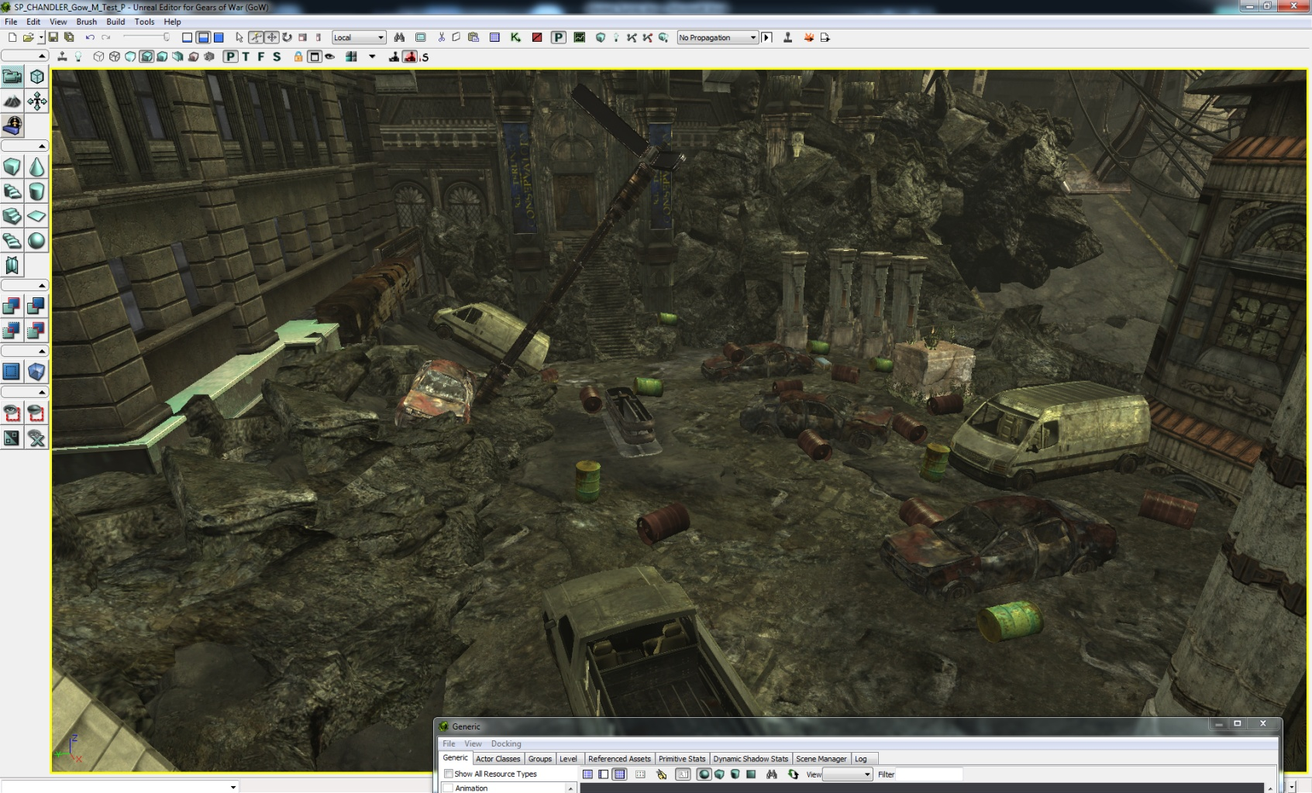
D
IO
H
G
B
A
C
E
F
Letters: ABEGHI

Was the objective to defeat the Locust clear? Yes / No
If not why not?

On a scale from 1-5, with 1 being easy and 5 being impossible, how would you rate the task to defeat the locust?
Easy Hard Impossible
1 2 3 4 5

Did the opening cinematic convey that the wrecked cars can be set off like explosives? Yes / No
If not, why not? I thought that that the barrel was the one that made the car explode

Were you able to use the explosive objects to fight the enemy. Yes / No
If so, was this easy / challenging/ impossible?

Did you ever find yourself shooting at an object expecting it to explode or fall apart and it did not?
Yes / No
If so describe what you felt when it did not react as anticipated?

Was the objective to breach the amphitheater clear and straight forward? Yes / No
If not why not? I wanted to kick through the door.

Was there anything that indicated that door could be destroyed? Yes / No
Only after it started to glow I thought of it, since everything else does
What was your solution to breach the door?
Grenade, kind of a hard throw
Did you notice the door glowing at any point? Yes / No
If so, what did this indicate to you? “DO SOMETHING HERE”

How fun would you rate this section on a scale from 1-5, with 1 being no fun and 5 being extremely fun?
No Fun Somewhat Fun Extremely Fun
1 2 3 4 5

How difficult would you rate this section on a scale from 1-5, with 1 being easy and 5 being impossible?
Easy Hard Impossible
1 2 3 4 5

AREA 3: Ampitheater

Please write the letters of the objects that can be destroyed below the image.
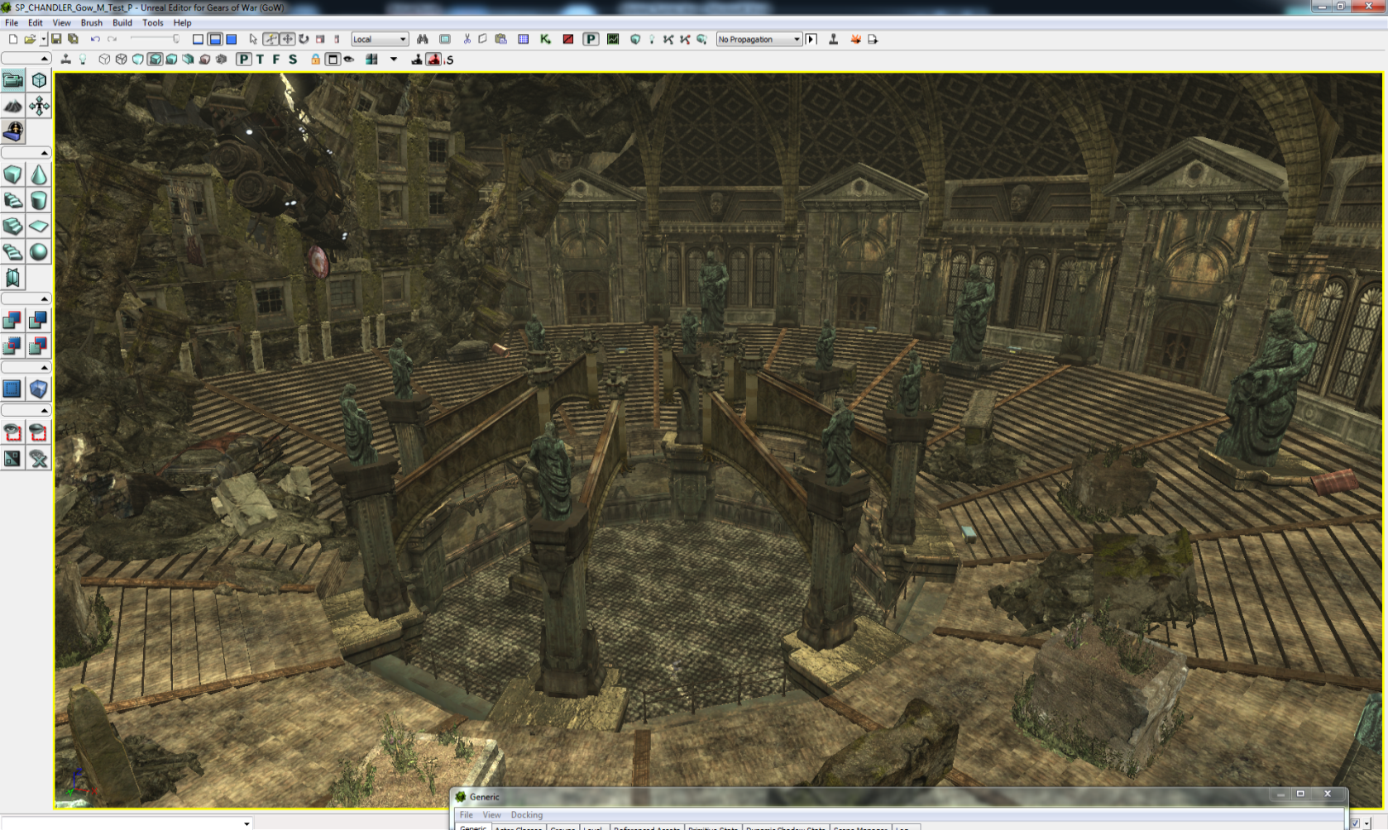
D
C
F
G
A
B
E
Letters:
BDGF
Was the objective to defeat the locust forces clear and straight forward? Yes / No
If not why not?

How would you rate the task to defeat the enemies on a scale from 1-5, with 1 being easy and 5 being impossible?
Easy Hard Impossible
1 2 3 4 5

Did the opening cinematic convey that the statues could be knocked over with an explosion?
Yes / No

How did you defeat the enemies and complete the objective?
A group with statues, another with the torque bow.
Did you use the collapsing statues to defeat any of the enemies? Yes / No

Did the falling statues make completing the objective easier? Yes / No

Was the objective to defeat the Boomer clear and straight forward? Yes / No
If not why not?

How did you defeat the Boomer?
I ran a car over him
Did you notice that the central pillars fell when hit with explosives? Yes / No
If so, did they help you complete your objectives? Yes / No

Did you shoot the glowing sign? Yes / No
If so, how did you know notice it? Did you know it had a purpose? It was glowing

How fun would you rate this section on a scale from 1-5, with 1 being no fun and 5 being extremely fun?
No Fun Somewhat Fun Extremely Fun
1 2 3 4 5
How difficult would you rate this section on a scale from 1-5, with 1 being easy and 5 being impossible?
Easy Hard Impossible
1 2 3 4 5

Overall Level Questions

How fun would you rate this level on a scale from 1-5, with 1 being no fun and 5 being extremely fun?
No Fun Somewhat Fun Extremely Fun
1 2 3 4 5

How difficult would you rate this level on a scale from 1-5, with 1 being easy and 5 being impossible?
Easy Hard Impossible
1 2 3 4 5

Did you notice that destructible features were a major part in helping you complete the objectives? Yes / No
If so, when did you first realize this? When they gave me a shotgun to fight long range...

Did you enjoy watching things blow up? Yes / No

Were there any frustrating moments in the level? Yes
If so, where?
Long range for shotgun, lack of cover, although locust where pretty bad?

Were you able to use the destructible objects to defeat enemies? Yes / No
If so, did it make the experience more satisfying? It made up for the lack of long range fire power

What did you like about the level? Hit and run the boomer

Is there anything you can think of that should be changed to make the level easier or less frustrating in a particular area?
More cover or make the cover feel more “complete”. I felt that cover wasn't really safe.

Pre-Test Survey

Name: Tester 9
Age: 24
Gender: Male

Please rate your experience with Gears of War (1 being anywhere from 1-5 hours to 5 being completed the game multiple times)
1-5 hours__________________________Finished Once____________________Finished Multiple Times
1 2 3 4 5
Highlight the games genres you play the most often”
First Person Shooter
Third Person Shooter
Strategy
RPG
Casual
Action/Adventure
Puzzle
Social

What is your favorite game genre?
First Person Shooter
Third Person Shooter
Strategy
RPG
Casual
Action/Adventure
Puzzle
Social

How many hours a week do you play games (before Guildhall in the case of Guildhall students)
0 1-5 6-10 10-15 16-20 20+

If you play First Person Shooters, do you enjoy multiplayer / singleplayer more?

Multiplayer Singleplayer

What Bartle Player type are you? (If you don’t know you can take a test here.)
Achiever
Explorer
Killer
Socializer
---------------------STOP HERE AND PLAY THE LEVEL-----------------
AREA 1: Crash Site

How did you break down the wall?
Shot the red barrel
Was the objective in this area clear? Yes / No
If not why not?

Was it immediately apparent what was required to escape the chamber? Yes / No

Did you notice the cracks in the wall? Yes / No
If so, when did you first notice?
Almost right away
Were the cracks enough to indicate the wall was weak and could be destroyed?
Yes / No

Did you notice the Red barrel? Yes / No
Did it help you complete the task? Yes / No

Have you seen red barrels in other games before? Yes / No
What does a red barrel generally indicate to you?
Most likely an explosion will occur

How fun would you rate this section on a scale from 1-5, with 1 being no fun and 5 being extremely fun?
1 2 3 4 5

How would you rate the difficulty of this section on a scale from 1-5, with 1 being easy and 5 being impossible?
Easy Hard Impossible
1 2 3 4 5
AREA 2: City Streets

Please write down the letters of the objects in this scene that can be destroyed.
D
A
B
H
C
IO
G
E
F
Letters:
E, C, D, I
Was the objective to defeat the Locust clear? Yes / No
If not why not?

On a scale from 1-5, with 1 being easy and 5 being impossible, how would you rate the task to defeat the locust?
Easy Hard Impossible
1 2 3 4 5

Did the opening cinematic convey that the wrecked cars can be set off like explosives? Yes / No
If not, why not?

Were you able to use the explosive objects to fight the enemy. Yes / No
If so, was this easy / challenging/ impossible?
Failry easily, but I mostly used grenades since there were so many of them. Didn’t seem as if exploding the barrels was necessary.
Did you ever find yourself shooting at an object expecting it to explode or fall apart and it did not?
Yes / No
If so describe what you felt when it did not react as anticipated?

Was the objective to breach the amphitheater clear and straight forward? Yes / No
If not why not?

Was there anything that indicated that door could be destroyed? Yes / No

What was your solution to breach the door?
Grenade
Did you notice the door glowing at any point? Yes / No
If so, what did this indicate to you?
A point of interest
How fun would you rate this section on a scale from 1-5, with 1 being no fun and 5 being extremely fun?
No Fun Somewhat Fun Extremely Fun
1 2 3 4 5

How difficult would you rate this section on a scale from 1-5, with 1 being easy and 5 being impossible?
Easy Hard Impossible
1 2 3 4 5
AREA 3: Ampitheater

Please write the letters of the objects that can be destroyed below the image.
E
B
A
C
D
G
F
Letters:
C, D, E, G, F
Was the objective to defeat the locust forces clear and straight forward? Yes / No
If not why not?

How would you rate the task to defeat the enemies on a scale from 1-5, with 1 being easy and 5 being impossible?
Easy Hard Impossible
1 2 3 4 5

Did the opening cinematic convey that the statues could be knocked over with an explosion?
Yes / No

How did you defeat the enemies and complete the objective?
Used grenades
Did you use the collapsing statues to defeat any of the enemies? Yes / No

Did the falling statues make completing the objective easier? Yes / No

Was the objective to defeat the Boomer clear and straight forward? Yes / No
If not why not?

How did you defeat the Boomer?
Torque bow to the face
Did you notice that the central pillars fell when hit with explosives? Yes / No
If so, did they help you complete your objectives? Yes / No

Did you shoot the glowing sign? Yes / No
If so, how did you know notice it? Did you know it had a purpose?

How fun would you rate this section on a scale from 1-5, with 1 being no fun and 5 being extremely fun?
No Fun Somewhat Fun Extremely Fun
1 2 3 4 5
How difficult would you rate this section on a scale from 1-5, with 1 being easy and 5 being impossible?
Easy Hard Impossible
1 2 3 4 5

Overall Level Questions

How fun would you rate this level on a scale from 1-5, with 1 being no fun and 5 being extremely fun?
No Fun Somewhat Fun Extremely Fun
1 2 3 4 5

How difficult would you rate this level on a scale from 1-5, with 1 being easy and 5 being impossible?
Easy Hard Impossible
1 2 3 4 5

Did you notice that destructible features were a major part in helping you complete the objectives? Yes / No
If so, when did you first realize this?
Level intro
Did you enjoy watching things blow up? Yes / No

Were there any frustrating moments in the level?
No
If so, where?

Were you able to use the destructible objects to defeat enemies? Yes / No
If so, did it make the experience more satisfying?
Yes
What did you like about the level?
Thoroughly enjoyed all of the explodable objects in the level. I didn’t really use them as much as I would have liked though. I think if I played the level a second time I probably would have tried to explode more objects and see their effectiveness in killing Locust.

Is there anything you can think of that should be changed to make the level easier or less frustrating in a particular area?
Less grenades would have probably caused me to use the explosive objects more.

Pre-Test Survey

Name: Tester 10
Age: 32
Gender: Male

Please rate your experience with Gears of War (1 being anwhere from 1-5 hours to 5 being completed the game multiple times)
1-5 hours__________________________Finished Once____________________Finished Multiple Times
1 2 3 4 5
Highlight the games genres you play the most often”
First Person Shooter
Third Person Shooter
Strategy
RPG
Casual
Action/Adventure
Puzzle
Social

What is your favorite game genre?
First Person Shooter
Third Person Shooter
Strategy
RPG
Casual
Action/Adventure
Puzzle
Social

How many hours a week do you play games (before Guildhall in the case of Guildhall students)
0 1-5 6-10 10-15 16-20 20+

If you play First Person Shooters, do you enjoy multiplayer / singleplayer more?

Multiplayer Singleplayer

What Bartle Player type are you? (If you don’t know you can take a test here.)
Achiever
Explorer
Killer
Socializer
---------------------STOP HERE AND PLAY THE LEVEL-----------------
AREA 1: Crash Site

How did you break down the wall? I used the provided mechanic of exploding barrels to damage the wall, conserving ammo (grenades)

Was the objective in this area clear? Yes / No
If not why not?

Was it immediately apparent what was required to escape the chamber? Yes / No

Did you notice the cracks in the wall? Yes / No
If so, when did you first notice? First noticed it through the very first appearance of them during the opening cinematic.

Were the cracks enough to indicate the wall was weak and could be destroyed?
Yes / No

Did you notice the Red barrel? Yes / No
Did it help you complete the task? Yes / No

Have you seen red barrels in other games before? Yes / No
What does a red barrel generally indicate to you? Something explosive.

How fun would you rate this section on a scale from 1-5, with 1 being no fun and 5 being extremely fun?
1 2 3 4 5

How would you rate the difficulty of this section on a scale from 1-5, with 1 being easy and 5 being impossible?
Easy Hard Impossible
1 2 3 4 5
AREA 2: City Streets

Please write down the letters of the objects in this scene that can be destroyed.
D
A
B
H
C
IO
G
E
F
Letters: B, H, E, I,

Was the objective to defeat the Locust clear? Yes / No
If not why not?

On a scale from 1-5, with 1 being easy and 5 being impossible, how would you rate the task to defeat the locust?
Easy Hard Impossible
1 2 3 4 5

Did the opening cinematic convey that the wrecked cars can be set off like explosives? Yes / No
If not, why not?

Were you able to use the explosive objects to fight the enemy. Yes / No
If so, was this easy / challenging/ impossible?

Did you ever find yourself shooting at an object expecting it to explode or fall apart and it did not?
Yes / No
If so describe what you felt when it did not react as anticipated? Both inquisitive and a relief because I was near the green barrels and I didn’t want to die by my own shots or enemy shots.

Was the objective to breach the amphitheater clear and straight forward? Yes / No
If not why not?

Was there anything that indicated that door could be destroyed? Yes / No

What was your solution to breach the door? Other than the objective telling me to ‘breach’ the door, which usually meant explosives, I used a grenade.

Did you notice the door glowing at any point? Yes / No
If so, what did this indicate to you? To me, the glowing door meant something to focus on, an objective.

How fun would you rate this section on a scale from 1-5, with 1 being no fun and 5 being extremely fun?
No Fun Somewhat Fun Extremely Fun
1 2 3 4 5

How difficult would you rate this section on a scale from 1-5, with 1 being easy and 5 being impossible?
Easy Hard Impossible
1 2 3 4 5
AREA 3: Ampitheater

Please write the letters of the objects that can be destroyed below the image.
E
B
A
C
D
G
F
Letters: B, C, D, G, F

Was the objective to defeat the locust forces clear and straight forward? Yes / No
If not why not?

How would you rate the task to defeat the enemies on a scale from 1-5, with 1 being easy and 5 being impossible?
Easy Hard Impossible
1 2 3 4 5

Did the opening cinematic convey that the statues could be knocked over with an explosion?
Yes / No

How did you defeat the enemies and complete the objective? If I had no explosives on me, I’d charge them with the shotgun, and shoot them from behind cover. If I had explosives and a torque bow, I’d try to shoot the cover they are on, or a statue.

Did you use the collapsing statues to defeat any of the enemies? Yes / No

Did the falling statues make completing the objective easier? Yes / No

Was the objective to defeat the Boomer clear and straight forward? Yes / No
If not why not?

How did you defeat the Boomer? Shot him in the head with the torque bow.

Did you notice that the central pillars fell when hit with explosives? Yes / No
If so, did they help you complete your objectives? Yes / No

Did you shoot the glowing sign? Yes / No
If so, how did you know notice it? Did you know it had a purpose?
I saw the sign in the very first cinematic… I assumed it might let the car drop ontop of the boomer, but after missing once, I chose just to shoot the boomer in the head with the torque bow.

How fun would you rate this section on a scale from 1-5, with 1 being no fun and 5 being extremely fun?
No Fun Somewhat Fun Extremely Fun
1 2 3 3.5 4 5
How difficult would you rate this section on a scale from 1-5, with 1 being easy and 5 being impossible?
Easy Hard Impossible
1 2 3 4 5

Overall Level Questions

How fun would you rate this level on a scale from 1-5, with 1 being no fun and 5 being extremely fun?
No Fun Somewhat Fun Extremely Fun
1 2 3 3.5 4 5

How difficult would you rate this level on a scale from 1-5, with 1 being easy and 5 being impossible?
Easy Hard Impossible
1 2 3 4 5

Did you notice that destructible features were a major part in helping you complete the objectives? Yes / No
If so, when did you first realize this?
I understood that destructible cover and explosive features are part of the design, but I didn’t seem or felt I needed to use them. How ever , playing it, and testing the features, are fun.

Did you enjoy watching things blow up? Yes / No

Were there any frustrating moments in the level? Nah only when I wanted to pick up a torque bow and got hit by the boomer.
If so, where?

Were you able to use the destructible objects to defeat enemies? Yes / No
If so, did it make the experience more satisfying? It does enhance the game play experience.

What did you like about the level?
I enjoyed most the chain reaction of barrels that would detonate and eventually gib the enemy.

Is there anything you can think of that should be changed to make the level easier or less frustrating in a particular area?
To really convey the use of only explosives… and destructible terrain, I’d force the boomer to only take a certain damage type that the ‘car’ or other falling debris’ could cause on him… likewise for some other enemies… ensure the only way to kill them is by destroying the environment if possible.

Pre-Test Survey

Name: Tester 11
Age: 24
Gender: M

Please rate your experience with Gears of War (1 being anwhere from 1-5 hours to 5 being completed the game multiple times)
1-5 hours__________________________Finished Once____________________Finished Multiple Times
1 2 3 4 5
Highlight the games genres you play the most often”
First Person Shooter
Third Person Shooter
Strategy
RPG
Casual
Action/Adventure
Puzzle
Social

What is your favorite game genre?
First Person Shooter
Third Person Shooter
Strategy
RPG
Casual
Action/Adventure
Puzzle
Social

How many hours a week do you play games (before Guildhall in the case of Guildhall students)
0 1-5 6-10 10-15 16-20 20+

If you play First Person Shooters, do you enjoy multiplayer / singleplayer more?

Multiplayer Singleplayer

What Bartle Player type are you? (If you don’t know you can take a test here.)
Achiever
Explorer
Killer
Socializer
---------------------STOP HERE AND PLAY THE LEVEL-----------------
AREA 1: Crash Site

How did you break down the wall?
Shooting the red barrel
Was the objective in this area clear? Yes / No
If not why not?

Was it immediately apparent what was required to escape the chamber? Yes / No

Did you notice the cracks in the wall? Yes / No
If so, when did you first notice?

Were the cracks enough to indicate the wall was weak and could be destroyed?
Yes / No
Did not notice

Did you notice the Red barrel? Yes / No
Did it help you complete the task? Yes / No

Have you seen red barrels in other games before? Yes / No
What does a red barrel generally indicate to you?
Explode mode

How fun would you rate this section on a scale from 1-5, with 1 being no fun and 5 being extremely fun?
1 2 3 4 5
How would you rate the difficulty of this section on a scale from 1-5, with 1 being easy and 5 being impossible?
Easy Hard Impossible
1 2 3 4 5
AREA 2: City Streets

Please write down the letters of the objects in this scene that can be destroyed.
D
A
B
H
C
IO
G
E
F
Letters: E

Was the objective to defeat the Locust clear? Yes / No
If not why not?

On a scale from 1-5, with 1 being easy and 5 being impossible, how would you rate the task to defeat the locust?
Easy Hard Impossible
1 2 3 4 5

Did the opening cinematic convey that the wrecked cars can be set off like explosives? Yes / No
If not, why not? Thought the barrel was exploding, not the car

Were you able to use the explosive objects to fight the enemy. Yes / No
If so, was this easy / challenging/ impossible?

Did you ever find yourself shooting at an object expecting it to explode or fall apart and it did not?
Yes / No
If so describe what you felt when it did not react as anticipated? Confused as to why the green barrels did not explode into acid or whatnot

Was the objective to breach the amphitheater clear and straight forward? Yes / No
If not why not?

Was there anything that indicated that door could be destroyed? Yes / No

What was your solution to breach the door? Threw a grenade at it. First grenade bounced off and confused me.

Did you notice the door glowing at any point? Yes / No
If so, what did this indicate to you?

How fun would you rate this section on a scale from 1-5, with 1 being no fun and 5 being extremely fun?
No Fun Somewhat Fun Extremely Fun
1 2 3 4 5

How difficult would you rate this section on a scale from 1-5, with 1 being easy and 5 being impossible?
Easy Hard Impossible
1 2 3 4 5
AREA 3: Ampitheater

Please write the letters of the objects that can be destroyed below the image.
E
B
A
C
D
G
F
Letters: B

Was the objective to defeat the locust forces clear and straight forward? Yes / No
If not why not?

How would you rate the task to defeat the enemies on a scale from 1-5, with 1 being easy and 5 being impossible?
Easy Hard Impossible
1 2 3 4 5

Did the opening cinematic convey that the statues could be knocked over with an explosion?
Yes / No

How did you defeat the enemies and complete the objective? Shotgun + head

Did you use the collapsing statues to defeat any of the enemies? Yes / No

Did the falling statues make completing the objective easier? Yes / No NA

Was the objective to defeat the Boomer clear and straight forward? Yes / No
If not why not?

How did you defeat the Boomer? Dropping a car on him

Did you notice that the central pillars fell when hit with explosives? Yes / No
If so, did they help you complete your objectives? Yes / No

Did you shoot the glowing sign? Yes / No
If so, how did you know notice it? Did you know it had a purpose? Glowing, looked like it was holding up the car.

How fun would you rate this section on a scale from 1-5, with 1 being no fun and 5 being extremely fun?
No Fun Somewhat Fun Extremely Fun
1 2 3 4 5
How difficult would you rate this section on a scale from 1-5, with 1 being easy and 5 being impossible?
Easy Hard Impossible
1 2 3 4 5

Overall Level Questions

How fun would you rate this level on a scale from 1-5, with 1 being no fun and 5 being extremely fun?
No Fun Somewhat Fun Extremely Fun
1 2 3 4 5

How difficult would you rate this level on a scale from 1-5, with 1 being easy and 5 being impossible?
Easy Hard Impossible
1 2 3 4 5

Did you notice that destructible features were a major part in helping you complete the objectives? Yes / No
If so, when did you first realize this?

Did you enjoy watching things blow up? Yes / No

Were there any frustrating moments in the level?
If so, where? Initial combat was frustrating due to lack of cover and no Lancer, and getting in close with the shotgun got me killed.

Were you able to use the destructible objects to defeat enemies? Yes / No
If so, did it make the experience more satisfying? Barrels made it much more satisfying

What did you like about the level?
The car-kills-boomer part was really cool, though the POV was a bit weird.

Is there anything you can think of that should be changed to make the level easier or less frustrating in a particular area?
More cover in the initial fight, a longer-ranged weapon.

Pre-Test Survey

Name: Tester 12
Age:28
Gender:male

Please rate your experience with Gears of War (1 being anwhere from 1-5 hours to 5 being completed the game multiple times)
1-5 hours__________________________Finished Once____________________Finished Multiple Times
1 2 3 4 5
Highlight the games genres you play the most often”
First Person Shooter
Third Person Shooter
Strategy
RPG
Casual
Action/Adventure
Puzzle
Social

What is your favorite game genre?
First Person Shooter
Third Person Shooter
Strategy
RPG
Casual
Action/Adventure
Puzzle
Social

How many hours a week do you play games (before Guildhall in the case of Guildhall students)
0 1-5 6-10 10-15 16-20 20+

If you play First Person Shooters, do you enjoy multiplayer / singleplayer more?

Multiplayer Singleplayer

What Bartle Player type are you? (If you don’t know you can take a test here.)
Achiever
Explorer
Killer
Socializer
---------------------STOP HERE AND PLAY THE LEVEL-----------------

AREA 1: Crash Site

How did you break down the wall?
Shot at the exploding Barrel

Was the objective in this area clear? Yes / No
If not why not?

Was it immediately apparent what was required to escape the chamber? Yes / No

Did you notice the cracks in the wall? Yes / No
If so, when did you first notice?

Were the cracks enough to indicate the wall was weak and could be destroyed?
Yes / No

Did you notice the Red barrel? Yes / No
Did it help you complete the task? Yes / No

Have you seen red barrels in other games before? Yes / No
What does a red barrel generally indicate to you?

How fun would you rate this section on a scale from 1-5, with 1 being no fun and 5 being extremely fun?
1 2 3 4 5

How would you rate the difficulty of this section on a scale from 1-5, with 1 being easy and 5 being impossible?
Easy Hard Impossible
1 2 3 4 5
AREA 2: City Streets

Please write down the letters of the objects in this scene that can be destroyed.
D
IO
H
G
B
A
C
E
F
Letters: BEGI

Was the objective to defeat the Locust clear? Yes / No
If not why not?

On a scale from 1-5, with 1 being easy and 5 being impossible, how would you rate the task to defeat the locust?
Easy Hard Impossible
1 2 3 4 5

Did the opening cinematic convey that the wrecked cars can be set off like explosives? Yes / No
If not, why not?

Were you able to use the explosive objects to fight the enemy. Yes / No
If so, was this easy / challenging/ impossible?

Did you ever find yourself shooting at an object expecting it to explode or fall apart and it did not?
Yes / No
If so describe what you felt when it did not react as anticipated?

Was the objective to breach the amphitheater clear and straight forward? Yes / No
If not why not?
But I did remember that the cinamtic said something about breaching the door so after a bit of hesitation I was able to guess that I needed to do something to the door to progress
Was there anything that indicated that door could be destroyed? Yes / No
Except the text at one point I think
What was your solution to breach the door?
Shoot the door with the cross-bow
Did you notice the door glowing at any point? Yes / No
If so, what did this indicate to you?

How fun would you rate this section on a scale from 1-5, with 1 being no fun and 5 being extremely fun?
No Fun Somewhat Fun Extremely Fun
1 2 3 4 5

How difficult would you rate this section on a scale from 1-5, with 1 being easy and 5 being impossible?
Easy Hard Impossible
1 2 3 4 5

AREA 3: Ampitheater

Please write the letters of the objects that can be destroyed below the image.
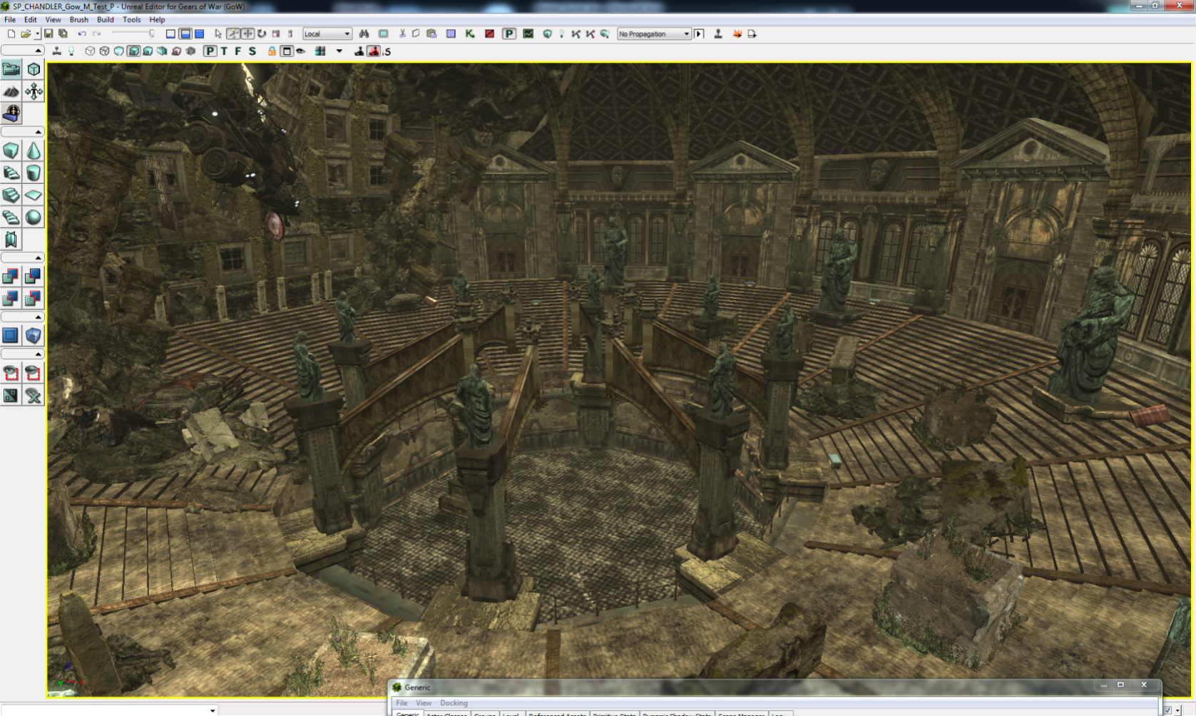
D
C
F
G
A
B
E
Letters: B, D,C,G

Was the objective to defeat the locust forces clear and straight forward? Yes / No
If not why not?

How would you rate the task to defeat the enemies on a scale from 1-5, with 1 being easy and 5 being impossible?
Easy Hard Impossible
1 2 3 4 5

Did the opening cinematic convey that the statues could be knocked over with an explosion?
Yes / No

How did you defeat the enemies and complete the objective?
Melee the Locust , then shot I the bulleyes of the truck
Did you use the collapsing statues to defeat any of the enemies? Yes / No

Did the falling statues make completing the objective easier? Yes / No

Was the objective to defeat the Boomer clear and straight forward? Yes / No
If not why not?

How did you defeat the Boomer?
Dropping the truck on him
Did you notice that the central pillars fell when hit with explosives? Yes / No
If so, did they help you complete your objectives? Yes / No

Did you shoot the glowing sign? Yes / No
If so, how did you know notice it? Did you know it had a purpose?

How fun would you rate this section on a scale from 1-5, with 1 being no fun and 5 being extremely fun?
No Fun Somewhat Fun Extremely Fun
1 2 3 4 5
How difficult would you rate this section on a scale from 1-5, with 1 being easy and 5 being impossible?
Easy Hard Impossible
1 2 3 4 5

Overall Level Questions

How fun would you rate this level on a scale from 1-5, with 1 being no fun and 5 being extremely fun?
No Fun Somewhat Fun Extremely Fun
1 2 3 4 5

How difficult would you rate this level on a scale from 1-5, with 1 being easy and 5 being impossible?
Easy Hard Impossible
1 2 3 4 5

Did you notice that destructible features were a major part in helping you complete the objectives? Yes / No
If so, when did you first realize this?

Did you enjoy watching things blow up? Yes / No

Were there any frustrating moments in the level?
If so, where?

Were you able to use the destructible objects to defeat enemies? Yes / No
If so, did it make the experience more satisfying? Yes

What did you like about the level?
Also the abundance of exploding barrels in section fun was cool, I’d rather kill things quick, then grinding them down.
The cinamatic were cool spefically the helicopter dropping from the ceiling and also when the Boomer was trampled by the hanging jeep in First Person, very cool.
Is there anything you can think of that should be changed to make the level easier or less frustrating in a particular area?
The ampahthieter door was diffcult to know that I needed to blow up instead of just open

Pre-Test Survey

Name: Tester 13
Age: 32
Gender: M

Please rate your experience with Gears of War (1 being anwhere from 1-5 hours to 5 being completed the game multiple times)
1-5 hours__________________________Finished Once____________________Finished Multiple Times
1 2 3 4 5
Highlight the games genres you play the most often”
First Person Shooter
Third Person Shooter
Strategy
RPG
Casual
Action/Adventure
Puzzle
Social

What is your favorite game genre?
First Person Shooter
Third Person Shooter
Strategy
RPG
Casual
Action/Adventure
Puzzle
Social

How many hours a week do you play games (before Guildhall in the case of Guildhall students)
0 1-5 6-10 10-15 16-20 20+

If you play First Person Shooters, do you enjoy multiplayer / singleplayer more?

Multiplayer Singleplayer

What Bartle Player type are you? (If you don’t know you can take a test here.)
Achiever
Explorer
Killer
Socializer
---------------------STOP HERE AND PLAY THE LEVEL-----------------
AREA 1: Crash Site

How did you break down the wall?
I used the exploding barrel

Was the objective in this area clear? Yes / No
If not why not?

Was it immediately apparent what was required to escape the chamber? Yes / No

Did you notice the cracks in the wall? Yes / No
If so, when did you first notice?
After inspecting the area maybe 20 seconds in to the level.
Were the cracks enough to indicate the wall was weak and could be destroyed?
Yes / No

Did you notice the Red barrel? Yes / No
Did it help you complete the task? Yes / No

Have you seen red barrels in other games before? Yes / No
What does a red barrel generally indicate to you?
That the barrel is explosive

How fun would you rate this section on a scale from 1-5, with 1 being no fun and 5 being extremely fun?
1 2 3 4 5

How would you rate the difficulty of this section on a scale from 1-5, with 1 being easy and 5 being impossible?
Easy Hard Impossible
1 2 3 4 5
AREA 2: City Streets

Please write down the letters of the objects in this scene that can be destroyed.
D
A
B
H
C
IO
G
E
F
Letters:
B, E, I
Was the objective to defeat the Locust clear? Yes / No
If not why not?

On a scale from 1-5, with 1 being easy and 5 being impossible, how would you rate the task to defeat the locust?
Easy Hard Impossible
1 2 3 4 5

Did the opening cinematic convey that the wrecked cars can be set off like explosives? Yes / No
If not, why not?

Were you able to use the explosive objects to fight the enemy. Yes / No
If so, was this easy / challenging/ impossible?

Did you ever find yourself shooting at an object expecting it to explode or fall apart and it did not?
Yes / No
If so describe what you felt when it did not react as anticipated?
Tried to shoot at the green barrels. They did not explode. I thought maybe they were poison because of the color association.
Was the objective to breach the amphitheater clear and straight forward? Yes / No
If not why not?
There wasn’t a POI pointing towards the door, however I surmised that the door was the amphitheater door and noticed I could see through the doors between a small slit between the doors.
Was there anything that indicated that door could be destroyed? Yes / No

What was your solution to breach the door?
Throw a grenade at the door
Did you notice the door glowing at any point? Yes / No
If so, what did this indicate to you?

How fun would you rate this section on a scale from 1-5, with 1 being no fun and 5 being extremely fun?
No Fun Somewhat Fun Extremely Fun
1 2 3 4 5

How difficult would you rate this section on a scale from 1-5, with 1 being easy and 5 being impossible?
Easy Hard Impossible
1 2 3 4 5
AREA 3: Ampitheater

Please write the letters of the objects that can be destroyed below the image.
E
B
A
C
D
G
F
Letters:
B, F, G
Was the objective to defeat the locust forces clear and straight forward? Yes / No
If not why not?

How would you rate the task to defeat the enemies on a scale from 1-5, with 1 being easy and 5 being impossible?
Easy Hard Impossible
1 2 3 4 5

Did the opening cinematic convey that the statues could be knocked over with an explosion?
Yes / No

How did you defeat the enemies and complete the objective?
Used the statues. Knocked over the statues with grenades
Did you use the collapsing statues to defeat any of the enemies? Yes / No

Did the falling statues make completing the objective easier? Yes / No

Was the objective to defeat the Boomer clear and straight forward? Yes / No
If not why not?

How did you defeat the Boomer?
Picked up a torque bow and shot the sigh holding up the truck
Did you notice that the central pillars fell when hit with explosives? Yes / No
If so, did they help you complete your objectives? Yes / No
N/A
Did you shoot the glowing sign? Yes / No
If so, how did you know notice it? Did you know it had a purpose?
It seemed logical. The sign coloration drew my attention immediately.

How fun would you rate this section on a scale from 1-5, with 1 being no fun and 5 being extremely fun?
No Fun Somewhat Fun Extremely Fun
1 2 3 4 5
How difficult would you rate this section on a scale from 1-5, with 1 being easy and 5 being impossible?
Easy Hard Impossible
1 2 3 4 5

Overall Level Questions

How fun would you rate this level on a scale from 1-5, with 1 being no fun and 5 being extremely fun?
No Fun Somewhat Fun Extremely Fun
1 2 3 4 5

How difficult would you rate this level on a scale from 1-5, with 1 being easy and 5 being impossible?
Easy Hard Impossible
1 2 3 4 5

Did you notice that destructible features were a major part in helping you complete the objectives? Yes / No
If so, when did you first realize this?
During the very first encounter
Did you enjoy watching things blow up? Yes / No

Were there any frustrating moments in the level?
If so, where?
Yes. The theron guard that emerges (second encounter) is challenging.

Were you able to use the destructible objects to defeat enemies? Yes / No
If so, did it make the experience more satisfying?
Yes.
What did you like about the level?
It is satisfying to see enemies exploded or crushed as a result of action that I’ve taken during the game.
The lighting looked great.
Lots of grenades and explosive weapons including the explosiove barrels!

Is there anything you can think of that should be changed to make the level easier or less frustrating in a particular area?
The Theron Guard that emerges during the second encounter might be too much.

Pre-Test Survey

Name: Tester 14
Age: 20
Gender: M

Please rate your experience with Gears of War (1 being anwhere from 1-5 hours to 5 being completed the game multiple times)
1-5 hours__________________________Finished Once____________________Finished Multiple Times
1 2 3 4 5
Highlight the games genres you play the most often”
First Person Shooter
Third Person Shooter
Strategy
RPG
Casual
Action/Adventure
Puzzle
Social

What is your favorite game genre?
First Person Shooter
Third Person Shooter
Strategy
RPG
Casual
Action/Adventure
Puzzle
Social

How many hours a week do you play games (before Guildhall in the case of Guildhall students)
0 1-5 6-10 10-15 16-20 20+

If you play First Person Shooters, do you enjoy multiplayer / singleplayer more?

Multiplayer Singleplayer

What Bartle Player type are you? (If you don’t know you can take a test here.)
Achiever
Explorer
Killer
Socializer
---------------------STOP HERE AND PLAY THE LEVEL-----------------
AREA 1: Crash Site

How did you break down the wall? Grenaded it

Was the objective in this area clear? Yes / No
If not why not?

Was it immediately apparent what was required to escape the chamber? Yes / No

Did you notice the cracks in the wall? Yes / No
If so, when did you first notice?

Were the cracks enough to indicate the wall was weak and could be destroyed?
Yes / No

Did you notice the Red barrel? Yes / No
Did it help you complete the task? Yes / No

Have you seen red barrels in other games before? Yes / No
What does a red barrel generally indicate to you?
Filled with magical Exploding Liquid X.

How fun would you rate this section on a scale from 1-5, with 1 being no fun and 5 being extremely fun?
1 2 3 4 5

How would you rate the difficulty of this section on a scale from 1-5, with 1 being easy and 5 being impossible?
Easy Hard Impossible
1 2 3 4 5
AREA 2: City Streets

Please write down the letters of the objects in this scene that can be destroyed.
D
A
B
H
C
IO
G
E
F
Letters: B, E, I, and I’m not sure but I think G.

Was the objective to defeat the Locust clear? Yes / No
If not why not?

On a scale from 1-5, with 1 being easy and 5 being impossible, how would you rate the task to defeat the locust?
Easy Hard Impossible
1 2 3 4 5

Did the opening cinematic convey that the wrecked cars can be set off like explosives? Yes / No
If not, why not?
It appeared as though it was the Red Barrel Exploding, not the car.

Were you able to use the explosive objects to fight the enemy. Yes / No
If so, was this easy / challenging/ impossible?

Did you ever find yourself shooting at an object expecting it to explode or fall apart and it did not?
Yes / No
If so describe what you felt when it did not react as anticipated?

Was the objective to breach the amphitheater clear and straight forward? Yes / No
If not why not?

Was there anything that indicated that door could be destroyed? Yes / No

What was your solution to breach the door?

Grenade

Did you notice the door glowing at any point? Yes / No
If so, what did this indicate to you?

How fun would you rate this section on a scale from 1-5, with 1 being no fun and 5 being extremely fun?
No Fun Somewhat Fun Extremely Fun
1 2 3 4 5

How difficult would you rate this section on a scale from 1-5, with 1 being easy and 5 being impossible?
Easy Hard Impossible
1 2 3 4 5
AREA 3: Ampitheater

Please write the letters of the objects that can be destroyed below the image.
E
B
A
C
D
G
F
Letters: A, B, G

Was the objective to defeat the locust forces clear and straight forward? Yes / No
If not why not?

How would you rate the task to defeat the enemies on a scale from 1-5, with 1 being easy and 5 being impossible?
Easy Hard Impossible
1 2 3 4 5

Did the opening cinematic convey that the statues could be knocked over with an explosion?
Yes / No

How did you defeat the enemies and complete the objective?
I shot them.

Did you use the collapsing statues to defeat any of the enemies? Yes / No

Did the falling statues make completing the objective easier? Yes / No

Was the objective to defeat the Boomer clear and straight forward? Yes / No
If not why not?

How did you defeat the Boomer?
Dropped the car on him.

Did you notice that the central pillars fell when hit with explosives? Yes / No
If so, did they help you complete your objectives? Yes / No

Did you shoot the glowing sign? Yes / No
If so, how did you know notice it? Did you know it had a purpose?
I knew I had to knock the car off. I wasn’t sure if the sign would do it or not.

How fun would you rate this section on a scale from 1-5, with 1 being no fun and 5 being extremely fun?
No Fun Somewhat Fun Extremely Fun
1 2 3 4 5
How difficult would you rate this section on a scale from 1-5, with 1 being easy and 5 being impossible?
Easy Hard Impossible
1 2 3 4 5

Overall Level Questions

How fun would you rate this level on a scale from 1-5, with 1 being no fun and 5 being extremely fun?
No Fun Somewhat Fun Extremely Fun
1 2 3 4 5

How difficult would you rate this level on a scale from 1-5, with 1 being easy and 5 being impossible?
Easy Hard Impossible
1 2 3 4 5

Did you notice that destructible features were a major part in helping you complete the objectives? Yes / No
If so, when did you first realize this?

Did you enjoy watching things blow up? Yes / No

Were there any frustrating moments in the level? Yes
If so, where?

Were you able to use the destructible objects to defeat enemies? Yes / No
If so, did it make the experience more satisfying?
When I used it, yes.

What did you like about the level?

The ending was pretty fun.

Is there anything you can think of that should be changed to make the level easier or less frustrating in a particular area?

Pre-Test Survey

Name: Tester 15
Age: 33
Gender: Female

Please rate your experience with Gears of War (1 being anwhere from 1-5 hours to 5 being completed the game multiple times)
1-5 hours__________________________Finished Once____________________Finished Multiple Times
1 2 3 4 5
Highlight the games genres you play the most often”
First Person Shooter
Third Person Shooter
Strategy
RPG
Casual
Action/Adventure
Puzzle
Social

What is your favorite game genre?
First Person Shooter
Third Person Shooter
Strategy
RPG
Casual
Action/Adventure
Puzzle
Social

How many hours a week do you play games (before Guildhall in the case of Guildhall students)
0 1-5 6-10 10-15 16-20 20+

If you play First Person Shooters, do you enjoy multiplayer / singleplayer more?

Multiplayer Singleplayer

What Bartle Player type are you? (If you don’t know you can take a test here.)
Achiever
Explorer
Killer
Socializer
---------------------STOP HERE AND PLAY THE LEVEL-----------------
AREA 1: Crash Site

How did you break down the wall? Blew up the explosive barrel next to the wall.

Was the objective in this area clear? Yes / No
If not why not?

Was it immediately apparent what was required to escape the chamber? Yes / No

Did you notice the cracks in the wall? Yes / No
If so, when did you first notice? During the cut scene

Were the cracks enough to indicate the wall was weak and could be destroyed?
Yes / No

Did you notice the Red barrel? Yes / No
Did it help you complete the task? Yes / No

Have you seen red barrels in other games before? Yes / No
What does a red barrel generally indicate to you? Explosive or fire

How fun would you rate this section on a scale from 1-5, with 1 being no fun and 5 being extremely fun?
1 2 3 4 5

How would you rate the difficulty of this section on a scale from 1-5, with 1 being easy and 5 being impossible?
Easy Hard Impossible
1 2 3 4 5
AREA 2: City Streets

Please write down the letters of the objects in this scene that can be destroyed.
D
A
B
H
C
IO
G
E
F
Letters: b, h, f, a

Was the objective to defeat the Locust clear? Yes / No
If not why not?

On a scale from 1-5, with 1 being easy and 5 being impossible, how would you rate the task to defeat the locust?
Easy Hard Impossible
1 2 3 4 5

Did the opening cinematic convey that the wrecked cars can be set off like explosives? Yes / No
If not, why not?

Were you able to use the explosive objects to fight the enemy. Yes / No
If so, was this easy / challenging/ impossible?

Did you ever find yourself shooting at an object expecting it to explode or fall apart and it did not?
Yes / No
If so describe what you felt when it did not react as anticipated? Tried shooting the doors, but they didn’t open. Thought I might have to drop an explosive from a hanging car like the cinema, but didn’t see anything. Decided to try the grenades and that worked.

Was the objective to breach the amphitheater clear and straight forward? Yes / No
If not why not?

Was there anything that indicated that door could be destroyed? Yes / No

What was your solution to breach the door? Used a grenade on it.

Did you notice the door glowing at any point? Yes / No
If so, what did this indicate to you? That I had to go through it, and there was someway to get it open.

How fun would you rate this section on a scale from 1-5, with 1 being no fun and 5 being extremely fun?
No Fun Somewhat Fun Extremely Fun
1 2 3 4 5

How difficult would you rate this section on a scale from 1-5, with 1 being easy and 5 being impossible?
Easy Hard Impossible
1 2 3 4 5
AREA 3: Ampitheater

Please write the letters of the objects that can be destroyed below the image.
E
B
A
C
D
G
F
Letters:

Was the objective to defeat the locust forces clear and straight forward? Yes / No
If not why not?

How would you rate the task to defeat the enemies on a scale from 1-5, with 1 being easy and 5 being impossible?
Easy Hard Impossible
1 2 3 4 5

Did the opening cinematic convey that the statues could be knocked over with an explosion?
Yes / No

How did you defeat the enemies and complete the objective? Sneak up and shoot them close up with the shotgun

Did you use the collapsing statues to defeat any of the enemies? Yes / No

Did the falling statues make completing the objective easier? Yes / No

Was the objective to defeat the Boomer clear and straight forward? Yes / No
If not why not?

How did you defeat the Boomer? Shot the target to drop the car onto the boomer

Did you notice that the central pillars fell when hit with explosives? Yes / No
If so, did they help you complete your objectives? Yes / No

Did you shoot the glowing sign? Yes / No
If so, how did you know notice it? Did you know it had a purpose? Cinema gave a huge hint.

How fun would you rate this section on a scale from 1-5, with 1 being no fun and 5 being extremely fun?
No Fun Somewhat Fun Extremely Fun
1 2 3 4 5
How difficult would you rate this section on a scale from 1-5, with 1 being easy and 5 being impossible?
Easy Hard Impossible
1 2 3 4 5

Overall Level Questions

How fun would you rate this level on a scale from 1-5, with 1 being no fun and 5 being extremely fun?
No Fun Somewhat Fun Extremely Fun
1 2 3 4 5

How difficult would you rate this level on a scale from 1-5, with 1 being easy and 5 being impossible?
Easy Hard Impossible
1 2 3 4 5

Did you notice that destructible features were a major part in helping you complete the objectives? Yes / No
If so, when did you first realize this?

Did you enjoy watching things blow up? Yes / No

Were there any frustrating moments in the level? yes
If so, where? Shot gun doesn’t have good range, so had to modify and sneak up to get close to the enemies

Were you able to use the destructible objects to defeat enemies? Yes / No
If so, did it make the experience more satisfying?

What did you like about the level?
Liked that I had to find a way to kill the enemies. Ended up having to sneak around and get them with the shotgun.

Is there anything you can think of that should be changed to make the level easier or less frustrating in a particular area?
Give the player a different weapon than the shotgun.

Pre-Test Survey

Name: Tester 16
Age:23
Gender:Male

Please rate your experience with Gears of War (1 being anwhere from 1-5 hours to 5 being completed the game multiple times)
1-5 hours__________________________Finished Once____________________Finished Multiple Times
1 2 3 4 5
Highlight the games genres you play the most often”
First Person Shooter
Third Person Shooter
Strategy
RPG
Casual
Action/Adventure
Puzzle
Social

What is your favorite game genre?
First Person Shooter
Third Person Shooter
Strategy
RPG
Casual
Action/Adventure
Puzzle
Social

How many hours a week do you play games (before Guildhall in the case of Guildhall students)
0 1-5 6-10 10-15 16-20 20+

If you play First Person Shooters, do you enjoy multiplayer / singleplayer more?

Multiplayer Singleplayer

What Bartle Player type are you? (If you don’t know you can take a test here.)
Achiever
Explorer
Killer
Socializer
---------------------STOP HERE AND PLAY THE LEVEL-----------------
AREA 1: Crash Site

How did you break down the wall? Shotgun, pistol, red barrel

Was the objective in this area clear? Yes / No
If not why not?

Was it immediately apparent what was required to escape the chamber? Yes / No

Did you notice the cracks in the wall? Yes / No
If so, when did you first notice?
In the Cutscene

Were the cracks enough to indicate the wall was weak and could be destroyed?
Yes / No

Did you notice the Red barrel? Yes / No
Did it help you complete the task? Yes / No

Have you seen red barrels in other games before? Yes / No
What does a red barrel generally indicate to you?
Explosions!

How fun would you rate this section on a scale from 1-5, with 1 being no fun and 5 being extremely fun?
1 2 3 4 5

How would you rate the difficulty of this section on a scale from 1-5, with 1 being easy and 5 being impossible?
Easy Hard Impossible
1 2 3 4 5
AREA 2: City Streets

Please write down the letters of the objects in this scene that can be destroyed.
D
A
B
H
C
IO
G
E
F
Letters: A,B, D, C, E, F, G, H, I

Was the objective to defeat the Locust clear? Yes / No
If not why not?

On a scale from 1-5, with 1 being easy and 5 being impossible, how would you rate the task to defeat the locust?
Easy Hard Impossible
1 2 3 4 5

Did the opening cinematic convey that the wrecked cars can be set off like explosives? Yes / No
If not, why not?

Were you able to use the explosive objects to fight the enemy. Yes / No
If so, was this easy / challenging/ impossible?

Did you ever find yourself shooting at an object expecting it to explode or fall apart and it did not?
Yes / No
If so describe what you felt when it did not react as anticipated?

Was the objective to breach the amphitheater clear and straight forward? Yes / No
If not why not? Didn’t notice the new objective asking to breach the door

Was there anything that indicated that door could be destroyed? Yes / No

What was your solution to breach the door? Grenade

Did you notice the door glowing at any point? Yes / No
If so, what did this indicate to you? It could be destroyed

How fun would you rate this section on a scale from 1-5, with 1 being no fun and 5 being extremely fun?
No Fun Somewhat Fun Extremely Fun
1 2 3 4 5

How difficult would you rate this section on a scale from 1-5, with 1 being easy and 5 being impossible?
Easy Hard Impossible
1 2 3 4 5
AREA 3: Ampitheater

Please write the letters of the objects that can be destroyed below the image.
E
B
A
C
D
G
F
Letters: A, B, C, D, E, F, G

Was the objective to defeat the locust forces clear and straight forward? Yes / No
If not why not?

How would you rate the task to defeat the enemies on a scale from 1-5, with 1 being easy and 5 being impossible?
Easy Hard Impossible
1 2 3 4 5

Did the opening cinematic convey that the statues could be knocked over with an explosion?
Yes / No

How did you defeat the enemies and complete the objective? Knocked over a statue and shot at the locust

Did you use the collapsing statues to defeat any of the enemies? Yes / No

Did the falling statues make completing the objective easier? Yes / No

Was the objective to defeat the Boomer clear and straight forward? Yes / No
If not why not?

How did you defeat the Boomer? Shot the sign to bring down the car

Did you notice that the central pillars fell when hit with explosives? Yes / No
If so, did they help you complete your objectives? Yes / No

Did you shoot the glowing sign? Yes / No
If so, how did you know notice it? Did you know it had a purpose?
It glowed during the cinematic. It was holding up the car so shooting it would make the car give way.

How fun would you rate this section on a scale from 1-5, with 1 being no fun and 5 being extremely fun?
No Fun Somewhat Fun Extremely Fun
1 2 3 4 5
How difficult would you rate this section on a scale from 1-5, with 1 being easy and 5 being impossible?
Easy Hard Impossible
1 2 3 4 5

Overall Level Questions

How fun would you rate this level on a scale from 1-5, with 1 being no fun and 5 being extremely fun?
No Fun Somewhat Fun Extremely Fun
1 2 3 4 5

How difficult would you rate this level on a scale from 1-5, with 1 being easy and 5 being impossible?
Easy Hard Impossible
1 2 3 4 5

Did you notice that destructible features were a major part in helping you complete the objectives? Yes / No
If so, when did you first realize this?
With the red barrels at the beginning
Did you enjoy watching things blow up? Yes / No

Were there any frustrating moments in the level? No
If so, where?

Were you able to use the destructible objects to defeat enemies? Yes / No
If so, did it make the experience more satisfying?
Yes!
What did you like about the level?
Amount of destructible objects, seeing locust get crushed by debris

Is there anything you can think of that should be changed to make the level easier or less frustrating in a particular area?
No

Pre-Test Survey

Name: Tester 17
Age:27
Gender: Male

Please rate your experience with Gears of War (1 being anwhere from 1-5 hours to 5 being completed the game multiple times)
1-5 hours__________________________Finished Once____________________Finished Multiple Times
1 2 3 4 5
Highlight the games genres you play the most often”
First Person Shooter
Third Person Shooter
Strategy
RPG
Casual
Action/Adventure
Puzzle
Social

What is your favorite game genre?
First Person Shooter
Third Person Shooter
Strategy
RPG
Casual
Action/Adventure
Puzzle
Social

How many hours a week do you play games (before Guildhall in the case of Guildhall students)
0 1-5 6-10 10-15 16-20 20+

If you play First Person Shooters, do you enjoy multiplayer / singleplayer more?

Multiplayer Singleplayer

What Bartle Player type are you? (If you don’t know you can take a test here.)
Achiever
Explorer
Killer
Socializer
---------------------STOP HERE AND PLAY THE LEVEL-----------------
AREA 1: Crash Site

How did you break down the wall? Show the barrel to blow it up

Was the objective in this area clear? Yes / No
If not why not? Lighting indicated doors were where to go, wasn’t until I explored and saw the red barrel that I thought to shoot it.

Was it immediately apparent what was required to escape the chamber? Yes / No

Did you notice the cracks in the wall? Yes / No
If so, when did you first notice? When I walked around the level and saw the barrel by it then I noticed the cracks in the wall.

Were the cracks enough to indicate the wall was weak and could be destroyed?
Yes / No

Did you notice the Red barrel? Yes / No
Did it help you complete the task? Yes / No

Have you seen red barrels in other games before? Yes / No
What does a red barrel generally indicate to you? Its explosive.

How fun would you rate this section on a scale from 1-5, with 1 being no fun and 5 being extremely fun?
1 2 3 4 5

How would you rate the difficulty of this section on a scale from 1-5, with 1 being easy and 5 being impossible?
Easy Hard Impossible
1 2 3 4 5
AREA 2: City Streets

Please write down the letters of the objects in this scene that can be destroyed.
D
A
B
H
C
IO
G
E
F
Letters:

Was the objective to defeat the Locust clear? Yes / No
If not why not?

On a scale from 1-5, with 1 being easy and 5 being impossible, how would you rate the task to defeat the locust?
Easy Hard Impossible
1 2 3 4 5

Did the opening cinematic convey that the wrecked cars can be set off like explosives? Yes / No
If not, why not?

Were you able to use the explosive objects to fight the enemy. Yes / No
If so, was this easy / challenging/ impossible? They ended up killing themselves instead of me fighting them.

Did you ever find yourself shooting at an object expecting it to explode or fall apart and it did not?
Yes / No
If so describe what you felt when it did not react as anticipated?

Was the objective to breach the amphitheater clear and straight forward? Yes / No
If not why not?

Was there anything that indicated that door could be destroyed? Yes / No

What was your solution to breach the door? Use the torque bow

Did you notice the door glowing at any point? Yes / No
If so, what did this indicate to you?

How fun would you rate this section on a scale from 1-5, with 1 being no fun and 5 being extremely fun?
No Fun Somewhat Fun Extremely Fun
1 2 3 4 5

How difficult would you rate this section on a scale from 1-5, with 1 being easy and 5 being impossible?
Easy Hard Impossible
1 2 3 4 5
AREA 3: Ampitheater

Please write the letters of the objects that can be destroyed below the image.
E
B
A
C
D
G
F
Letters:

Was the objective to defeat the locust forces clear and straight forward? Yes / No
If not why not?

How would you rate the task to defeat the enemies on a scale from 1-5, with 1 being easy and 5 being impossible?
Easy Hard Impossible
1 2 3 4 5

Did the opening cinematic convey that the statues could be knocked over with an explosion?
Yes / No

How did you defeat the enemies and complete the objective? With bullets

Did you use the collapsing statues to defeat any of the enemies? Yes / No

Did the falling statues make completing the objective easier? Yes / No

Was the objective to defeat the Boomer clear and straight forward? Yes / No
If not why not?

How did you defeat the Boomer?

Did you notice that the central pillars fell when hit with explosives? Yes / No
If so, did they help you complete your objectives? Yes / No

Did you shoot the glowing sign? Yes / No
If so, how did you know notice it? Did you know it had a purpose? It was glowing and looked like a target with a precarious vehicle hanging above it, so I shot it.

How fun would you rate this section on a scale from 1-5, with 1 being no fun and 5 being extremely fun?
No Fun Somewhat Fun Extremely Fun
1 2 3 4 5
How difficult would you rate this section on a scale from 1-5, with 1 being easy and 5 being impossible?
Easy Hard Impossible
1 2 3 4 5

Overall Level Questions

How fun would you rate this level on a scale from 1-5, with 1 being no fun and 5 being extremely fun?
No Fun Somewhat Fun Extremely Fun
1 2 3 4 5

How difficult would you rate this level on a scale from 1-5, with 1 being easy and 5 being impossible?
Easy Hard Impossible
1 2 3 4 5

Did you notice that destructible features were a major part in helping you complete the objectives? Yes / No
If so, when did you first realize this? When I had to destroy the first wall to get out of the first chamber.

Did you enjoy watching things blow up? Yes / No

Were there any frustrating moments in the level?
Not really no, the last room had some cover issues but nothing major.
If so, where?

Were you able to use the destructible objects to defeat enemies? Yes / No
If so, did it make the experience more satisfying?
Yes
What did you like about the level?
Blowing up stuff and watching the enemies blow themselves up.

Is there anything you can think of that should be changed to make the level easier or less frustrating in a particular area?
Not really just cover nodes being wonky.

Pre-Test Survey

Name: Tester 18
Age: 30
Gender: Male

Please rate your experience with Gears of War (1 being anwhere from 1-5 hours to 5 being completed the game multiple times)
1-5 hours__________________________Finished Once____________________Finished Multiple Times
1 2 3 4 5
Highlight the games genres you play the most often”
First Person Shooter
Third Person Shooter
Strategy
RPG
Casual
Action/Adventure
Puzzle
Social

What is your favorite game genre?
First Person Shooter
Third Person Shooter
Strategy
RPG
Casual
Action/Adventure
Puzzle
Social

How many hours a week do you play games (before Guildhall in the case of Guildhall students)
0 1-5 6-10 10-15 16-20 20+

If you play First Person Shooters, do you enjoy multiplayer / singleplayer more?

Multiplayer Singleplayer

What Bartle Player type are you? (If you don’t know you can take a test here.)
Achiever
Explorer
Killer
Socializer
---------------------STOP HERE AND PLAY THE LEVEL-----------------
AREA 1: Crash Site

How did you break down the wall?
With the barrel
Was the objective in this area clear? Yes / No
If not why not?

Was it immediately apparent what was required to escape the chamber? Yes / No

Did you notice the cracks in the wall? Yes / No
If so, when did you first notice?
Cutscene
Were the cracks enough to indicate the wall was weak and could be destroyed?
Yes / No

Did you notice the Red barrel? Yes / No
Did it help you complete the task? Yes / No

Have you seen red barrels in other games before? Yes / No
What does a red barrel generally indicate to you?
Explosive

How fun would you rate this section on a scale from 1-5, with 1 being no fun and 5 being extremely fun?
1 2 3 4 5

How would you rate the difficulty of this section on a scale from 1-5, with 1 being easy and 5 being impossible?
Easy Hard Impossible
1 2 3 4 5
AREA 2: City Streets

Please write down the letters of the objects in this scene that can be destroyed.
D
A
B
H
C
IO
G
E
F
Letters:D B

Was the objective to defeat the Locust clear? Yes / No
If not why not?
They shot at me
On a scale from 1-5, with 1 being easy and 5 being impossible, how would you rate the task to defeat the locust?
Easy Hard Impossible
1 2 3 4 5

Did the opening cinematic convey that the wrecked cars can be set off like explosives? Yes / No
If not, why not?
It looked like a barrel made the explosion
Were you able to use the explosive objects to fight the enemy. Yes / No
If so, was this easy / challenging/ impossible?

Did you ever find yourself shooting at an object expecting it to explode or fall apart and it did not?
Yes / No
If so describe what you felt when it did not react as anticipated?
Annoyed
Was the objective to breach the amphitheater clear and straight forward? Yes / No
If not why not?

Was there anything that indicated that door could be destroyed? Yes / No

What was your solution to breach the door?
grenade
Did you notice the door glowing at any point? Yes / No
If so, what did this indicate to you?
Go here…
How fun would you rate this section on a scale from 1-5, with 1 being no fun and 5 being extremely fun?
No Fun Somewhat Fun Extremely Fun
1 2 3 4 5

How difficult would you rate this section on a scale from 1-5, with 1 being easy and 5 being impossible?
Easy Hard Impossible
1 2 3 4 5
AREA 3: Ampitheater

Please write the letters of the objects that can be destroyed below the image.
E
B
A
C
D
G
F
Letters: E B

Was the objective to defeat the locust forces clear and straight forward? Yes / No
If not why not?
They shot at me
How would you rate the task to defeat the enemies on a scale from 1-5, with 1 being easy and 5 being impossible?
Easy Hard Impossible
1 2 3 4 5

Did the opening cinematic convey that the statues could be knocked over with an explosion?
Yes / No

How did you defeat the enemies and complete the objective?
Eventually used explosive to knock over statue
Did you use the collapsing statues to defeat any of the enemies? Yes / No

Did the falling statues make completing the objective easier? Yes / No

Was the objective to defeat the Boomer clear and straight forward? Yes / No
If not why not?

How did you defeat the Boomer?
Hit the glowing sign
Did you notice that the central pillars fell when hit with explosives? Yes / No
If so, did they help you complete your objectives? Yes / No

Did you shoot the glowing sign? Yes / No
If so, how did you know notice it? Did you know it had a purpose?
Cinematic, and thought I was supposed to shoot it to release the vehicle.

How fun would you rate this section on a scale from 1-5, with 1 being no fun and 5 being extremely fun?
No Fun Somewhat Fun Extremely Fun
1 2 3 4 5
How difficult would you rate this section on a scale from 1-5, with 1 being easy and 5 being impossible?
Easy Hard Impossible
1 2 3 4 5

Overall Level Questions

How fun would you rate this level on a scale from 1-5, with 1 being no fun and 5 being extremely fun?
No Fun Somewhat Fun Extremely Fun
1 2 3 4 5

How difficult would you rate this level on a scale from 1-5, with 1 being easy and 5 being impossible?
Easy Hard Impossible
1 2 3 4 5

Did you notice that destructible features were a major part in helping you complete the objectives? Yes / No
If so, when did you first realize this?
Opening Cinematic
Did you enjoy watching things blow up? Yes / No

Were there any frustrating moments in the level? Yes
If so, where?
In the cathedral… did not know how to kill enemies at first.
Were you able to use the destructible objects to defeat enemies? Yes / No
If so, did it make the experience more satisfying?
Not really.
What did you like about the level? Pretty basic level, not much special that I could tell.

Is there anything you can think of that should be changed to make the level easier or less frustrating in a particular area?
Put a barrel behind the pillars to make it obvious they can be knocked over with explosives.

Pre-Test Survey

Name: Tester 19
Age: 23
Gender: Male

Please rate your experience with Gears of War (1 being anwhere from 1-5 hours to 5 being completed the game multiple times)
1-5 hours__________________________Finished Once____________________Finished Multiple Times
1 2 3 4 5
Highlight the games genres you play the most often”
First Person Shooter
Third Person Shooter
Strategy
RPG
Casual
Action/Adventure
Puzzle
Social

What is your favorite game genre?
First Person Shooter
Third Person Shooter
Strategy
RPG
Casual
Action/Adventure
Puzzle
Social

How many hours a week do you play games (before Guildhall in the case of Guildhall students)
0 1-5 6-10 10-15 16-20 20+

If you play First Person Shooters, do you enjoy multiplayer / singleplayer more?

Multiplayer Singleplayer

What Bartle Player type are you? (If you don’t know you can take a test here.)
Achiever
Explorer
Killer
Socializer
---------------------STOP HERE AND PLAY THE LEVEL-----------------
AREA 1: Crash Site

How did you break down the wall?
Shot an explosive barrel to break the wall
Was the objective in this area clear? Yes / No
If not why not?

Was it immediately apparent what was required to escape the chamber? Yes / No

Did you notice the cracks in the wall? Yes / No
If so, when did you first notice?
During the intro matinee sequence.

Were the cracks enough to indicate the wall was weak and could be destroyed?
Yes / No

Did you notice the Red barrel? Yes / No
Did it help you complete the task? Yes / No

Have you seen red barrels in other games before? Yes / No
What does a red barrel generally indicate to you?
That it explodes if shot at.

How fun would you rate this section on a scale from 1-5, with 1 being no fun and 5 being extremely fun?
1 2 3 4 5

How would you rate the difficulty of this section on a scale from 1-5, with 1 being easy and 5 being impossible?
Easy Hard Impossible
1 2 3 4 5
AREA 2: City Streets

Please write down the letters of the objects in this scene that can be destroyed.
D
A
B
H
C
IO
G
E
F
Letters:
A, B, E, F, I
Was the objective to defeat the Locust clear? Yes / No
If not why not?

On a scale from 1-5, with 1 being easy and 5 being impossible, how would you rate the task to defeat the locust?
Easy Hard Impossible
1 2 3 4 5

Did the opening cinematic convey that the wrecked cars can be set off like explosives? Yes / No
If not, why not?

Were you able to use the explosive objects to fight the enemy. Yes / No
If so, was this easy / challenging/ impossible?

Did you ever find yourself shooting at an object expecting it to explode or fall apart and it did not?
Yes / No
If so describe what you felt when it did not react as anticipated?

Was the objective to breach the amphitheater clear and straight forward? Yes / No
If not why not?

Was there anything that indicated that door could be destroyed? Yes / No

What was your solution to breach the door?
Shot it with a Torque Bow
Did you notice the door glowing at any point? Yes / No
If so, what did this indicate to you?
That this was a major objective that I should interact with.
How fun would you rate this section on a scale from 1-5, with 1 being no fun and 5 being extremely fun?
No Fun Somewhat Fun Extremely Fun
1 2 3 4 5

How difficult would you rate this section on a scale from 1-5, with 1 being easy and 5 being impossible?
Easy Hard Impossible
1 2 3 4 5
AREA 3: Ampitheater

Please write the letters of the objects that can be destroyed below the image.
E
B
A
C
D
G
F
Letters:
B, D, G
Was the objective to defeat the locust forces clear and straight forward? Yes / No
If not why not?

How would you rate the task to defeat the enemies on a scale from 1-5, with 1 being easy and 5 being impossible?
Easy Hard Impossible
1 2 3 4 5

Did the opening cinematic convey that the statues could be knocked over with an explosion?
Yes / No

How did you defeat the enemies and complete the objective?
I just shot them normally.
Did you use the collapsing statues to defeat any of the enemies? Yes / No

Did the falling statues make completing the objective easier? Yes / No

Was the objective to defeat the Boomer clear and straight forward? Yes / No
If not why not?

How did you defeat the Boomer?
I shot down the vehicle that crushed him.
Did you notice that the central pillars fell when hit with explosives? Yes / No
If so, did they help you complete your objectives? Yes / No

Did you shoot the glowing sign? Yes / No
If so, how did you know notice it? Did you know it had a purpose?
I knew that I wanted to shoot down the vehicle, and the fact that the sign was glowing clued me in that shooting the sign was the method to do that.

How fun would you rate this section on a scale from 1-5, with 1 being no fun and 5 being extremely fun?
No Fun Somewhat Fun Extremely Fun
1 2 3 4 5
How difficult would you rate this section on a scale from 1-5, with 1 being easy and 5 being impossible?
Easy Hard Impossible
1 2 3 4 5

Overall Level Questions

How fun would you rate this level on a scale from 1-5, with 1 being no fun and 5 being extremely fun?
No Fun Somewhat Fun Extremely Fun
1 2 3 4 5

How difficult would you rate this level on a scale from 1-5, with 1 being easy and 5 being impossible?
Easy Hard Impossible
1 2 3 4 5

Did you notice that destructible features were a major part in helping you complete the objectives? Yes / No
If so, when did you first realize this?
When I entered the courtyard area and saw it littered with red barrels.
Did you enjoy watching things blow up? Yes / No

Were there any frustrating moments in the level? Yes
If so, where?
Once I tried blowing open the amphitheatre door with a barrel and it glitched out of existence. Not a design issue though.

Were you able to use the destructible objects to defeat enemies? Yes / No
If so, did it make the experience more satisfying?
Yes. It wasn’t so easy that I felt ripped off, or too hard that I didn’t want to use them. They were just available enough to complement the normal action, and in spots where I needed them.

What did you like about the level?
I liked the destructible environment theme of the level. The courtyard area was littered with all kinds of explosives and I felt that it would be really fun to make use of some of the stuff.

Is there anything you can think of that should be changed to make the level easier or less frustrating in a particular area?
Perhaps give me a little more time before being attacked to look around and decide what I think I can use and how best to use the environment to my advantage. Really fun level though.

Pre-Test Survey

Name: Tester 20
Age: 36
Gender: Male

Please rate your experience with Gears of War (1 being anwhere from 1-5 hours to 5 being completed the game multiple times)
1-5 hours__________________________Finished Once____________________Finished Multiple Times
1 2 3 4 5
Highlight the games genres you play the most often”
First Person Shooter
Third Person Shooter
Strategy
RPG
Casual
Action/Adventure
Puzzle
Social

What is your favorite game genre?
First Person Shooter
Third Person Shooter
Strategy
RPG
Casual
Action/Adventure
Puzzle
Social

How many hours a week do you play games (before Guildhall in the case of Guildhall students)
0 1-5 6-10 10-15 16-20 20+

If you play First Person Shooters, do you enjoy multiplayer / singleplayer more?

Multiplayer Singleplayer

What Bartle Player type are you? (If you don’t know you can take a test here.)
Achiever
Explorer
Killer
Socializer
---------------------STOP HERE AND PLAY THE LEVEL-----------------
AREA 1: Crash Site

How did you break down the wall?
I exploded the adjacent barrel.
Was the objective in this area clear? Yes / No
Yes. The level defined the objective and presented several methods to clear it: shoot the barrel, use grenades, etc.

Was it immediately apparent what was required to escape the chamber? Yes / No
Yes. The red barrel color indicated danger and a possible explosion. Destroying the barrel rewarded the player with a satisfying explosion.

Did you notice the cracks in the wall? Yes / No
If so, when did you first notice? Yes, during the opening cinematic.

Were the cracks enough to indicate the wall was weak and could be destroyed?
Yes / No
Yes, absolutely.

Did you notice the Red barrel? Yes / No
Did it help you complete the task? Yes / No
Yes, and yes.

Have you seen red barrels in other games before? Yes / No
What does a red barrel generally indicate to you?
Yes, that it is hazardous, possibly explosive.

How fun would you rate this section on a scale from 1-5, with 1 being no fun and 5 being extremely fun?
1 2 3 4 5

How would you rate the difficulty of this section on a scale from 1-5, with 1 being easy and 5 being impossible?
Easy Hard Impossible
1 2 3 4 5
AREA 2: City Streets

Please write down the letters of the objects in this scene that can be destroyed.
D
A
B
H
C
IO
G
E
F
Letters:
B, E,
Was the objective to defeat the Locust clear? Yes / No
If not why not? Yes, they are always an immediate threat.

On a scale from 1-5, with 1 being easy and 5 being impossible, how would you rate the task to defeat the locust?
Easy Hard Impossible
1 2 3 4 5

Did the opening cinematic convey that the wrecked cars can be set off like explosives? Yes / No
If not, why not? Yes

Were you able to use the explosive objects to fight the enemy. Yes / No
If so, was this easy / challenging/ impossible? Yes, the Theron guard hit a close barrel and eliminated himself.

Did you ever find yourself shooting at an object expecting it to explode or fall apart and it did not?
Yes / No
If so describe what you felt when it did not react as anticipated?
Yes, I tested the green barrel to confirm that they did not explode. The green color can indicate a poison/toxin, so I shot one to be sure.
Was the objective to breach the amphitheater clear and straight forward? Yes / No
If not why not?
Yes, landing a grenade on the front step was a bit challenging.

Was there anything that indicated that door could be destroyed? Yes / No
The door was flashing.
What was your solution to breach the door?

Dropping a grenade on the step and retreating like hell.

Did you notice the door glowing at any point? Yes / No
If so, what did this indicate to you? Yes, that it was an object to interact with.

How fun would you rate this section on a scale from 1-5, with 1 being no fun and 5 being extremely fun?
No Fun Somewhat Fun Extremely Fun
1 2 3 4 5

How difficult would you rate this section on a scale from 1-5, with 1 being easy and 5 being impossible?
Easy Hard Impossible
1 2 3 4 5
AREA 3: Ampitheater

Please write the letters of the objects that can be destroyed below the image.
E
B
A
C
D
G
F
Letters:
B, G
Was the objective to defeat the locust forces clear and straight forward? Yes / No
If not why not? Yes

How would you rate the task to defeat the enemies on a scale from 1-5, with 1 being easy and 5 being impossible?
Easy Hard Impossible
1 2 3 4 5

Did the opening cinematic convey that the statues could be knocked over with an explosion?
Yes / No, Yes, though I did’t explore that route with the Torque Bor nor grenades.

How did you defeat the enemies and complete the objective?
Normal weapons, use of cover.
Did you use the collapsing statues to defeat any of the enemies? Yes / No
No.

Did the falling statues make completing the objective easier? Yes / No
N/A
Was the objective to defeat the Boomer clear and straight forward? Yes / No
If not why not?
Yes
How did you defeat the Boomer?
Dropped the vehicle on him.
Did you notice that the central pillars fell when hit with explosives? Yes / No
If so, did they help you complete your objectives? Yes / No
No, didn’t explore them.
Did you shoot the glowing sign? Yes / No
If so, how did you know notice it? Did you know it had a purpose?
Yes, twice. Once before it was activated, as it looks like a target. Once the target was ready (during the Boomer phase), I shot it again.

How fun would you rate this section on a scale from 1-5, with 1 being no fun and 5 being extremely fun?
No Fun Somewhat Fun Extremely Fun
1 2 3 4 5
How difficult would you rate this section on a scale from 1-5, with 1 being easy and 5 being impossible?
Easy Hard Impossible
1 2 3 4 5

Overall Level Questions

How fun would you rate this level on a scale from 1-5, with 1 being no fun and 5 being extremely fun?
No Fun Somewhat Fun Extremely Fun
1 2 3 4 5

How difficult would you rate this level on a scale from 1-5, with 1 being easy and 5 being impossible?
Easy Hard Impossible
1 2 3 4 5

Did you notice that destructible features were a major part in helping you complete the objectives? Yes / No
If so, when did you first realize this?
Yes, in the citystreet area

Did you enjoy watching things blow up? Yes / No
Yes
Were there any frustrating moments in the level?
If so, where?
No
Were you able to use the destructible objects to defeat enemies? Yes / No
If so, did it make the experience more satisfying?
Yes, and yes. Using barrels at range to gib Theron Guards is always satisfying.
What did you like about the level?
Interactions with the destrucible objects.
Is there anything you can think of that should be changed to make the level easier or less frustrating in a particular area?

No.

Pre-Test Survey

Name: Tester 21
Age: 22
Gender: M

Please rate your experience with Gears of War (1 being anwhere from 1-5 hours to 5 being completed the game multiple times)
1-5 hours__________________________Finished Once____________________Finished Multiple Times
1 2 3 4 5
Highlight the games genres you play the most often”
First Person Shooter
Third Person Shooter
Strategy
RPG
Casual
Action/Adventure
Puzzle
Social

What is your favorite game genre?
First Person Shooter
Third Person Shooter
Strategy
RPG
Casual
Action/Adventure
Puzzle
Social

How many hours a week do you play games (before Guildhall in the case of Guildhall students)
0 1-5 6-10 10-15 16-20 20+

If you play First Person Shooters, do you enjoy multiplayer / singleplayer more?

Multiplayer Singleplayer

What Bartle Player type are you? (If you don’t know you can take a test here.)
Achiever
Explorer
Killer
Socializer
---------------------STOP HERE AND PLAY THE LEVEL-----------------
AREA 1: Crash Site

How did you break down the wall? Shooting the barrel with the shotgun which exploded and destroyed the wall.

Was the objective in this area clear? Yes / No
If not why not?

Was it immediately apparent what was required to escape the chamber? Yes / No

Did you notice the cracks in the wall? Yes / No
If so, when did you first notice?

Were the cracks enough to indicate the wall was weak and could be destroyed?
Yes / No

Did you notice the Red barrel? Yes / No
Did it help you complete the task? Yes / No

Have you seen red barrels in other games before? Yes / No
What does a red barrel generally indicate to you? Shooting it will cause it to explode.

How fun would you rate this section on a scale from 1-5, with 1 being no fun and 5 being extremely fun?
1 2 3 4 5

How would you rate the difficulty of this section on a scale from 1-5, with 1 being easy and 5 being impossible?
Easy Hard Impossible
1 2 3 4 5
AREA 2: City Streets

Please write down the letters of the objects in this scene that can be destroyed.
D
A
B
H
C
IO
G
E
F
Letters: E, H, B

Was the objective to defeat the Locust clear? Yes / No
If not why not?

On a scale from 1-5, with 1 being easy and 5 being impossible, how would you rate the task to defeat the locust?
Easy Hard Impossible
1 2 3 4 5

Did the opening cinematic convey that the wrecked cars can be set off like explosives? Yes / No
If not, why not? I assumed the cinematic meant something, but once the Locust appeared I was totally focused on killing them with a gun or shooting a barrel. In retrospect, it seems that the enemies could all be killed by triggering some sort of environmental hazard.

Were you able to use the explosive objects to fight the enemy. Yes / No
If so, was this easy / challenging/ impossible?

Did you ever find yourself shooting at an object expecting it to explode or fall apart and it did not?
Yes / No
If so describe what you felt when it did not react as anticipated?

Was the objective to breach the amphitheater clear and straight forward? Yes / No
If not why not? I initially approached the door because it made sense to do so with the stairway leading as a guide. However, when I attempted to shoot it nothing happened so I descended the stairs and looked around for another exit. I almost thought there wasn’t one, but I decided to attempt destroying the door again with a grenade and then the game provided a tip stating that the door was made of wood.

Was there anything that indicated that door could be destroyed? Yes / No
I noticed that I could see through a crack in the middle of the door, and the game provided a tip.
What was your solution to breach the door? I threw a grenade.

Did you notice the door glowing at any point? Yes / No
If so, what did this indicate to you?
That the door was interactive.

How fun would you rate this section on a scale from 1-5, with 1 being no fun and 5 being extremely fun?
No Fun Somewhat Fun Extremely Fun
1 2 3 4 5

How difficult would you rate this section on a scale from 1-5, with 1 being easy and 5 being impossible?
Easy Hard Impossible
1 2 3 4 5
AREA 3: Ampitheater

Please write the letters of the objects that can be destroyed below the image.
E
B
A
C
D
G
F
Letters: B, G

Was the objective to defeat the locust forces clear and straight forward? Yes / No
If not why not?

How would you rate the task to defeat the enemies on a scale from 1-5, with 1 being easy and 5 being impossible?
Easy Hard Impossible
1 2 3 4 5

Did the opening cinematic convey that the statues could be knocked over with an explosion?
Yes / No

How did you defeat the enemies and complete the objective?
I shot minor Locust with the crossbow and killed the big one with the vehicle.

Did you use the collapsing statues to defeat any of the enemies? Yes / No

Did the falling statues make completing the objective easier? Yes / No

Was the objective to defeat the Boomer clear and straight forward? Yes / No
If not why not?

How did you defeat the Boomer? By causing the vehicle to fall.

Did you notice that the central pillars fell when hit with explosives? Yes / No
If so, did they help you complete your objectives? Yes / No

Did you shoot the glowing sign? Yes / No
If so, how did you know notice it? Did you know it had a purpose?
I assumed it had some purpose since it was glowing (nothing else was that I noticed) and it was located directly below the vehicle teetering on the edge of a hole.

How fun would you rate this section on a scale from 1-5, with 1 being no fun and 5 being extremely fun?
No Fun Somewhat Fun Extremely Fun
1 2 3 4 5
How difficult would you rate this section on a scale from 1-5, with 1 being easy and 5 being impossible?
Easy Hard Impossible
1 2 3 4 5

Overall Level Questions

How fun would you rate this level on a scale from 1-5, with 1 being no fun and 5 being extremely fun?
No Fun Somewhat Fun Extremely Fun
1 2 3 4 5

How difficult would you rate this level on a scale from 1-5, with 1 being easy and 5 being impossible?
Easy Hard Impossible
1 2 3 4 5

Did you notice that destructible features were a major part in helping you complete the objectives? Yes / No
If so, when did you first realize this? From the very beginning.

Did you enjoy watching things blow up? Yes / No

Were there any frustrating moments in the level? Yes
If so, where? I wasn’t quite sure if the door was destructible at first so I ran around. It would have been cool if I could have destroyed it with the shotgun. I was also a bit rusty with the controls but once I got a bit more comfortable it was easier.

Were you able to use the destructible objects to defeat enemies? Yes / No
If so, did it make the experience more satisfying? Somewhat. I was so occupied with protecting myself that I wasn’t always looking for alternative other than shooting directly at the enemy or a red barrel.

What did you like about the level? The destructible environments were a nice addition. I would have utilized them more if I was more comfortable with the controls.

Is there anything you can think of that should be changed to make the level easier or less frustrating in a particular area? I think the explosions for the vehicles should have been a bit larger than the barrel explosions, because when the barrel fell on the car in the city streets area I just thought it exploded normally and did not affect the car.
The addition of a longer ranged weapon may have made it a bit more accessible; the shotgun wasn’t very useful.
The levels seemed a bit underwhelming, but I am sure there were only made to test the thesis.
Good work and good luck!

Pre-Test Survey

Name: Tester 22
Age: 25
Gender: Male

Please rate your experience with Gears of War (1 being anwhere from 1-5 hours to 5 being completed the game multiple times)
1-5 hours__________________________Finished Once____________________Finished Multiple Times
1 2 3 4 5
Highlight the games genres you play the most often”
First Person Shooter
Third Person Shooter
Strategy
RPG
Casual
Action/Adventure
Puzzle
Social

What is your favorite game genre?
First Person Shooter
Third Person Shooter
Strategy
RPG
Casual
Action/Adventure
Puzzle
Social

How many hours a week do you play games (before Guildhall in the case of Guildhall students)
0 1-5 6-10 10-15 16-20 20+

If you play First Person Shooters, do you enjoy multiplayer / singleplayer more?

Multiplayer Singleplayer

What Bartle Player type are you? (If you don’t know you can take a test here.)
Achiever
Explorer
Killer
Socializer
---------------------STOP HERE AND PLAY THE LEVEL-----------------
AREA 1: Crash Site

How did you break down the wall? Grenade

Was the objective in this area clear? Yes / No
If not why not?
Possibly b/c I wasn’t paying attention, and/or am not used to having to destroy walls in GoW to advance, but a point of interest might have helped

Was it immediately apparent what was required to escape the chamber? Yes / No

Did you notice the cracks in the wall? Yes / No
If so, when did you first notice?
After exploring the rest of the room and discovering that none of the doors were kickable
Were the cracks enough to indicate the wall was weak and could be destroyed?
Yes / No

Did you notice the Red barrel? Yes / No
Did it help you complete the task? Yes / No
I did expect to be able to shoot it, though

Have you seen red barrels in other games before? Yes / No
What does a red barrel generally indicate to you?
Boom!

How fun would you rate this section on a scale from 1-5, with 1 being no fun and 5 being extremely fun?
1 2 3 4 5

How would you rate the difficulty of this section on a scale from 1-5, with 1 being easy and 5 being impossible?
Easy Hard Impossible
1 2 3 4 5
AREA 2: City Streets

Please write down the letters of the objects in this scene that can be destroyed.
D
A
B
H
C
IO
G
E
F
Letters:
B, C, E, I
Was the objective to defeat the Locust clear? Yes / No
If not why not?

On a scale from 1-5, with 1 being easy and 5 being impossible, how would you rate the task to defeat the locust?
Easy Hard Impossible
1 2 3 4 5

Did the opening cinematic convey that the wrecked cars can be set off like explosives? Yes / No
If not, why not?

Were you able to use the explosive objects to fight the enemy. Yes / No
If so, was this easy / challenging/ impossible?

Did you ever find yourself shooting at an object expecting it to explode or fall apart and it did not?
Yes / No
If so describe what you felt when it did not react as anticipated?

Was the objective to breach the amphitheater clear and straight forward? Yes / No
If not why not?

Was there anything that indicated that door could be destroyed? Yes / No
However, at that point it was apparent just due to the theme of the level
What was your solution to breach the door?
Grenades
Did you notice the door glowing at any point? Yes / No
If so, what did this indicate to you?
Indicated it was destructible (I’d already reached that conclusion before it glowed)
How fun would you rate this section on a scale from 1-5, with 1 being no fun and 5 being extremely fun?
No Fun Somewhat Fun Extremely Fun
1 2 3 4 5

How difficult would you rate this section on a scale from 1-5, with 1 being easy and 5 being impossible?
Easy Hard Impossible
1 2 3 4 5
AREA 3: Ampitheater

Please write the letters of the objects that can be destroyed below the image.
E
B
A
C
D
G
F
Letters:
B, C, D, G
Was the objective to defeat the locust forces clear and straight forward? Yes / No
If not why not?

How would you rate the task to defeat the enemies on a scale from 1-5, with 1 being easy and 5 being impossible?
Easy Hard Impossible
1 2 3 4 5

Did the opening cinematic convey that the statues could be knocked over with an explosion?
Yes / No

How did you defeat the enemies and complete the objective?
Just shot them
Did you use the collapsing statues to defeat any of the enemies? Yes / No

Did the falling statues make completing the objective easier? Yes / No
I’d assume so, but I didn’t use them
Was the objective to defeat the Boomer clear and straight forward? Yes / No
If not why not?

How did you defeat the Boomer?
Released the junker
Did you notice that the central pillars fell when hit with explosives? Yes / No
If so, did they help you complete your objectives? Yes / No

Did you shoot the glowing sign? Yes / No
If so, how did you know notice it? Did you know it had a purpose?
Indicated it was destructible (I’d already reached that conclusion before it glowed)

How fun would you rate this section on a scale from 1-5, with 1 being no fun and 5 being extremely fun?
No Fun Somewhat Fun Extremely Fun
1 2 3 4 5
How difficult would you rate this section on a scale from 1-5, with 1 being easy and 5 being impossible?
Easy Hard Impossible
1 2 3 4 5

Overall Level Questions

How fun would you rate this level on a scale from 1-5, with 1 being no fun and 5 being extremely fun?
No Fun Somewhat Fun Extremely Fun
1 2 3 4 5

How difficult would you rate this level on a scale from 1-5, with 1 being easy and 5 being impossible?
Easy Hard Impossible
1 2 3 4 5

Did you notice that destructible features were a major part in helping you complete the objectives? Yes / No
If so, when did you first realize this?
Either when destroying the first wall or immediately thereafter when the cut scene showed additional explosive elements
Did you enjoy watching things blow up? Yes / No

Were there any frustrating moments in the level? Yes
If so, where?
Searching for a way out of the first room, but the frustration was fairly minor
Trying to shoot guys who were far away with the shotgun, but again fairly minor as I realized the explosives were easier to use and more effective
Level was laggy at times, which made combat difficult in a few spots
Were you able to use the destructible objects to defeat enemies? Yes / No
If so, did it make the experience more satisfying?
Definitely!
What did you like about the level?
Using the environment to my advantage, and the cut scenes showing enemies getting squished
Is there anything you can think of that should be changed to make the level easier or less frustrating in a particular area?
PoI on the first destructible wall, something to reduce the lag

Pre-Test Survey

Name: Tester 23
Age: 27
Gender: M

Please rate your experience with Gears of War (1 being anwhere from 1-5 hours to 5 being completed the game multiple times)
1-5 hours__________________________Finished Once____________________Finished Multiple Times
1 2 3 4 5
Highlight the games genres you play the most often”
First Person Shooter
Third Person Shooter
Strategy
RPG
Casual
Action/Adventure
Puzzle
Social

What is your favorite game genre?
First Person Shooter
Third Person Shooter
Strategy
RPG
Casual
Action/Adventure
Puzzle
Social

How many hours a week do you play games (before Guildhall in the case of Guildhall students)
0 1-5 6-10 10-15 16-20 20+

If you play First Person Shooters, do you enjoy multiplayer / singleplayer more?

Multiplayer Singleplayer

What Bartle Player type are you? (If you don’t know you can take a test here.)
Achiever
Explorer
Killer
Socializer
---------------------STOP HERE AND PLAY THE LEVEL-----------------

AREA 1: Crash Site

How did you break down the wall?
Shooting the barrel with the shotgun
Was the objective in this area clear? Yes / No
If not why not?

Was it immediately apparent what was required to escape the chamber? Yes / No

Did you notice the cracks in the wall? Yes / No
If so, when did you first notice?
During the cutscene

Were the cracks enough to indicate the wall was weak and could be destroyed?
Yes / No

Did you notice the Red barrel? Yes / No
Did it help you complete the task? Yes / No

Have you seen red barrels in other games before? Yes / No
What does a red barrel generally indicate to you?
That they explode

How fun would you rate this section on a scale from 1-5, with 1 being no fun and 5 being extremely fun?
1 2 3 4 5

How would you rate the difficulty of this section on a scale from 1-5, with 1 being easy and 5 being impossible?
Easy Hard Impossible
1 2 3 4 5
AREA 2: City Streets

Please write down the letters of the objects in this scene that can be destroyed.
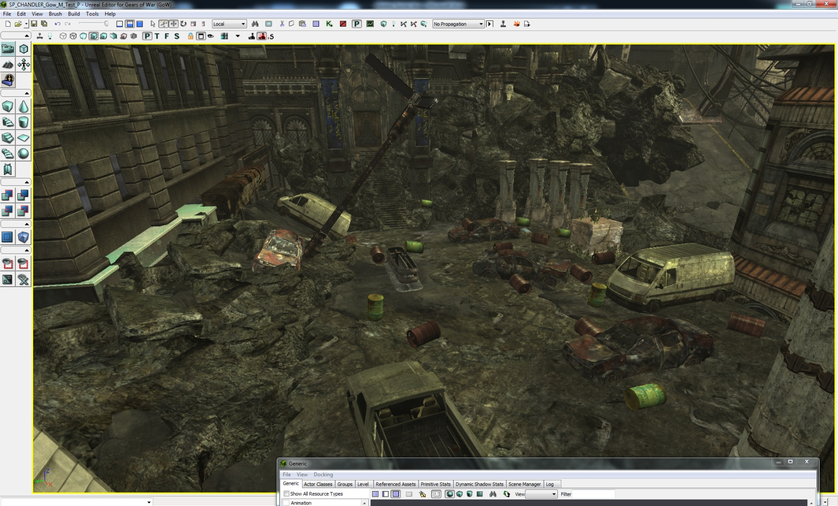
D
IO
H
G
B
A
C
E
F
Letters: EB

Was the objective to defeat the Locust clear? Yes / No
If not why not?

On a scale from 1-5, with 1 being easy and 5 being impossible, how would you rate the task to defeat the locust?
Easy Hard Impossible
1 2 3 4 5

Did the opening cinematic convey that the wrecked cars can be set off like explosives? Yes / No
If not, why not?
It looked like the barrel was exploding and the car was just setting on fire
Were you able to use the explosive objects to fight the enemy. Yes / No
If so, was this easy / challenging/ impossible?

Did you ever find yourself shooting at an object expecting it to explode or fall apart and it did not?
Yes / No
If so describe what you felt when it did not react as anticipated?

Was the objective to breach the amphitheater clear and straight forward? Yes / No
If not why not?

Was there anything that indicated that door could be destroyed? Yes / No

What was your solution to breach the door?
Throw a grenade at it
Did you notice the door glowing at any point? Yes / No
If so, what did this indicate to you?

How fun would you rate this section on a scale from 1-5, with 1 being no fun and 5 being extremely fun?
No Fun Somewhat Fun Extremely Fun
1 2 3 4 5

How difficult would you rate this section on a scale from 1-5, with 1 being easy and 5 being impossible?
Easy Hard Impossible
1 2 3 4 5

AREA 3: Ampitheater

Please write the letters of the objects that can be destroyed below the image.
D
C
F
G
A
B
E
Letters: GAD

Was the objective to defeat the locust forces clear and straight forward? Yes / No
If not why not?

How would you rate the task to defeat the enemies on a scale from 1-5, with 1 being easy and 5 being impossible?
Easy Hard Impossible
1 2 3 4 5

Did the opening cinematic convey that the statues could be knocked over with an explosion?
Yes / No

How did you defeat the enemies and complete the objective?
I knocked over statues to kill them
Did you use the collapsing statues to defeat any of the enemies? Yes / No

Did the falling statues make completing the objective easier? Yes / No

Was the objective to defeat the Boomer clear and straight forward? Yes / No
If not why not?

How did you defeat the Boomer?
I dropped the car on him
Did you notice that the central pillars fell when hit with explosives? Yes / No
If so, did they help you complete your objectives? Yes / No

Did you shoot the glowing sign? Yes / No
If so, how did you know notice it? Did you know it had a purpose?

How fun would you rate this section on a scale from 1-5, with 1 being no fun and 5 being extremely fun?
No Fun Somewhat Fun Extremely Fun
1 2 3 4 5
How difficult would you rate this section on a scale from 1-5, with 1 being easy and 5 being impossible?
Easy Hard Impossible
1 2 3 4 5

Overall Level Questions

How fun would you rate this level on a scale from 1-5, with 1 being no fun and 5 being extremely fun?
No Fun Somewhat Fun Extremely Fun
1 2 3 4 5

How difficult would you rate this level on a scale from 1-5, with 1 being easy and 5 being impossible?
Easy Hard Impossible
1 2 3 4 5

Did you notice that destructible features were a major part in helping you complete the objectives? Yes / No
If so, when did you first realize this?
When I blew up the first door and saw the field littered with red barrels
Did you enjoy watching things blow up? Yes / No

Were there any frustrating moments in the level?
If so, where?

Were you able to use the destructible objects to defeat enemies? Yes / No
If so, did it make the experience more satisfying?
Yes, it made me feel clever and strategic
What did you like about the level?
It was straightforward and simple, with clear objectives
Is there anything you can think of that should be changed to make the level easier or less frustrating in a particular area?
I would have preferred some weapons besides the starting pistol and the shotgun. It would have been easier to hit exploding objects if I could hit them from a distance in the second area

